Commonwealth of Kentucky
Withholding Return and Payment System (WRAPS)
User Guide

Contents
Overview 4
Login 5
Login Page 6
New User Registration 7
Email Confirmation 11
Trouble Accessing Your Account 13
Forgot Username 15
Reset Password 20
Unlock Account 25
Online Filing 30
WRAPS Home/Dashboard 30
Online Filing Registration 32
User Request Submission Confirmation 35
Business Administrator 36
Terms and Conditions 36
Invalid Registration……………………………………………………………………………………………………………………………………………………………………………………….38
Manage WRAPS Requests 39
Bulk Filing 42
Filing 43
Withholding Return 46
Credits 47
Electronic Signature 49
View Return 50
Edit a Return 51
Disabled Period 53
Amend Return 54
Managing Users 57
Adding Users 58
Inviting Users 61
Update Permissions & Remove Users 62
WRAPS Manage Account Filing Method 63
Update WRAPS Account Filing Method 63
Important Links 68
Links in WRAPS 69

1

Overview

The Withholding Return and Payment System (WRAPS) provides the taxpayers of the Commonwealth, the ability to file their Withholding K-1 and K-3 returns online. Taxpayers will be able to file returns, view and amend returns that were previously filed online, request refunds and credit forwards, as well as the ability to access the Enterprise Electronic Payment System (EEPS) for paying Withholding Tax Due.
This User Manual is being provided as a guide to working with the system and can be used as a quick reference guide for frequently asked questions.
Please review the table of contents for quick access to necessary information.

2

Login

To register a Business for online filing, the User will need to go to the Department of Revenue home page (https://revenue.ky.gov) and then look for Employer Payroll Withholding under Business. The user will then be directed towards the Withholding Returns and Payment System (WRAPS).
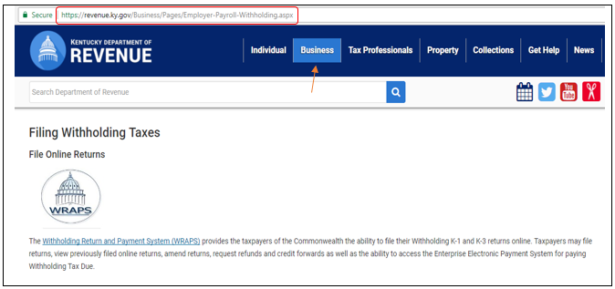

This will take the user to the One Stop Login screen.

Login Page

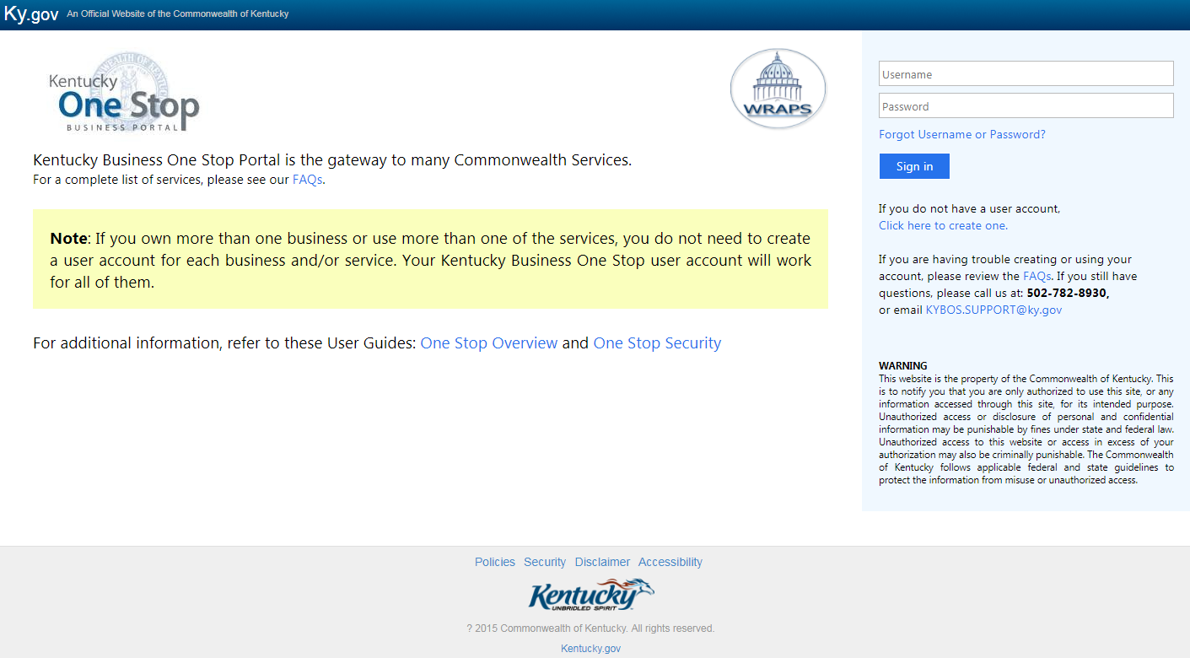
If the user is an existing user, they will need to enter their Username and Password and click ‘Sign in’. If the user is a new user, they will need to click ‘Click here to create a user account.’

Note

New User Registration

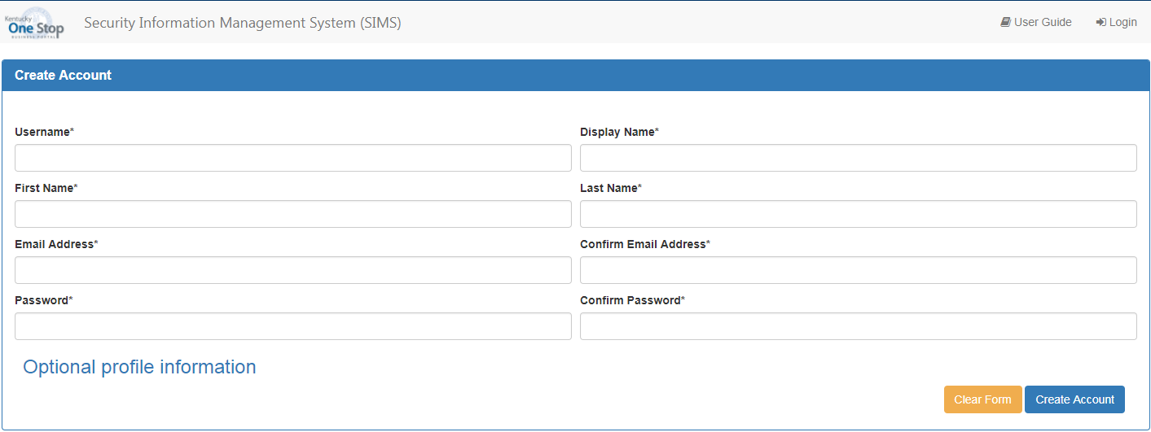

Once the user is presented with the Create Account page, the user will need to enter the required information:
  - User Name
  - Display Name
  - First Name
  - Last Name
  - Email Address (requires duplicate entry for confirmation)
  - Password (requires duplicate entry for confirmation)

Optional Profile Information

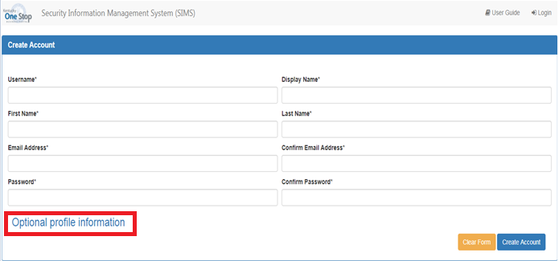

Note

Note

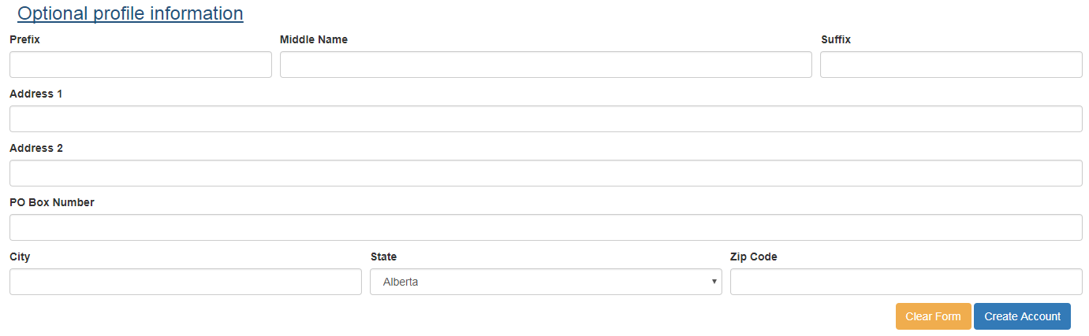

Upon completion of all required and applicable fields, the user will click ‘Create Account’.

Once the user clicks the ‘Create Account’ button, they will see a screen that shows an account creation confirmation message confirming that they have created an account with One Stop. However, the user cannot log in yet, as they still need to activate their account.
The user should follow the instructions provided on this screen to check their email.

Email Confirmation

The user will need to check the email account that they entered on the Create Account screen for an email from noreply.sims@ky.gov. The email will look similar to the one shown below:

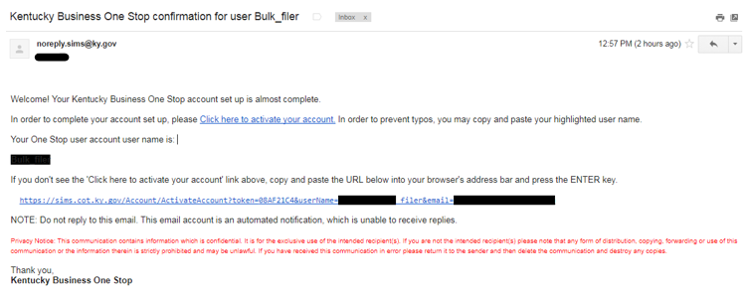

In order to activate their account, the user should click on the hyperlink (Click here to Activate Your Account) provided in the email. This will take the user back to the One Stop login screen.

Once back at the One Stop login screen, users should input the Username and password they entered on the Create Account screen as shown in the highlighted red box.

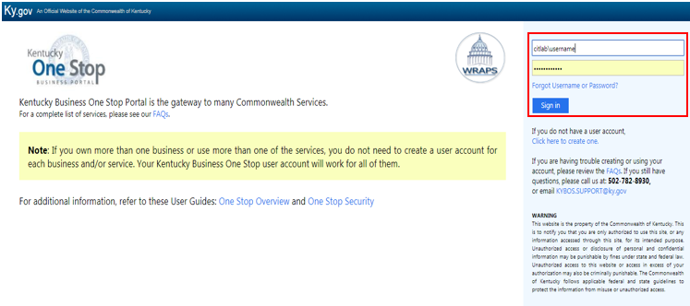

Please be aware that One Stop will auto generate ‘cit\’ at the beginning of the user’s username. This is not an error and is necessary for the user to successfully log into One Stop and the Withholding Return and Payment System.

Note

3

Trouble Accessing Your Account

If the user is unable to successfully login, has forgotten the correct username and/or password, or if the account has become locked, the user should click the ‘Trouble accessing your account?’ link on the WRAPS homepage.
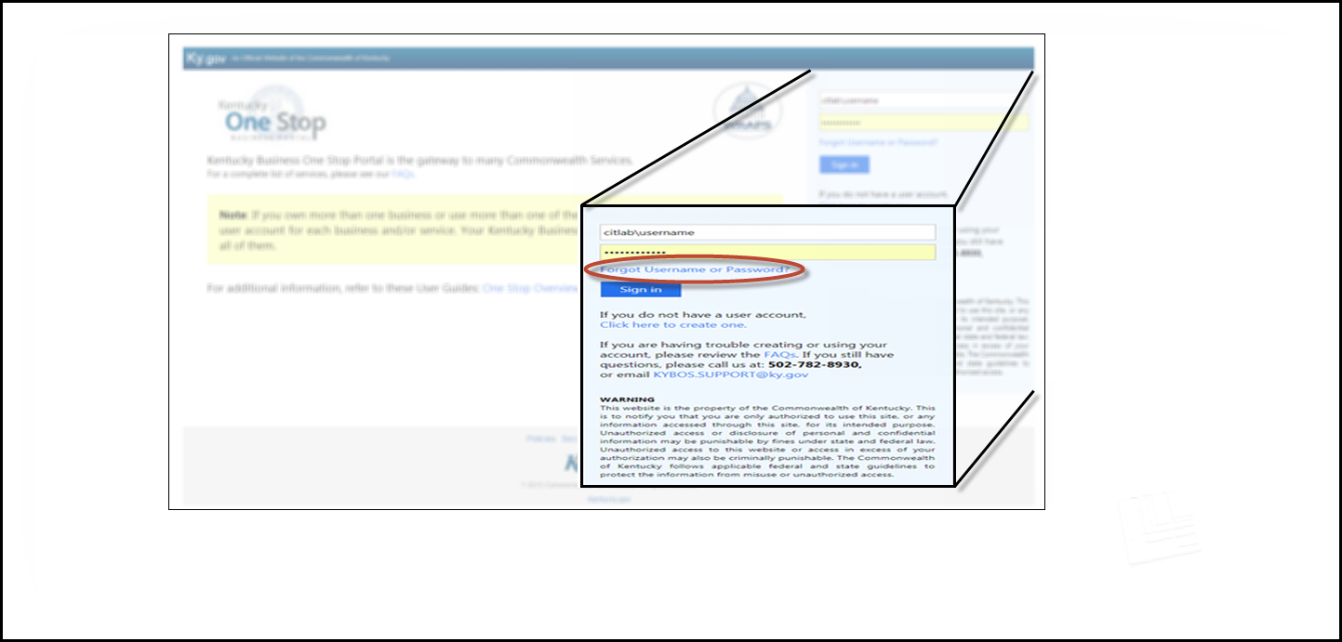

This will take the user to the Account Self-Service page where the user can select the appropriate link to obtain the Username associated with the account, reset the account password, unlock the account, and login to the Kentucky Business One stop Portal.

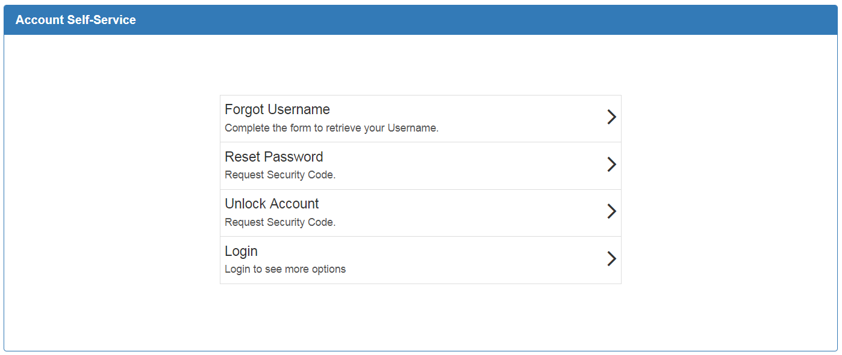

Forgot Username

If the user has forgotten the Username that was entered when the profile was generated, the user will select ‘Forgot Username’.

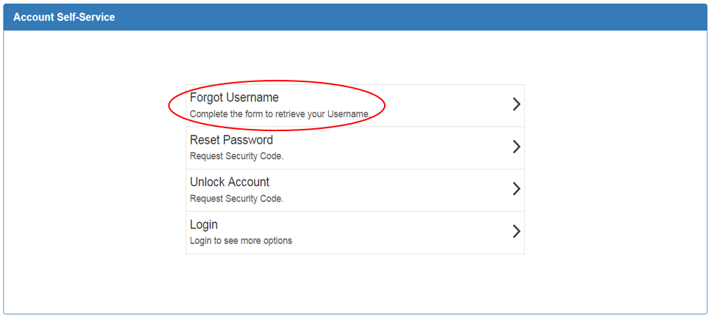

The next screen will prompt the user to indicate where the Username associated with the account should be sent.

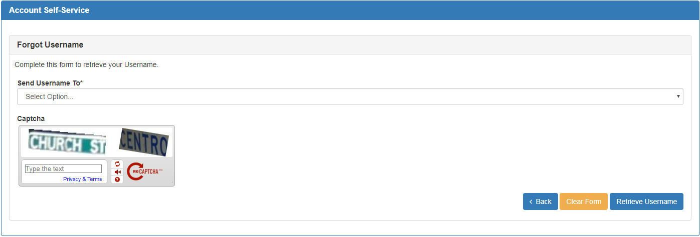

At present, the only option to select is “My Email.” The user should enter the email address used when the SIMS profile was created.
Note

Clicking on the drop down menu under the “Send Username To*” field will enable the user to input the email address used when the SIMS profile was created. Enter the “Captcha” verification information, and click ‘Retrieve Username’.

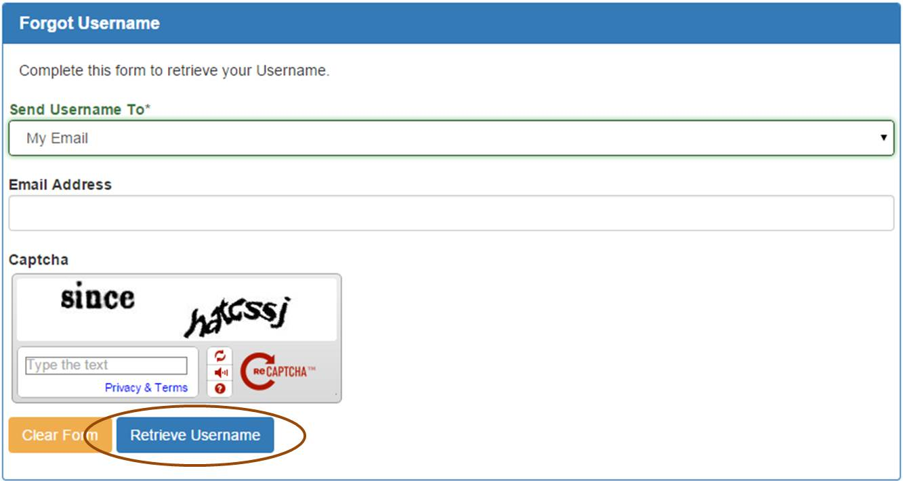

The system will indicate that details regarding the account have been sent to the user via email.

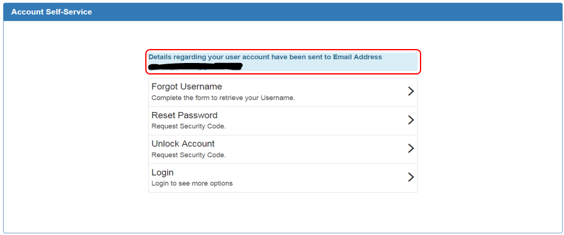

The user will receive an email similar to the example below. The user will utilize the account username listed in the email to login to WRAPS.

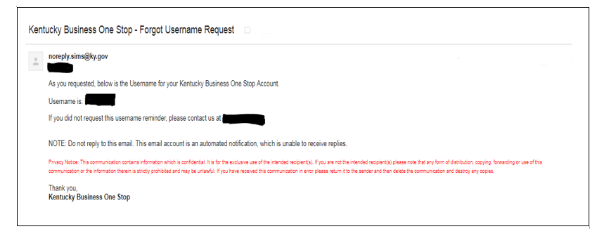

Reset Password

If the user has forgotten the account password and needs to reset it, the user will select ‘Reset Password’.

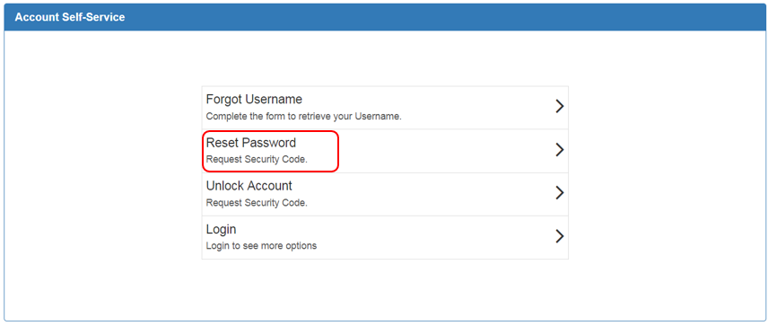

The next screen will prompt the user to indicate where password reset information should be sent.

The user will key in the Username associated with the account, select “My Email” under “Send Code To*” drop down menu, and then enter the SIMS profile Email address. The user will type the “Captcha” verification information and click ‘Request Security Code’.

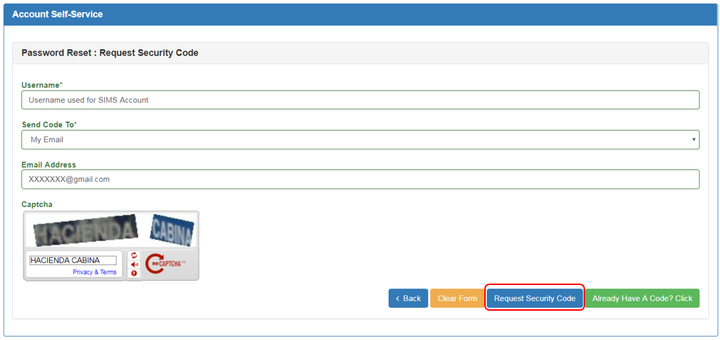

Note
The following radio buttons perform the following functions:

‘Back’ = Will take the user to the earlier page.
‘Clear Form’ = Will clear the data that had been entered in the current field.
‘Already Have A Code?Click’ = The user can key in the system generated code.

The user will receive an email similar to the example below. The user will utilize the system generated recovery code and included instructions to reset the password.

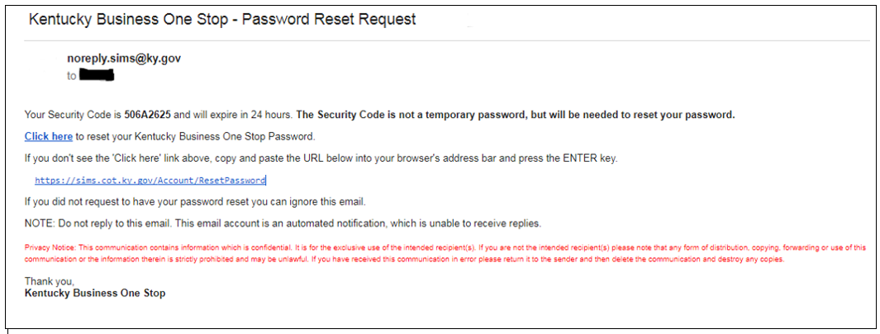

Note
The system generated recovery code is only valid for 24 hours. If 24 hours has passed since the code was issued, the request process must be repeated in order to obtain a new code.

Upon returning to WRAPS, the user will input the Username associated with the account, the system generated recovery code, and the new password. The user will re-enter the new password to confirm, input the “Captcha” verification information, and click ‘Reset Password’.

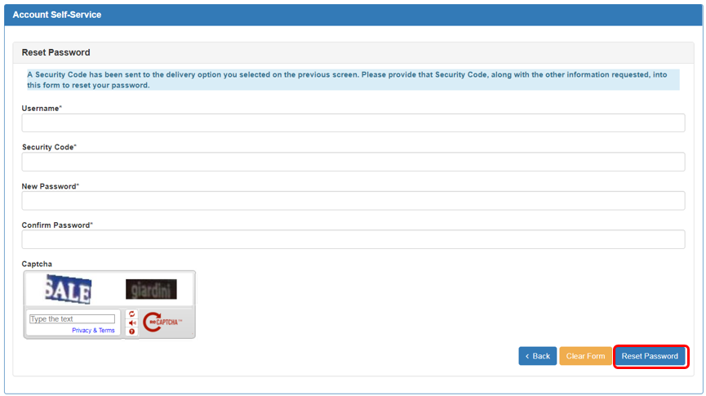

Note
New passwords must be between 8 and 15 characters long and contain at least one of the following: one number, one letter, one special character and one capital letter. Passwords must not contain the Username, First Name or Last Name.

The system will indicate that the account password has been reset.

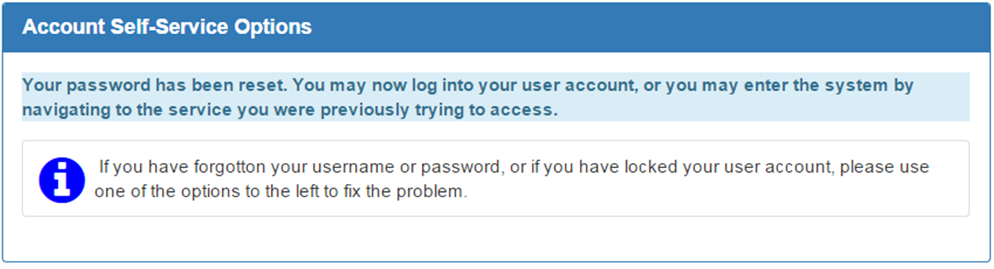

The user will receive an email similar to the example below indicating that the password for the account has been changed.

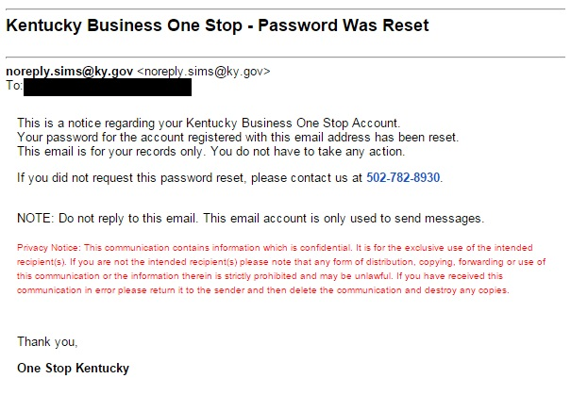

Unlock Account

If the user account has become locked, the user will select ‘Unlock Account’.

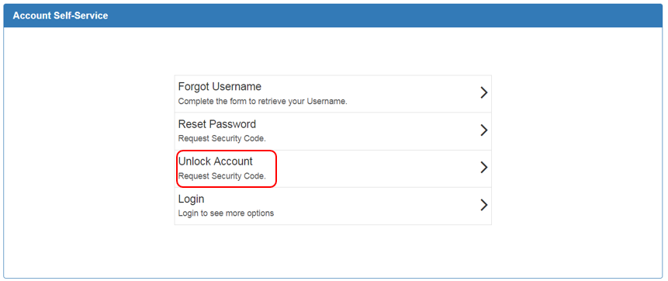

The next screen will prompt the user to indicate where unlock account information should be sent.

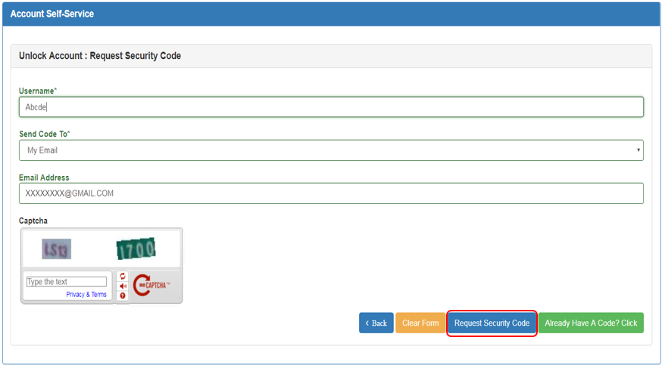

The user will input the Username associated with the account, select “My Email” for “Send Code To*”, and then enter the email address used when the profile was created. The user will input the “Captcha” verification information and click ‘Request Security Code’.

The user will receive an email similar to the example below. The user will utilize the system generated recovery code and included instructions to unlock the account.

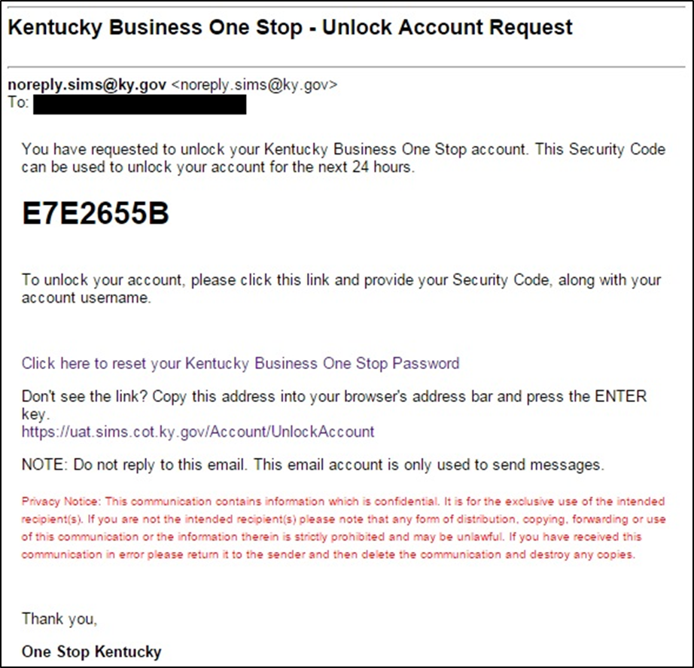

Note
The system generated recovery code is only valid for 24 hours. If 24 hours has passed since the code was issued, the request process must be repeated in order to obtain a new code.

Upon returning to WRAPS, the user will input the Username associated with the account and the system generated recovery code. The user will input the “Captcha” verification information, and click ‘Unlock Account’.

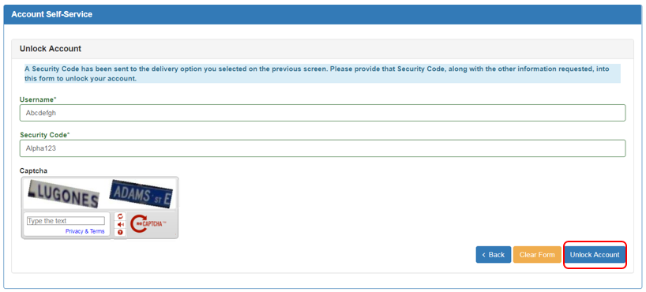

The system will reference that the account has been unlocked .
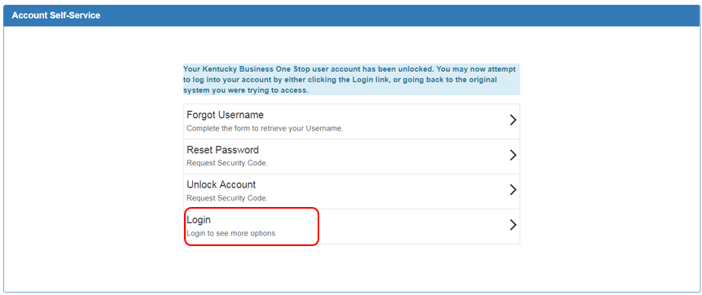

If the user selects the ‘Login’ option to the left, the user will login to the Kentucky Business One Stop Portal .In order to access WRAPS from this location, the user must click the ‘WRAPS’ icon under the “Quick Links” section to the right.
Note

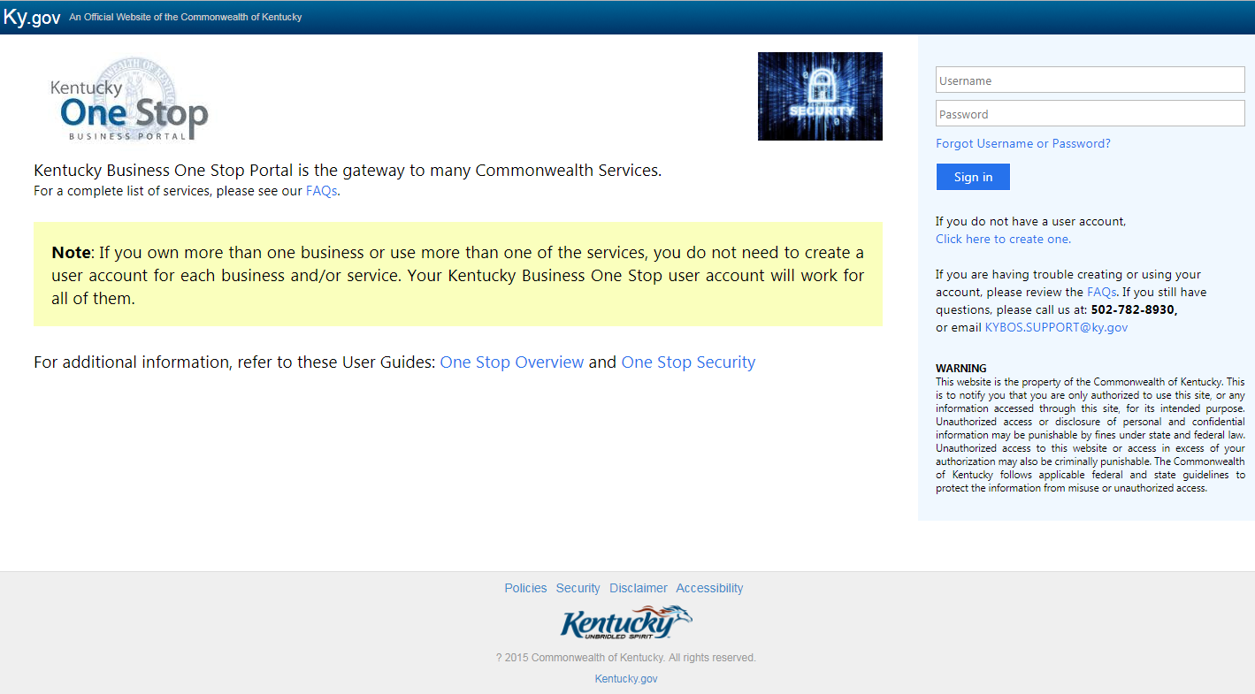

4

Online Filing

WRAPS Home/Dashboard

Once the user has entered their user name and password in the One Stop login page, the user will be directed to the WRAPS Home Dashboard.

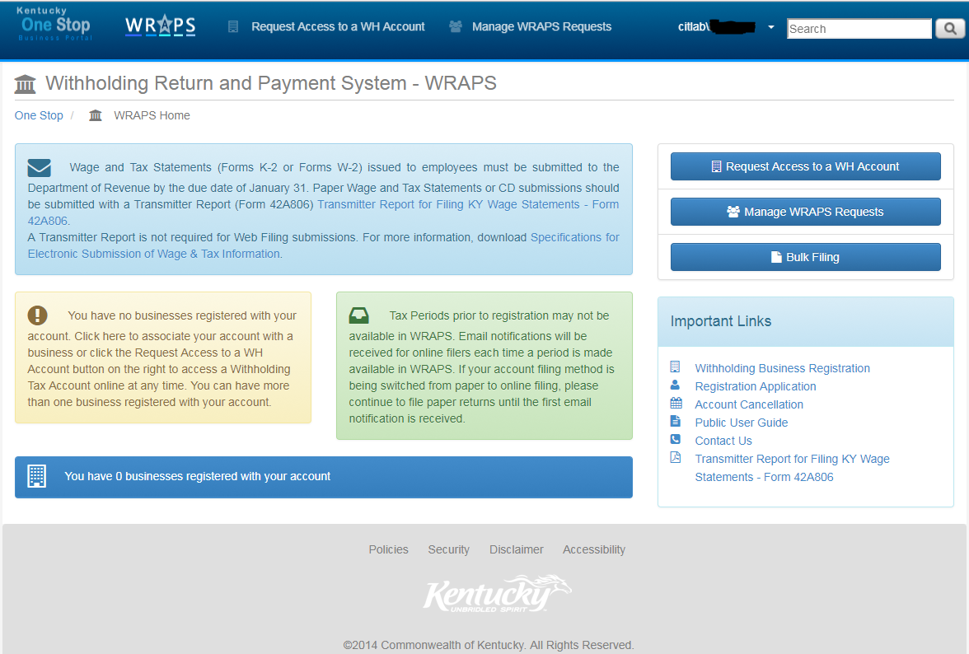

If a user does not have any businesses associated with their account, a message will appear indicating that they need to ‘Request access to a registered business’ or ‘Register a business for online filing’.
Note

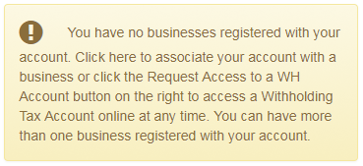

Online Filing Registration

The “Request Access to a WH Account” button (highlighted in red) will enable the user to request for a WH Account access.

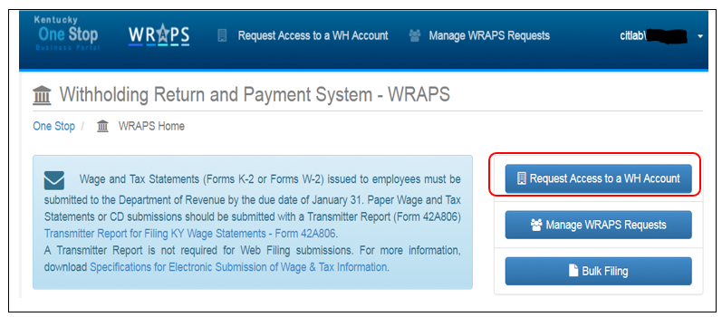

The user will need to enter the correct withholding tax account number and either the Business Name as registered or the Federal Employer Identification Number (FEIN). Once the required information is entered, the user will click ‘Submit’ as shown below.

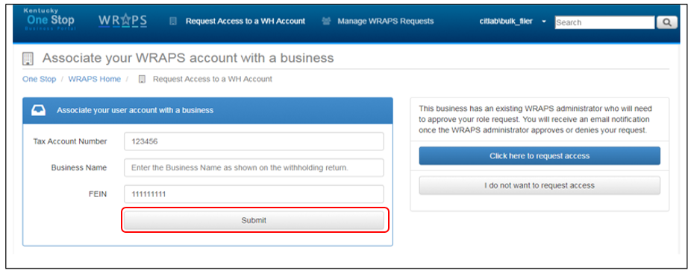

After entering the correct credentials and clicking the submit button, two new radio buttons are displayed (“Click here to request access” and “I do not want to request access”). In order to request access for the specific role (Filer, Payor, Viewer, Filer + Payer or Admin to the WH Tax Account from the Admin, the user will need to click on the “Click here to Request Access” button as shown below.
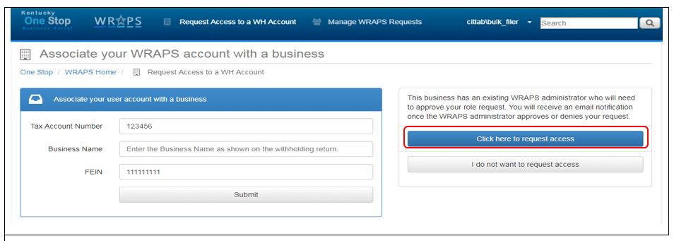

After clicking the “Click here to request access” button, the user will be notified through an email as shown below:
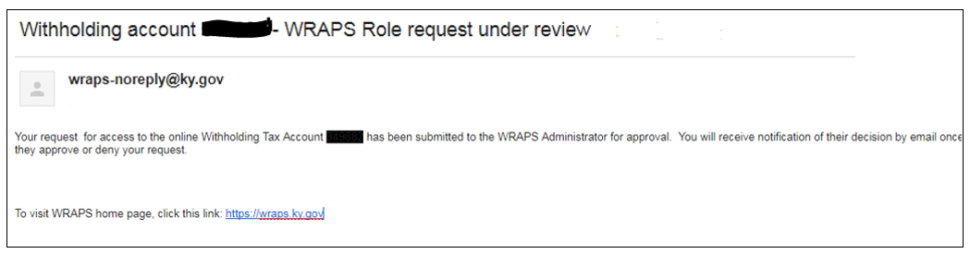
The User can also see see the submission confirmation on the WRAPS Page as shown below:
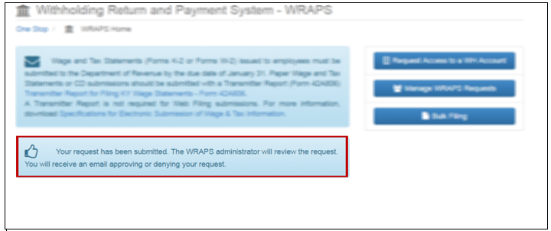

When the Admin grants the requested role to the user for WH Tax Account. An email will be sent to the user as displayed below:
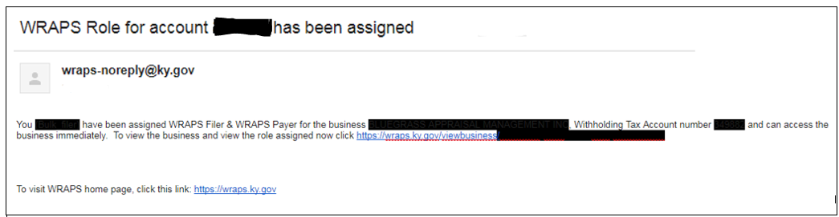

Business Administrator

If the user enters the correct Tax Account Number and the correct Business Name and/or FEIN, and if the business is not already registered for Bulk filing, the user will be presented with a screen asking them if they would like to become the administrator for the business.
Note
In order for a business to be registered for Online Filing, there must always be an administrator assigned to the business.

Terms and Conditions
If the user chooses to ‘Become the WRAPS Administrator’, they will be presented with a screen where they can hit ‘cancel’ to cancel the registration process, or check the Terms and Conditions box and click ‘Register as the WRAPS Administrator’.
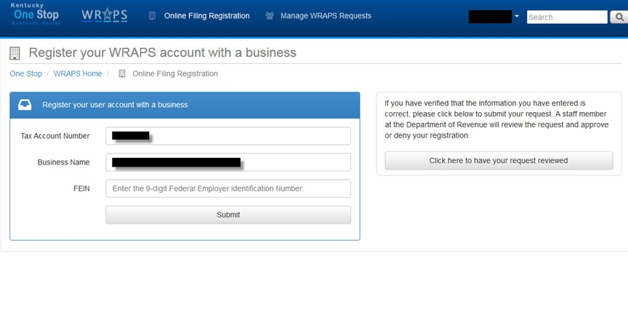
The user must also agree to terms and conditions when sending a request for registration to DOR.
Note

After the User agrees to the terms and conditions, they will be presented with the screen below.
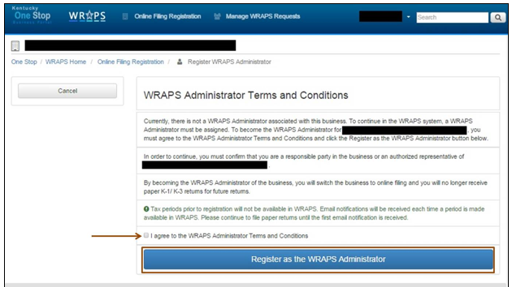

The User can also deny the request for the Role Access by clicking on the radio button as shown below:
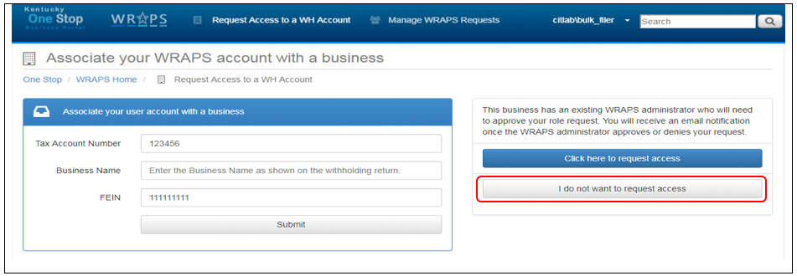

Invalid Registration
If the user enters an invalid Withholding Tax Account Number, the system will display an error message stating that the user needs to contact the Kentucky Department of Revenue to receive additional assistance.
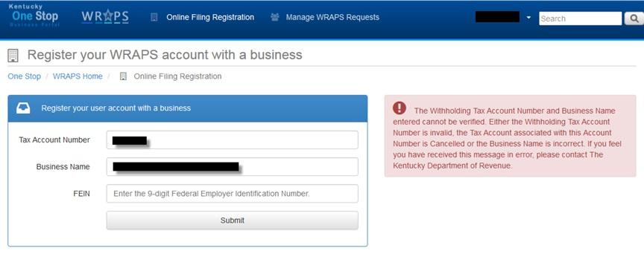

Manage WRAPS Requests

The Manage WRAPS Requests feature allows withholding tax account administrators using the WRAPS online tools to approve or deny requests made by users who are not associated with the business. This allows the WRAPS Administrator to easily manage who has access to the withholding tax account.

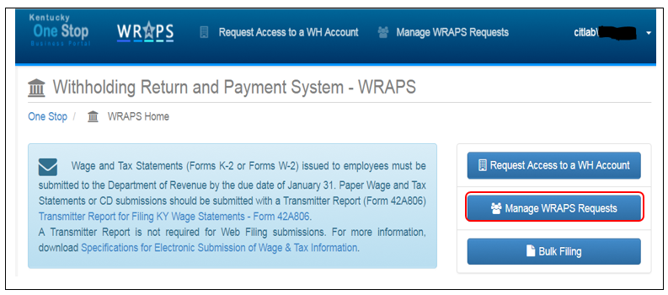

The Admin of the WH Bulk Account can see the user requests in the following screen.
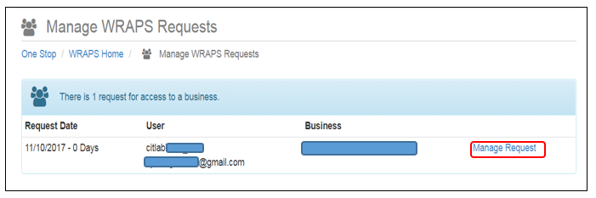

After clicking the Manage Request Button the user is taken to the following Screen as shown below. The Admin User can deny the User Request or grant the Roles of WRAPS Filer + Payer, Wraps Filer, Wraps Payer, Wraps Viewer or even grant the WRAPS Admin Role.

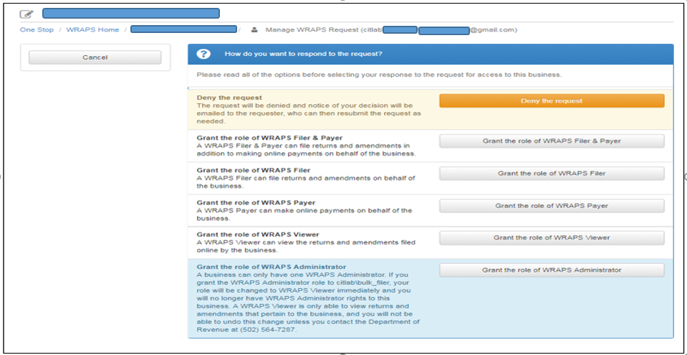

Bulk Filing
Clicking on the “Bulk Filing” radio button will enable the user to register for Bulk Transmitter ID. Payroll providers wishing to register their business as Bulk Transmitter must be assigned a Bulk Transmitter ID by completing the registration process.
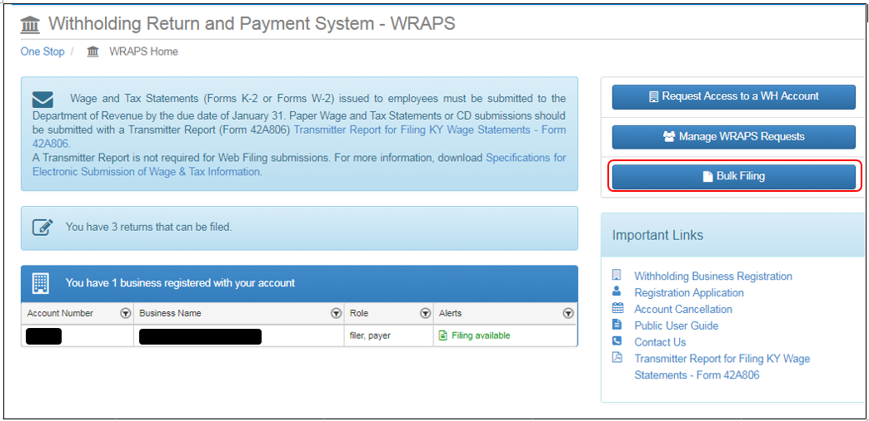
Clicking on the “New Registration” button will direct the user to the Vendor Gateway Portal where they have to fill in their necessary business information and get registered as Bulk Transmitter.
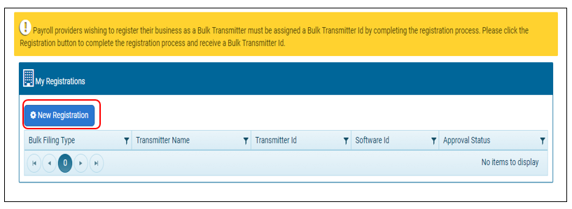

Filing

When the user has at least one business registered with their user account, the user will see a dashboard/home screen with all businesses associated with their account.

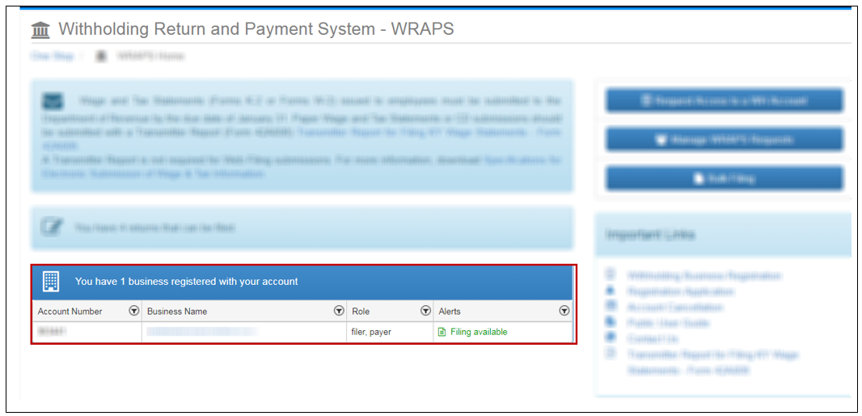

If a return is available for filing, there will be an alert in the alert column for the business. To access the business page the user can click the Business Name. To file a return, the user will need to click ‘Filing available’ or “! Not filed online”.

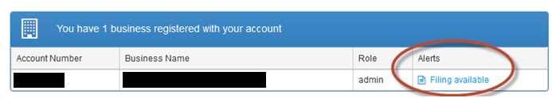

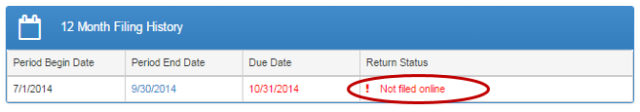
To file the K-1 or K-3 return, the user will need to click ‘File K-1/K-3 Original’ in the period section on the left or the button on the right.

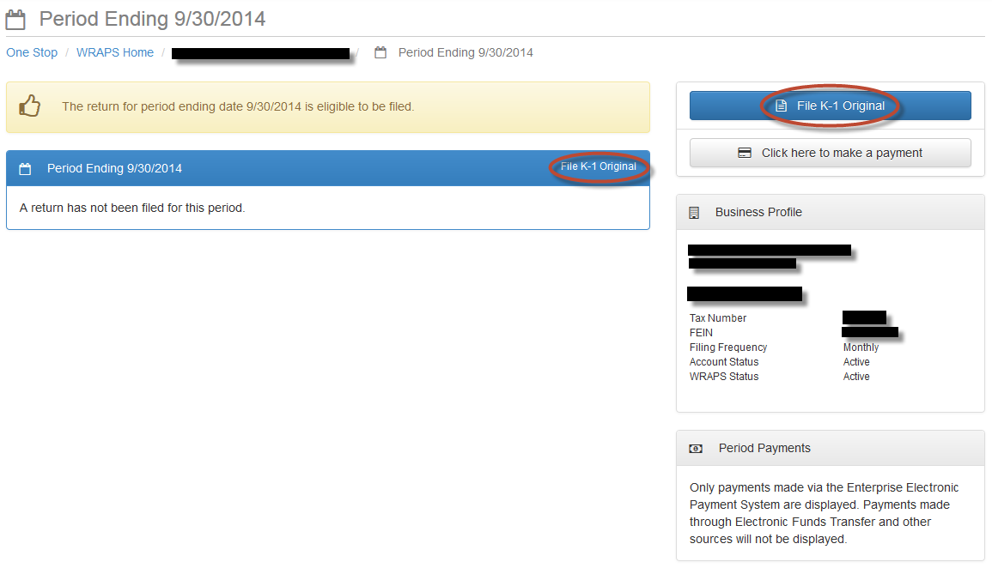

Withholding Return

The user will then need to fill out all required fields and click ‘Submit the K-1 Original return’.

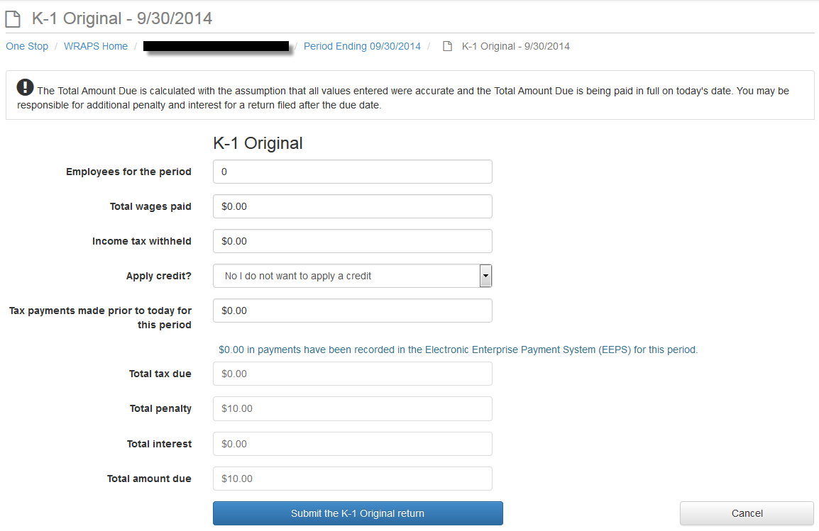

Credits
In order for the user to apply credit to a return, the user must click the arrow at the “Apply credit?” field and select either “Yes, apply credit from a different period” or “Yes, apply Economic Incentive Credit”.
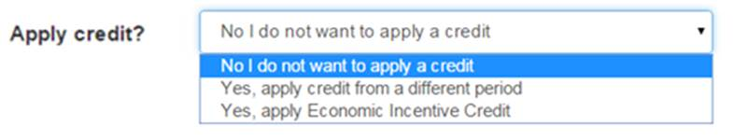

If a credit from a different period is to be used, the user will select the appropriate option and additional fields will appear.
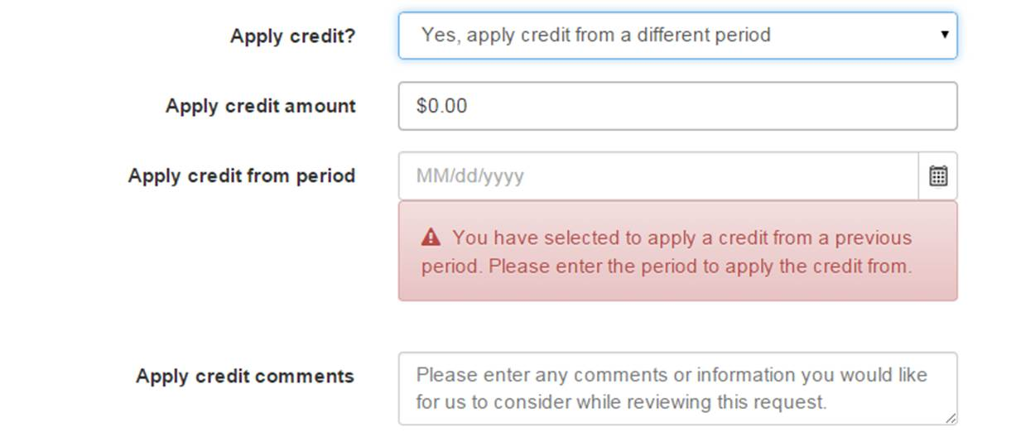

If the Economic Incentive Credit is to be used, the user will select the appropriate option and additional fields will appear.

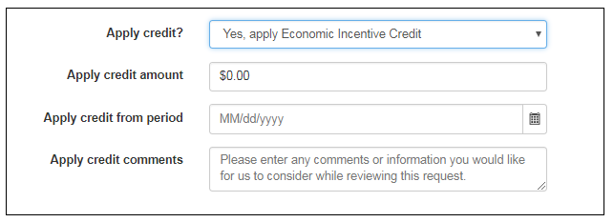

Electronic Signature

In order to submit the return, the user will need to agree to the electronic signature terms and submit ‘Sign and Submit the return.’

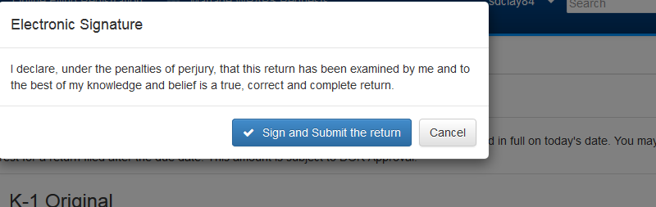

View Return

In order to view the filed return, the user can view the summary or click the return link on the Period Screen to view the detailed return.
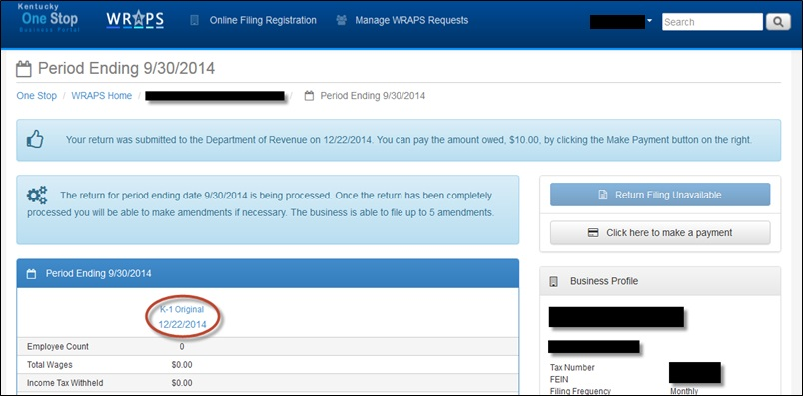

Edit a Return

The user can edit the return by clicking the ‘click here to edit the return’ button.

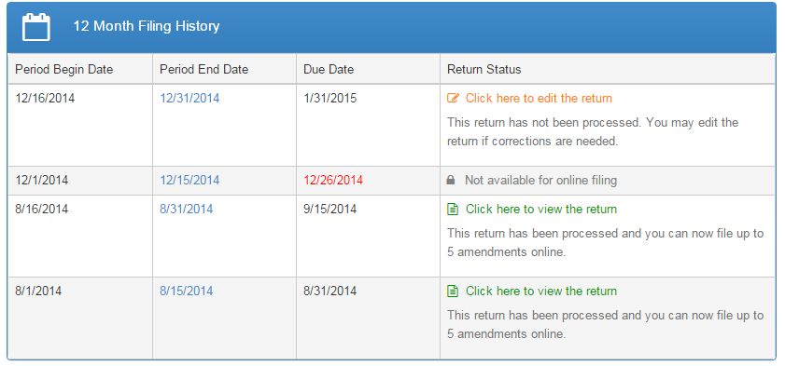

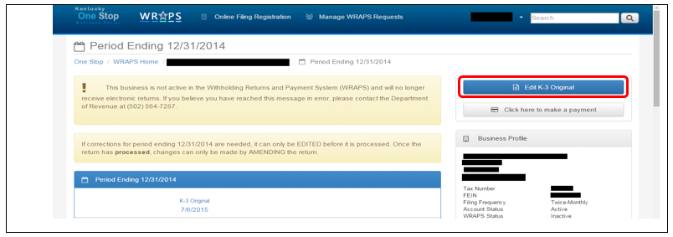

Note: If corrections for period are needed, it can only be EDITED before it is processed. Once the return has been processed, changes can only be made by AMENDING the return.

Disabled Period

The user can notice that a period is disabled as the return for that period cannot be filed online.

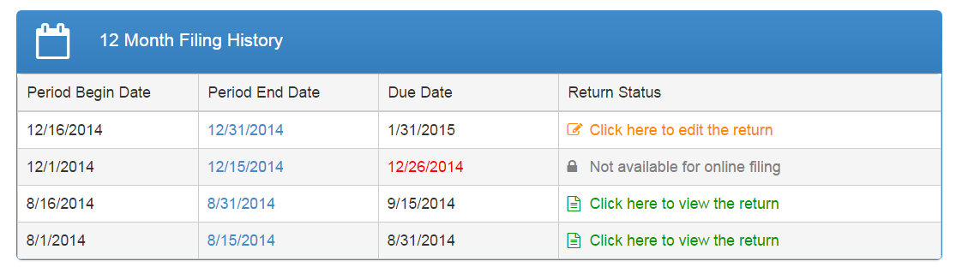

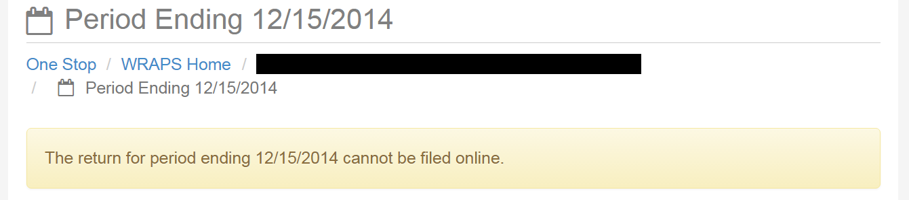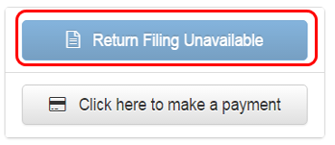
After the user has clicked the “Not available for online filing” in the ‘Return Status’ column, the user can notice a disabled tab that states ‘Return filing unavailable’.

Amend Return
Note
To amend the return, the user will need to click “File Amendment” from the Period Screen for the Business.

The return will be available to amend once the original return has been processed.

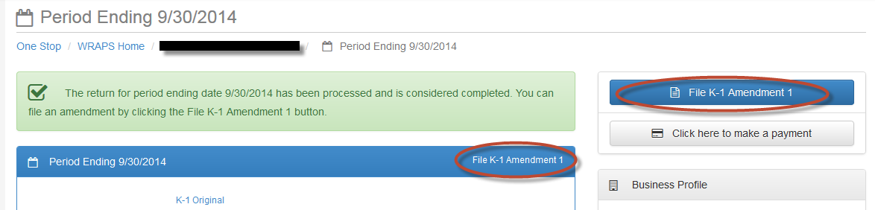

The user will need to update any values necessary and click ‘Submit the return’.
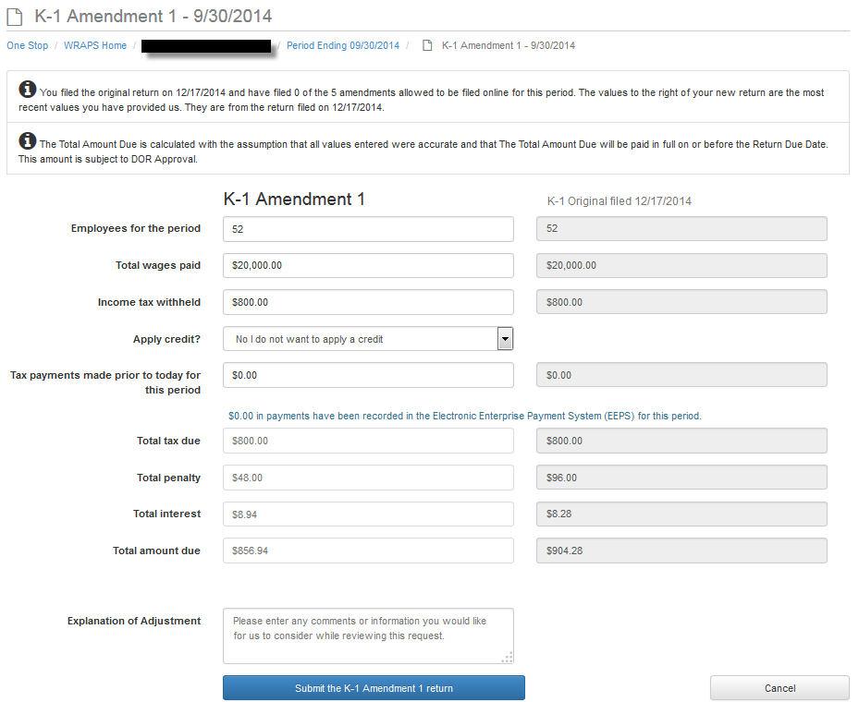

A return may only be amended up to 5 times online. Once the maximum number of amendments has been reached, the user will be allowed to download a paper amendment form.
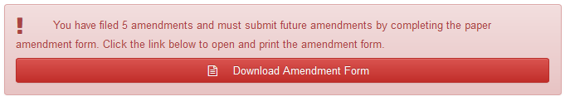

5

Managing Users

In order to add, remove or update a user’s permissions, the business administrator will access the Business’ home screen.
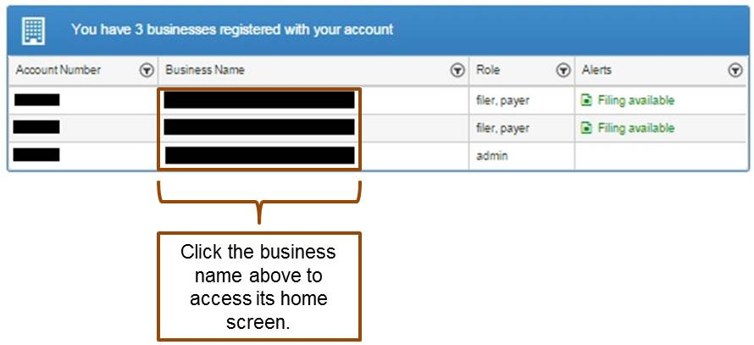

Adding Users

To add a new user to the Business, the Business Administrator will click ‘Add WRAPS User’.
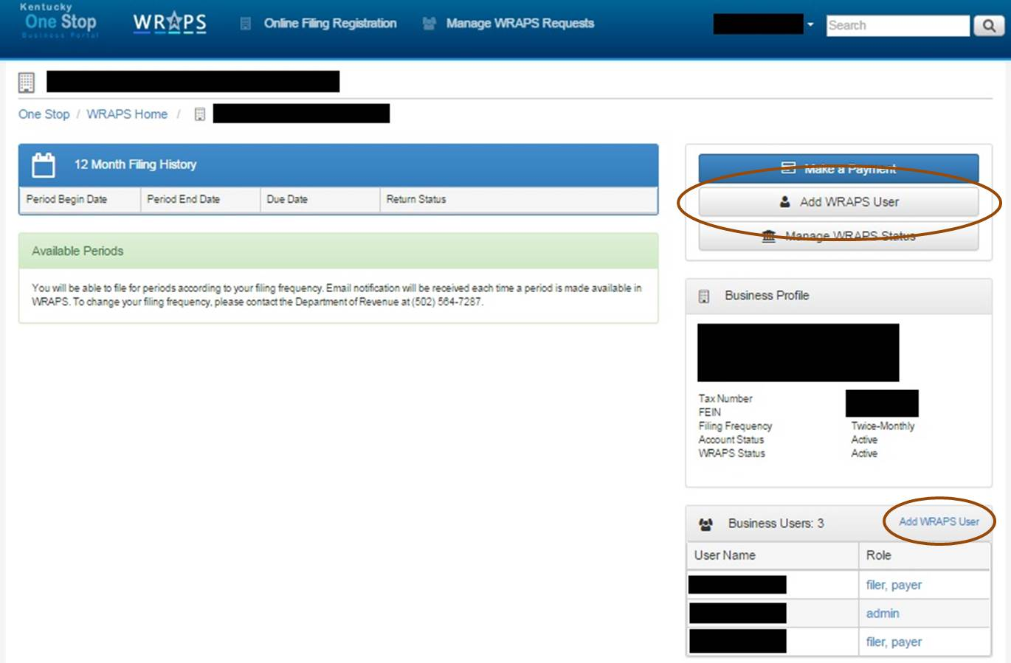

The Business Administrator will then enter the email address that is associated with a user registered with One Stop and click ‘Search for a registered email address ’.

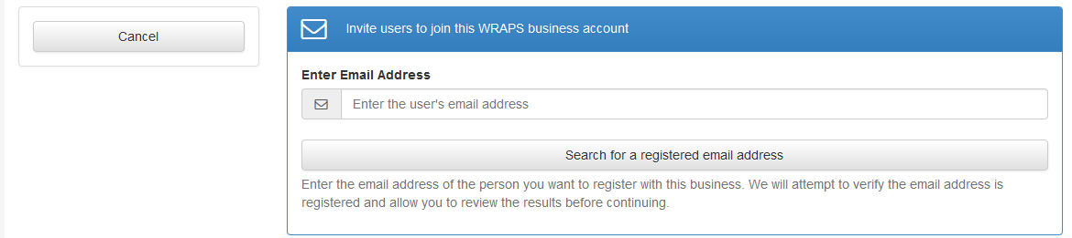

If the user is registered with One Stop, the Business Administrator will be presented with the option to grant the user one of the following roles: Filer & Payer, Filer, Payer, Viewer or Administrator.

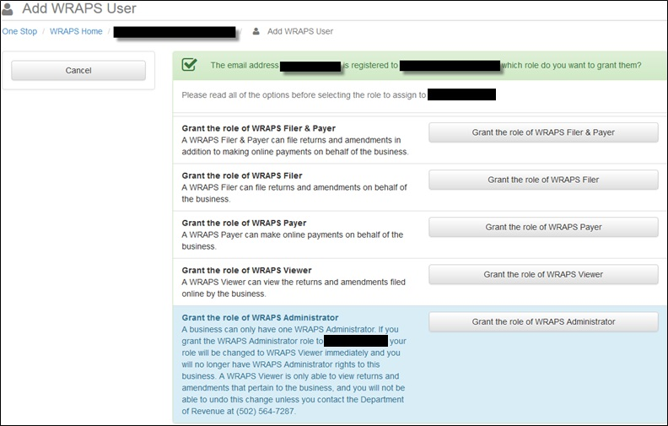

Inviting Users

If the user is not registered with One Stop, the Business Administrator will be presented with the option to send the user an invitation to create a user account. To send the invitation, the Business Administrator will need to click ‘Send invitation to: (email address)’.
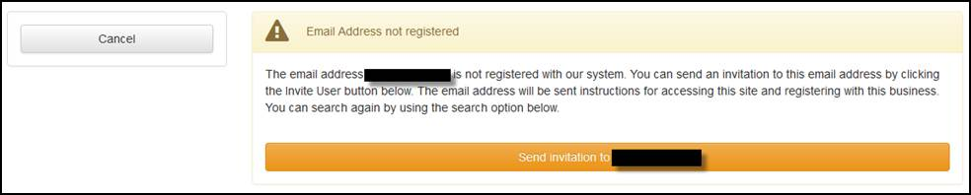

The user will receive an email similar to the one below, indicating to which business the user has been added and the permission level that was granted.
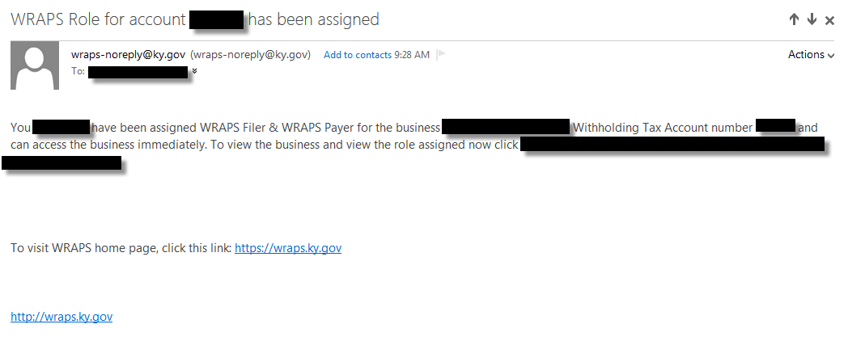
Update Permissions & Remove Users

To edit a user’s permissions or to remove a user from the Business, the Business Administrator will need to click on the role.
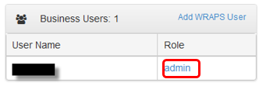

The Business Administrator will then need to choose to ‘Remove user access’ or grant the user another permission level. 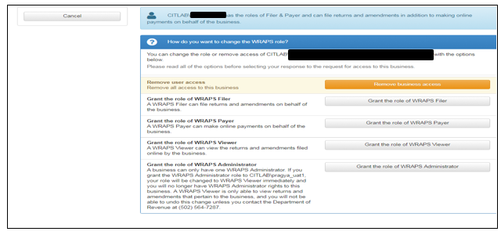
6

WRAPS Manage Account Filing Method

Update WRAPS Account Filing Method

To update the Online Filing Status, the Business Administrator will need to access the Business Home Screen in WRAPS and click ‘Manage Account Filing Method’.

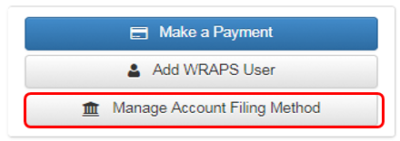
If the Business is currently registered for Bulk filing, the Business Administrator will need to click Account Filing Method and opt for the appropriate Filing Method (Online/ Paper or Bulk Filing). The user will then need to provide a reason and click on the “Change Account Filing Method” button as shown in the screen shot below.

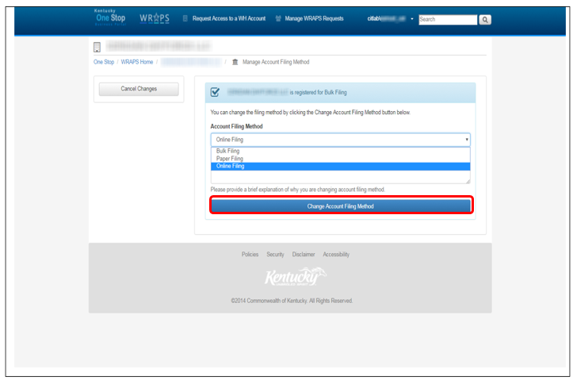

Clicking on the ‘Change Account Filing Method’ button will take the user to the following screen below to confirm the changes.

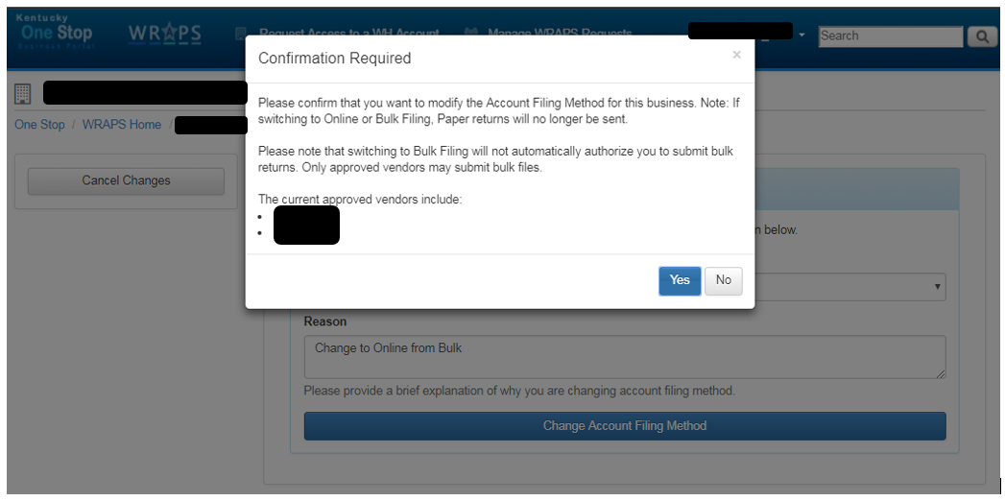

After confirming the request by clicking on ‘Yes’ tab in the screen shot below, the admin will be able to see the desired Account Filing Method under the Business Profile.

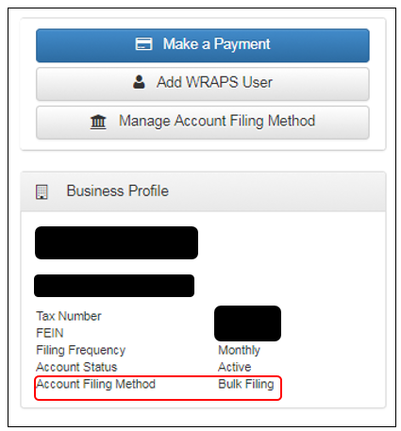

If the Business is not currently registered for online filing, but was at one time, the Business Administrator will need to click “Register for Online Filing” and click “Yes” in the confirmation box.

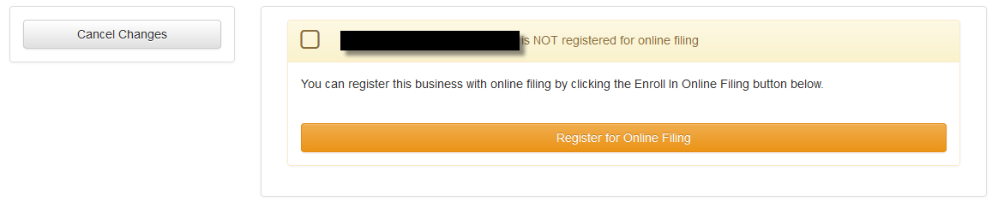

7

Important Links

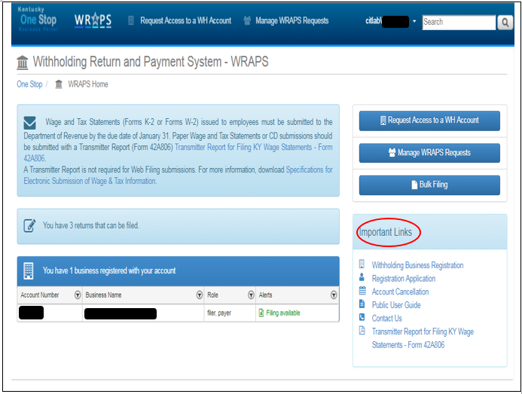

Links in WRAPS

The following links can be found on the WRAPS Home Page:
- Withholding Business Registration (paper registration form)
- Registration Application form
- Account Cancellation form
- Public User Guide
- Contact Us Link
- Transmitter Report for Filing KY Wage Statements – Form 42A806.

