Property Valuation Administrators

MOTAX User’s Manual

February 2023
KENTUCKY DEPARTMENT OF REVENUE
501 High Street, Frankfort, KY 40601

Table of Contents

Section I 6
General Information 6
Responsibility 6
Duties of Property Valuation Administrator 6
Duties of the Department of Revenue 7
Duties of the County Clerk 7
Duties of the Taxpayer 7
Alternative Registration Month 7
Section II 8
Kentucky Revised Statute & Soldiers’ and Sailors’ Civil Relief Act 8
Kentucky Revised Statutes 8
Governmental Leasing Act 8
KRS Chapter 131 Kentucky Department of Revenue 9
KRS Chapter 132 Levy and Assessment of Property Taxes 11
KRS Chapter 133 Supervision, Equalization, and Review of Assessments 16
KRS Chapter 134 Payment, Collection, and Refund of Taxes 17
KRS Chapter 136 Vehicles of System Operating Route Partly Within State 20
KRS Chapter 138 Excise Taxes 21
KRS Chapter 186 Licensing of Motor Vehicles, Operators, and Trailers 22
KRS Chapter 186A Automated Motor Vehicle Registration System 25
KRS Chapter 235 Boats and Boating 30
KRS Chapter 523 Perjury and Related Offenses 31
KRS Chapter 516 Forgery and Related Offenses 32
Soldiers' and Sailors' Civil Relief Act 32
Section III 33
MOTAX System Screenshots 33
MOTAX Main Menu Screen 33
PF1 Screen – Registration Inquiry 34
PF2 Screen – Adval Vehicle Tax Detail and Update 36
PF3 Screen – Property Tax Vehicle Record Update 37
PF4 Screen – Transfer of Ad Valorem Tax Payment 38
PF5 Screen – Delinquency Inquiry 39
PF6 Screen – Revenue Lien Release 40
PF8 Screen – Title Inquiry 41
PF9 Screen – Chain of Ownership by Title or Plate 43
PODD – Print on Demand Decal 43
Section IV 44
Reports 44
On-Line Transfer Report – R5532 44
On-Line Change Report –R5537 45
Vehicle Batch Update – R5504 –Vehicle 88 45
Ad Valorem District “88” Report (BOAT) 46
Motor Vehicle Tax Roll 46
Boat Tax Roll 47
Utility Trailer Report 47
Projected Monthly Collections 48
Annual District “88” Report 49
Annual District “00” Report 50
Advance Tax Listing Obligation Report 50
Section V 51
Forms Used by PVA and County Clerk 51
Form 62A044 Affidavit for Correction/Exoneration of Motor Vehicle/Boat/Trailer Property Tax 51
Form 62A044-T Affidavit for Correction/Exoneration of Fleet of Trailers 52
Form TC 96-182 Application for Kentucky Certificate of Title or Registration 53
Form TC 96-215 Affidavit of Motor Vehicle Assembled from Wrecked or Salvaged Motor Vehicles 54 Form TC 96-192 Affidavit Supporting Repossession and Disposition of a Vehicle 56
Form TC 96-3 Affidavit of Incomplete Transfer 57
Form TC 96-183 Notice to County Clerk of Vehicle Acquisition 58
Form 62A645- End of Year Motor Vehicle Transfers not Titled Until Next Year 59
Section VI 60
Assessment of Motor Vehicles 60
Valuing of All Motor Vehicles 60
Vehicles 19 Years Old or Less 61
Vehicles 20 years or Older 61
Large Trucks (Heavy and Medium Duty) 61
Recreational Vehicles (RVs), Travel Trailers Campers, Motor Homes, and Van Conversions 62
Van Conversions 62
Motorcycles 62
Boats 62
Section VII 63
Adjustments to J.D. Power Value 63
Adjustments to Assessment 63
Documentation Required for Reduction of Assessment 63
Examples of Assessment Adjustments 64
Section VIII 66
Tax Status Codes and Account Numbers 66
Tax Status Codes 66
Tax Status Codes Explained 66
Apportioned Vehicles 67
Junk, Sold Out-of-State, Mobile Homes, and Stolen Codes 67
Transfer of Ownership of Vehicle 68
Change of Situs (County Code Change) 68
Account Numbers 69
Section IX 70
Exonerations 70
Exonerations on MOTAX 70
Special Types of Vehicles or Transactions 71
Salvage Titled Vehicles 71
Leased Vehicles 71
Apportioned Vehicles 72
Historic Registration 72
Motor Vehicle Dealers 72
Divorce 73
Public Service Company Vehicles 73
Bankruptcy 74
Seized Vehicle 74
Section X 75
Collection and Refund of Tax 75
Collection and Refund of Tax 75
Penalty and Interest Waivers for Local Officials 76
Statute of Limitations 82
Tax Due Date 83
Section XI 83
Frequently Asked Questions 83
How do I create an ad valorem tax segment? 83
How do I change an ad valorem tax segment in the system? 84
How do I find a delinquency in the MOTAX system? 84
What if a delinquency of someone else displays on the screen? 84
How do I find a social security number? 84
How do local jurisdictions set motor vehicle and watercraft tax rates? 85
How do I determine legal owner for property tax purposes? 85
Transactions prior to January 1 where title is not requested until after January 1 86
Why does the Department of Revenue create tax segments on vehicles that were coded “N” (non- taxable) for the previous year? 86
How does the taxpayer remove a junked vehicle from the system? 86
What is the proper procedure for eliminating a tax on a vehicle that was sold out-of-state or sold to a Kentucky resident prior to January 1 of the tax year? 87
Why do mobile homes continue to have taxes in MOTAX? 87
Why are most property tax values different from the usage tax value? 87
What do I tell the taxpayer to do if their vehicle has been repossessed prior to January 1 of the tax year? 88
How does a taxpayer protest an assessment? 88
How does the Department of Revenue program AVIS once the PVA codes the tax segment with “T”, “E”, “M”, “S”, “V”, or “J”? 89
What are the tax codes that may be used in the MOTAX system? What are their purposes? 90
Can the PVA set a minimum value on a vehicle which has a salvage title? 90
Should the PVA exonerate property taxes on a vehicle which has been sold, but has not legally been transferred to the new owner in AVIS? 90
If a customer has no proof as to why a property tax should be exonerated or an assessment lowered, what is the PVA required to do? 91
If a vehicle has ownership by a church and an individual (joint ownership), is this vehicle exempt from property taxation? 91
Can the PVA change an apportioned vehicle to taxable on the PF3 screen? 91
Can the PVA or deputy deny the use of an affidavit to exonerate or reassess property? 91
If a vehicle has been seized by a governmental agency, who is the legal owner for tax purposes? 92
What is a documented boat? 92
Are documented boats required to be registered and titled with the County Clerk? 92
Are documented boats taxable? 92
Under the confidentiality rules, can the Department or PVA disclose a person’s SSN or a company’s FEIN to the County Clerk? 92
What is to be considered household goods for MOTAX? 92
What is to be considered agricultural property and exempt from taxation in the MOTAX system?. 93 What is Freddie Freeroader? 93
Section XII 94
Useful Websites 94
Section XIII 95
Phone Numbers 95
Section XIV Access to Systems 96
Computer Access Form 96
IT Cheat Sheet 97
Self Service Password Management 100
Change your temporary password 101
Enroll your account 103
Change your expired password 104
Reset a forgotten password 105
Unlock your account 107
Reset your security answers 109
KHRIS User ID and Reset Password through KHRIS Portal Self Service 111

Disclaimer

The information in this presentation is for educational and informational purposes only and does not constitute legal advice. Information is presented as an overall review that is subject to law changes and may not apply to all states.

Information in this presentation is believed to be accurate as of the date of publication. In the event that any information in this presentation is later determined to be in error, this presentation cannot be used by taxpayers in supporting a specific position or issue before the Department of Revenue, as it does not have the statutory or regulatory authority.

Section I

General Information
This manual is intended for users of the Ad Valorem subsystem of the Automated Vehicle Information System (AVIS) known as MOTAX. All transactions performed by the Property Valuation Administrator (PVA) and deputies are within the MOTAX system.
The Transportation Cabinet oversees the AVIS portion of the system, which is generally all transactions regarding titling and/or registration of motor vehicles within the County Clerk’s office. The Department of Revenue, Office of Property Valuation, oversees the MOTAX subsystem, which is used to assess and collect ad valorem (property) taxes from the owner of record.
Each section of this manual follows a basic structure whenever possible – responsibilities, laws, policies, applicable screens, reports, forms, valuation guides, adjustments to assessments, tax status codes, exonerations, special types of vehicles, collection and refund of tax and frequently asked questions. This manual represents procedures for assessing all motor vehicles for property tax purposes within the MOTAX system.
This manual sets forth the uniform policies and procedures, direction for handling certain situations, and identifies and explains forms and reports for all involved.

Responsibility

Duties of Property Valuation Administrator
The creation or correction of a motor vehicle tax record is the responsibility of the PVA according to KRS 132.487(5) and KRS 132.485 (1)(a)3. These activities include the determination and assignment of the assessment, tax status, and the taxable situs of such property. These transactions occur on the “PROPERTY TAX VEHICLE RECORD UPDATE” screen (PF3) or the boating counterpart.
Assessment of property, corrections of tax status, taxing district and exonerations are the responsibility of the PVA (ref. KRS 132.487(5), KRS 132.485 (1)(a)3 and KRS 133.110). The PVA is required to perform all such duties within the MOTAX system. Delegation of this responsibility to the County Clerk or anyone other than properly trained authorized deputies of the PVA office is prohibited.
Many of these tasks are electronically performed via a mass apprasial on behalf of the PVAs within the MOTAX system by the Commonwealth Office of Technology and Office of Property Valuation. However, failure of some citizens to comply with the law regarding transfer of ownership, address change and titling requirements, requires the PVA to manually correct various records (tax segments). The PVA shall keep a motor vehicle tax roll in his/her office for public inspection. The PVA must keep on file all exonerations, along with supporting documentation, for at least three (3) years.
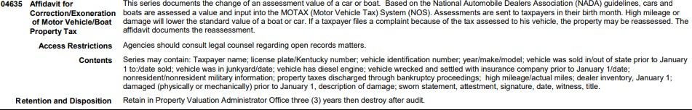

The PVA is under the supervision of the Department of Revenue and along with all deputies must comply with policies, laws and procedures required by the Department of Revenue.

Duties of the Department of Revenue
KRS 132.487 requires that the Department of Revenue develop, implement, supervise and monitor the MOTAX system. The MOTAX system is a “piggyback” component of AVIS.
The Department is responsible for the direction, instruction, and the supervision of the PVA in assessing motor vehicles. The Department adopts the policies, procedures and manuals, which the PVA shall use in the implementation of the ad valorem tax laws.

Duties of the County Clerk
The titling and registration of a vehicle, collection of the property tax and assignment of the tax account number (social security or federal identification number) are the responsibility of the Clerk. These activities include the creation or correction of title and registration records, collection and or refund of taxes and other fees, filing or release of liens and the refund of monies erroneously collected. Collection activities generally occur on the “ADVAL VEHICLE TAX DETAIL AND UPDATE” and “POST TRANSFER PAYMENT”
screens in AVIS.

Duties of the Taxpayer
Each Kentucky resident who owns a motor vehicle or watercraft shall title that vehicle in Kentucky. If the vehicle or boat is to be driven or trolled on Kentucky highways or waterways, a Kentucky registration is necessary. The owner is required to notify the County Clerk of ownership of any vehicle.
All owners are required to notify the County Clerk of any address change within fifteen (15) days of relocating. All new Kentucky residents are required to apply for a Kentucky title within fifteen (15) days of locating in Kentucky. (KRS 186A.235)
During the registration renewal month, the owner is responsible for renewing the registration if the vehicle is to be driven on the highway. Payment of any applicable property tax shall occur at that time.

Alternative Registration Month
There will be occasions when the owner will have an alternative month for paying the property taxes other than the registration renewal month. For example, taxpayers who purchase vehicles at year-end and the title is transferred after the assessment date of January 1. A tax segment is not created in the year-end valuation process and therefore the taxpayer would not receive the post card notice. The PVA and Department works to create segments for those with birth months later in the year. The Department will create alternative schedules for those with early renewal months where the taxpayer will receive the tax only postcard and will pay the tax to the County Clerk.
We encourage the PVA and County Clerk to work together to share the VTR information when a taxpayer comes in to the Clerk’s Office so these segments can be created so the taxpayer gets his post card in the regular birth month when possible.

Section II

Kentucky Revised Statute & Soldiers’ and Sailors’ Civil Relief Act

Kentucky Revised Statutes
On the following pages are the laws to which the Office of Property Valuation, PVA and deputies must adhere in assessing and collecting personal property tax on motor vehicles, trailers, and boats. The General Assembly has adopted these laws to conform to the Kentucky Constitution and to mandate uniformity in the Commonwealth’s effort to assess and collect ad valorem taxes. Many times the taxpayer or an official may question why a policy exists or why a procedure may limit one’s action, so becoming familiar with these statutes may assist in explaining or understanding such policies or procedures.
It is highly recommended that all involved become familiar with these laws or provide a more efficient public service. An informed or knowledgeable public will comply more easily with the duty of paying taxes.
The Kentucky Constitution, Section 172, states that "all property, not exempted from taxation by this Constitution, shall be assessed for taxation at its fair cash value, estimated at the price it would bring at a fair voluntary sale; and any officer, or other person authorized to assess values for taxation, who shall commit any willful error in the performance of his duty, shall be deemed guilty of misfeasance, and upon conviction thereof shall forfeit his office, and be otherwise punished as may be provided by law."
The Kentucky Constitution, Section 170, was amended by public vote to exempt from taxation all personal property owned by churches as of January 1, 1991. Personal property owned by a purely public charity, public bodies, and institutions of education are exempt as well.

Governmental Leasing Act

KRS 65.940(5) Definitions for KRS 65.942 to 65.956
As used in KRS 65.942 to 65.956, unless the context otherwise requires:
- “Governmental agency” means any county, urban-county government, consolidated local government, city, taxing district, special district, school district, or other political subdivision of the Commonwealth or body corporate or politic or any instrumentality of the foregoing.

KRS 65.948 Leased property exempt from state and local taxation.
A governmental agency shall be considered the equitable owner of any personal or real property leased under KRS 65.940 to 65.956 where the property is used solely for public purposes, unless the governmental agency is vested with legal ownership pursuant to KRS 65.952. Personal or real property which is equitably or legally owned by a governmental agency shall be exempt from all taxation by the Commonwealth and any of its political subdivisions. Leases and interests therein and payments received by lessors or their assigns which are identified as interest shall be exempt from taxation by the Commonwealth and any of its political subdivisions to the same extent as bonds or notes issued by the Commonwealth and any governmental agency.

Agencies of the central state government are not included within the scope of the definition of “governmental agencies” under KRS 65.940(5). Therefore, as tax exemption statutes must be interpreted narrowly, the ad valorem tax exemption under KRS 65.948 for tangible personal property subject to a lease between a private company and a “governmental agency” does not apply to such leases in which a Kentucky state government agency is the lessee.

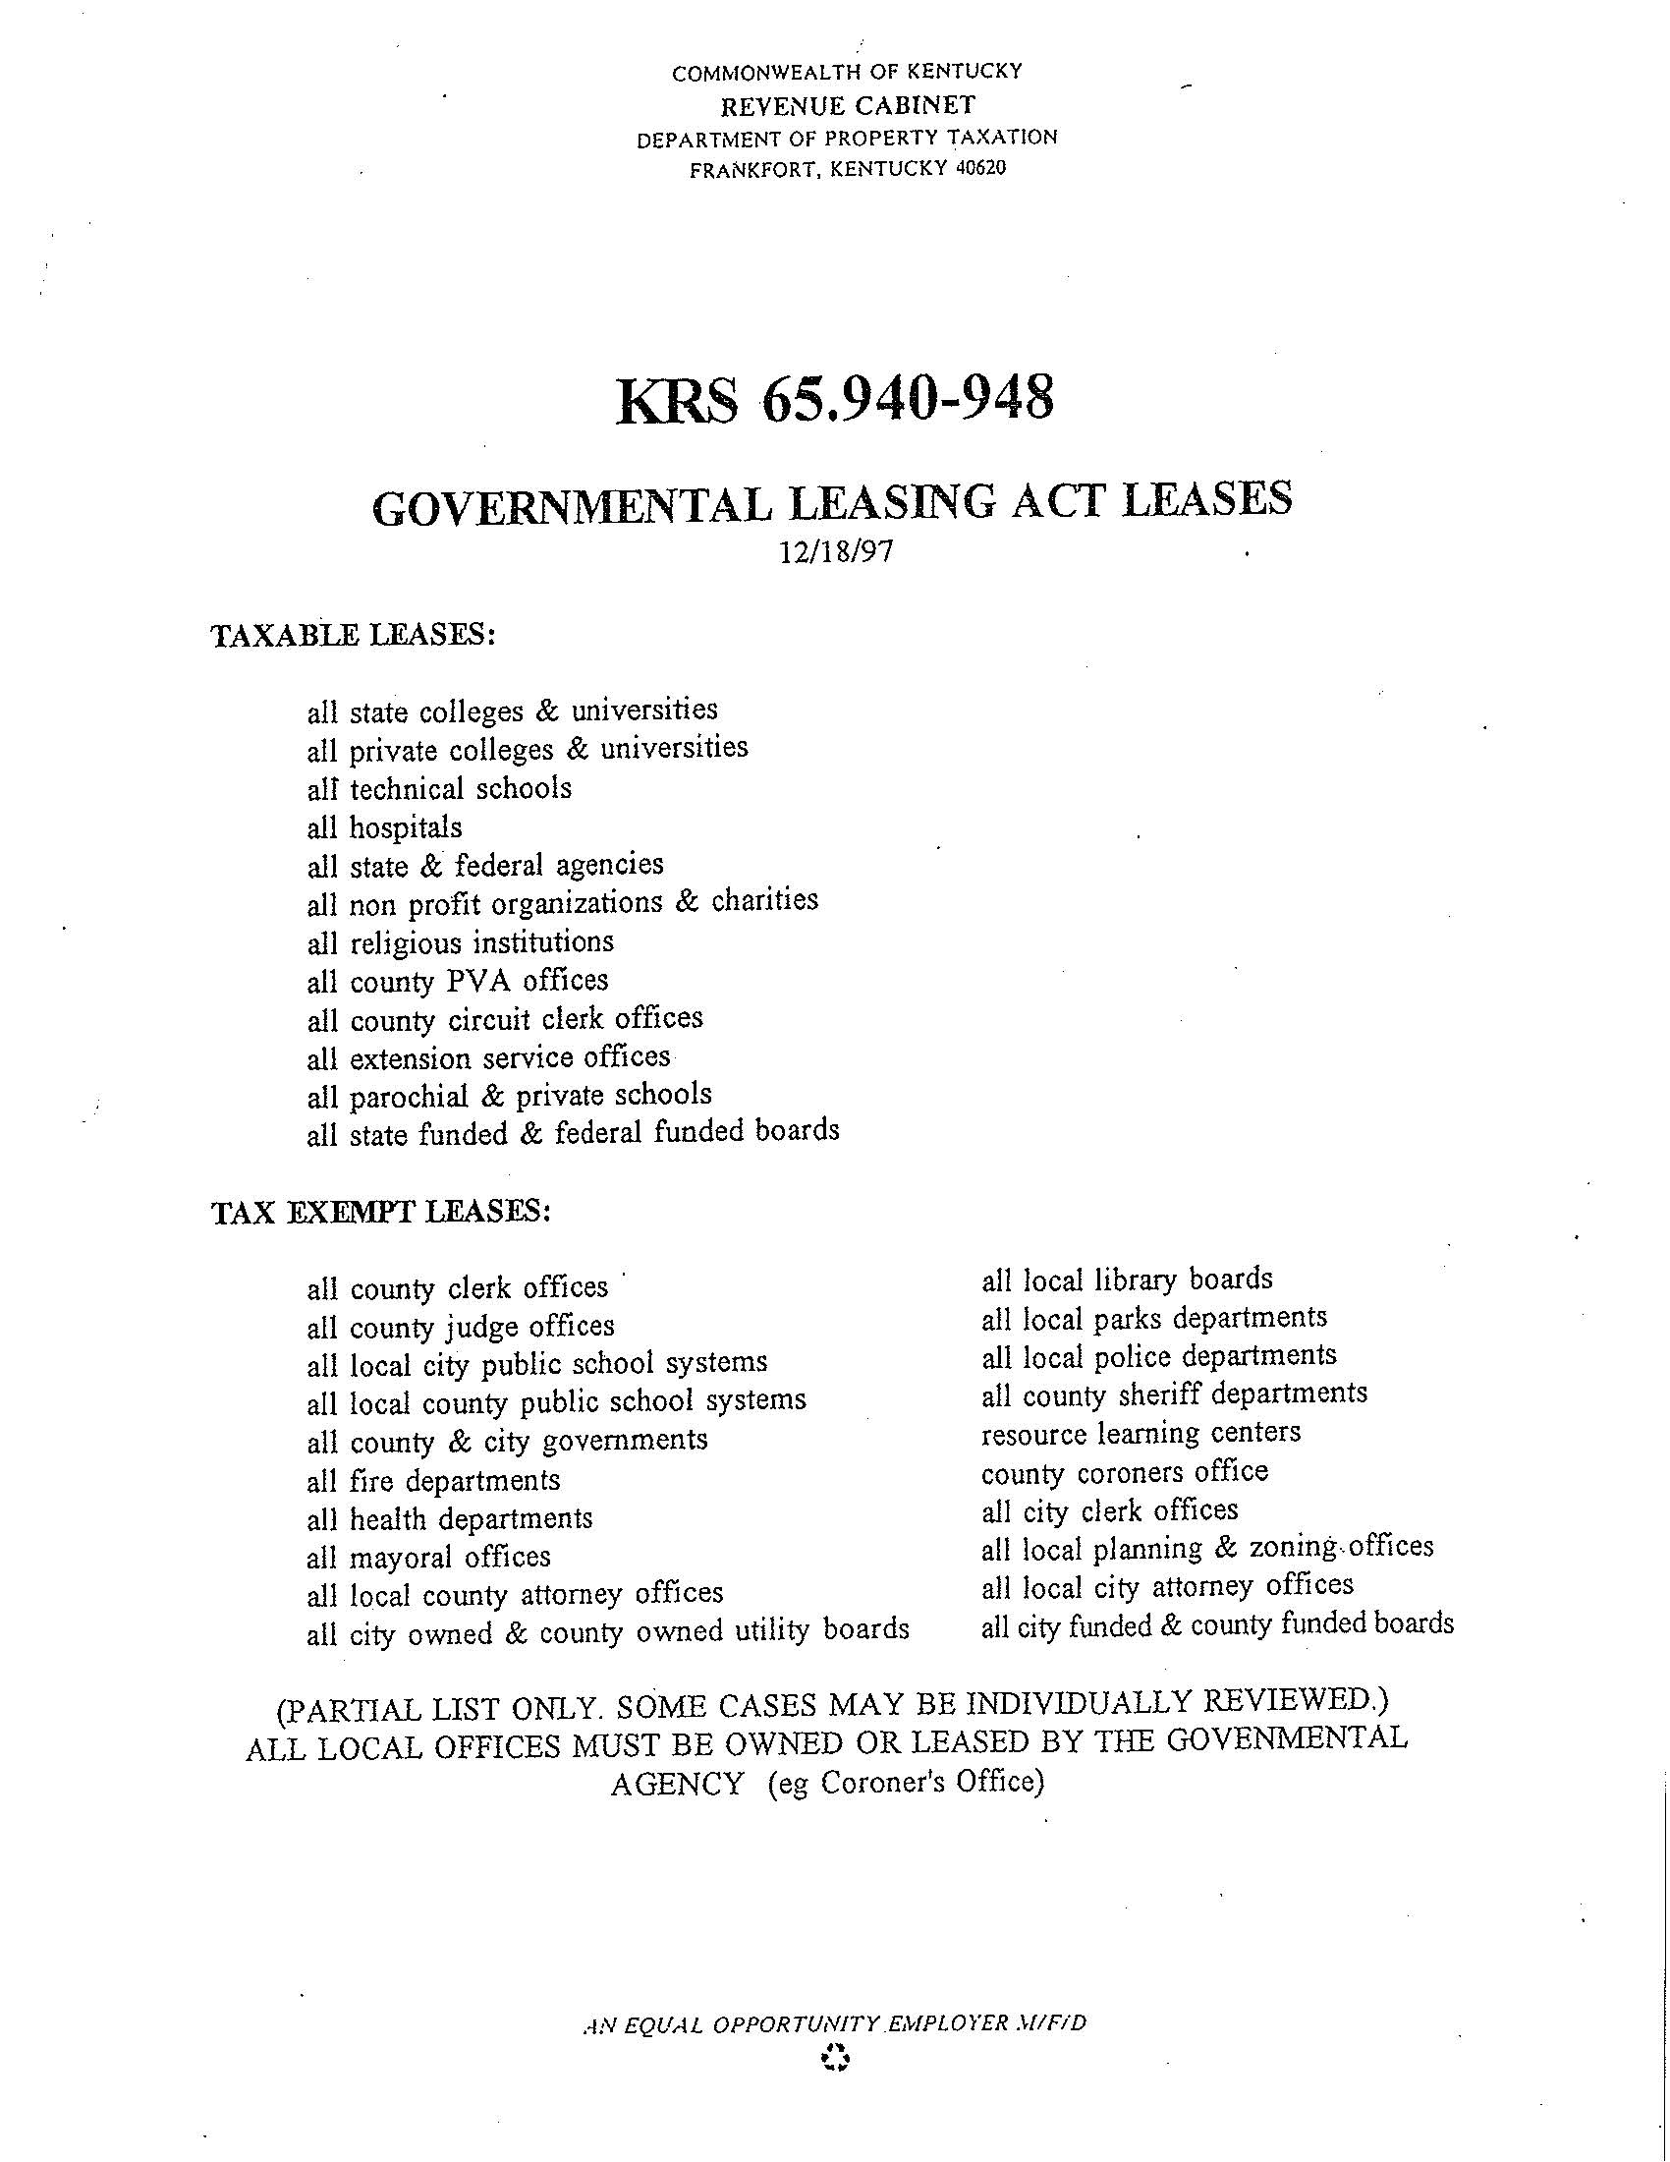

KRS Chapter 131 Kentucky Department of Revenue

KRS 131.030 Functions of department – Settlement of tax cases.
  - The Department of Revenue shall exercise all administrative functions of the state in relation to the state revenue and tax laws, the licensing and registering of motor vehicles, the equalization of tax assessments, the assessment of public utilities and public service corporations for taxes, the assessment of franchises, the supervision of tax collections, and the enforcement of revenue and tax laws, either directly or through supervision of tax administration activity in other departments to which the Department of Revenue may commit administration of certain taxes.
  - The Department of Revenue shall have all powers and duties with reference to assessment or equalization of the assessment of property heretofore exercised or performed by any state board or commission.
  - The Department of Revenue shall have all the powers and duties necessary to consider and settle tax cases under KRS 131.110 and refund claims made under KRS 134.580. The Department of Revenue is encouraged to settle controversies on a fair and equitable basis and shall be authorized to settle tax controversies based on the hazards of litigation applicable to them.
  - The department shall have all the powers and duties necessary to collect any debts owed to the Commonwealth, or any local government of the Commonwealth, that are referred to the department by an organizational unit or administrative body in the executive branch of state government, as defined in KRS 12.010, the Court of Justice in the judicial branch of state government, and any local government, under KRS 45.237 and 45.241.

KRS 131.110 Protest of assessment by Department of Revenue – Review – Appeal.
- (a) The Department of Revenue shall mail to the taxpayer a notice of any tax assessed by it. The assessment shall be due and payable if not protested in writing to the department within:
  - Forty-five (45) days from the date of notice, for assessments issued prior to July 1, 2018; and
  - Sixty (60) days from the date of notice, for assessments issued on or after July 1, 2018.
- Claims for refund of paid assessments may be made under KRS 134.580 and denials appealed under KRS 49.220.
- 1. The protest shall be accompanied by a supporting statement setting forth the grounds upon which the protest is made.
  - Upon written request, the department may extend the time for filing the supporting statement if it appears the delay is necessary and unavoidable.
  - The refusal of the extension may be reviewed in the same manner as a protested assessment.
- After a timely protest has been filed, the taxpayer may request a conference with the department. The request shall be granted in writing stating the date and time set for the conference. The taxpayer may appear in person or by representative. Further conferences may be held by mutual agreement.
- (a) After considering the taxpayer's protest, including any matters presented at the final conference, the department shall issue a final ruling on any matter still in controversy, which shall be mailed to the taxpayer. The ruling shall state that it is a final ruling of the department, generally state the issues in controversy, the department's position thereon and set forth the procedure for prosecuting an appeal to the Board of Tax Appeals.
(b) The taxpayer may request in writing a final ruling at any time after filing a timely protest and supporting statement. When a final ruling is requested, the department shall issue such ruling within thirty (30) days from the date the request is received by the department.
(c) If a taxpayer files a timely protest in dispute of a property tax assessment issued under KRS 136.120 to 136.180 and does not receive from the department, within one (1) year from the date on which the protest was filed:
- A fully executed written agreement to settle the protest as authorized under KRS 131.030(3);
- A final ruling in accordance with paragraphs (a) or (b) of this subsection; or
- Resolution and closure of the protest;
the department shall immediately issue a final ruling that accepts the taxpayer's grounds of the protest, including the taxpayer's proposed true value as stated in the protest.
(4) After a final ruling has been issued, the taxpayer may appeal to the Board of Tax Appeals pursuant to the provisions of KRS 49.220.

KRS 131.170 Extension of time for filing reports and returns.
The Department of Revenue may, when extension is not otherwise provided for, grant a reasonable extension of time for filing reports or returns whenever, in its judgment, good cause therefore exists. The department shall keep a record of such extensions. Except where a taxpayer is abroad, no extension shall be granted for more than six (6) months, and in no case for more than one (1) year. If any extension operates to postpone a tax payment, interest at the tax interest rate as defined in KRS 131.010(6) shall be collected. The department may condition the extension upon a bond sufficient to cover any tax and penalty determined to be due. The department may, on request, permit a person to file a tax return or report or pay tax on a date other than that prescribed by statute, or to change the fiscal period covered by such return or report, if the variation will not ultimately effect a reduction in revenue.

KRS 131.175 Commissioner authorized to waive penalty, but not interest.
Notwithstanding any other provisions of KRS Chapters 131 to 143A, for all taxes payable directly to the Department of Revenue, the sheriff or the county clerk, the commissioner shall have authority to waive the penalty, but not interest, where it is shown to the satisfaction of the department that failure to pay timely is due to reasonable cause. For purposes of this section, any addition to tax provided in KRS 141.044 and 141.305 shall be considered as penalty.

KRS Chapter 132 Levy and Assessment of Property Taxes

KRS 132.020 State ad valorem taxes.
- (b) Twenty-five cents ($0.25) upon each one hundred dollars ($100) of value of motor vehicles qualifying for permanent registration as historic motor vehicles under the provisions of KRS 186.043.
(h) Forty-five cents ($0.45) upon each one hundred dollars ($100) of value of all other property directed to be assessed for taxation shall be paid by the owner or person assessed, except as provided in KRS 132.030, 132.200, 136.300, and 136.320, providing a different tax rate for particular property.

KRS 132.028. Rate on business inventories levied by a city or urban-county government – Exception.
- Subject to the provisions of KRS 132.027, a city or urban-county government may levy a rate of business inventories equal to or less than the prevailing rate of taxation on other tangible personal property in the respective city or urban-county government.
- The tangible personal property tax shall not be levied upon:
  - The inventories of licensed motor vehicle dealer, including licensed motor vehicle auction dealers; or
  - Motor vehicles that are in the possession of a licensed motor vehicle dealer, including licensed motor vehicle auction dealers, for sale, although ownership has not been transferred to the dealer.

KRS 132.220 Assessment dates – Listing – Owner – Liability – Exemptions, listing, annual review.
- (a) All taxable property and all interests in taxable property, unless otherwise specifically provided by law, shall be listed, assessed, and valued as of January 1 of each year.

KRS 132.227 Situs of Vehicle.
The taxable situs of a motor vehicle is presumed to be the county of registration as of the assessment date.

KRS 132.485(1)(2)(3) Motor vehicle registration as consent to assess - Ownership - Assessment of vehicle purchased and registered in different years.
- (a) 1. The registration of a motor vehicle with a county clerk in order to operate it or permit it to be operated upon the highways of the state shall be deemed consent by the registrant for the motor vehicle to be assessed by the property valuation administrator from a standard manual prescribed by the department for valuing motor vehicles for assessment unless:
  - The registrant appears before the property valuation administrator to assess the vehicle; or
  - The motor vehicle is twenty (20) years old or older, in which case paragraph (b) of this subsection applies regarding its valuation.
2. The standard value of motor vehicles shall be the average trade-in value, not the rough or clean trade-in values, prescribed by the valuation manual.
3. The property valuation administrator may adjust the value of a motor vehicle when the registrant has provided evidence that the standard value does not reflect the motor vehicle’s condition, options, mileage, or certificate of title issued.
    - In the case of motor vehicles that are twenty (20) years old or older:
      - It shall not be presumed that a vehicle has been maintained in, or restored to, the original factory or otherwise classic condition or that its value has increased over the previous year;
      - In assessing motor vehicles under this paragraph and calculating the taxes due thereon, through the AVIS or otherwise, if the registrant does not appear before the property valuation administrator to assess the vehicle, the standard value shall be as follows:
        - The actual valuation of the vehicle as was assessed in the vehicle’s nineteenth year, if the vehicle was assessed for taxation in the Commonwealth in that year; or
        - The average trade-in value prescribed by the applicable edition of the valuation manual for the vehicle in its nineteenth year, if the vehicle was not assessed for taxation in the Commonwealth in that year;
reduced by ten percent (10%) annually for each year beyond nineteen (19) years; and

      - In the case of any motor vehicle for which the assessment procedure provided in subparagraph 2.b. of this paragraph would apply but cannot be carried out because the applicable edition of the valuation manual is unavailable, the property valuation administrator shall conduct an assessment of the vehicle to determine the value thereof for the given taxable year. The assessment under this subsection may be done in person if the vehicle’s owner presents the vehicle at the property valuation administrator’s office, or the assessment may be done through a review of photographs and other documentary evidence. In subsequent years, that valuation shall be reduced by ten percent (10%) annually.
      - The registration of a recreational vehicle with the county clerk in order to operate it or permit it to be operated upon the highways shall be deemed consent by the registrant thereof for the recreational vehicle to be assessed by the property valuation administrator at a valuation determined from a standard manual prescribed by the department for valuing recreational vehicles for assessment unless the registrant appears in person before the property valuation administrator to assess the vehicle.
      - The registration of a motor vehicle on or before the date that the registration of the vehicle is required is prima facie evidence of ownership on January 1.
      - When a motor vehicle is purchased in one (1) year, but registration takes place after January 1 of the following year through no fault of the owner, the department shall assess the motor vehicle and shall send notice of the assessment to the January 1 owner in accordance with KRS 186A.035. If the month of registration has passed for the current year, the assessment shall be due and payable if not protested to the department within sixty (60) days from the date of the notice. Payments made after the due date shall carry the normal penalty and interest for motor vehicles.
      - This section does not apply to motor vehicles or recreational vehicles owned and operated by public service companies, common carriers, or agencies of the state and federal governments.

KRS 132.487 Centralized ad valorem tax system for all motor vehicles – General and compensating tax rates – Access to records – Property valuation administrator to assess motor vehicles.
- The department shall develop and administer a centralized ad valorem tax system for all motor vehicles as defined in KRS 186.010. This system shall be designed to allow the collection of state, county, city, urban-county government, school, and special taxing district ad valorem taxes due on each motor vehicle at the time of registration
of the motor vehicle by the party charged with issuing the registration. The department shall supervise and instruct the property valuation administrators and other officials with respect to their duties in relation to this system.

- Except as otherwise provided by law, the tax rate levied by the state, counties, schools, cities, and special tax districts on motor vehicles shall not exceed the rate that could have been levied on motor vehicles by the district on the January 1, 1983 assessments. All counties, schools, cities, and special taxing districts proposing to levy an ad valorem tax on motor vehicles shall submit to the department on or before October 1 of the year preceding the assessment date, the tax rate to be levied against valuations as of that assessment date. Any district that fails to timely submit the tax rate shall receive the rate in effect for the prior year.

- The compensating tax rate and maximum possible tax rate allowable for counties, schools, cities, and special taxing districts on property other than motor vehicles for the 1984 and subsequent tax periods shall be calculated excluding all valuations of and tax revenues from motor vehicles from the base amounts used in arriving at these general rates.

- The Transportation Cabinet shall provide access to all records of motor vehicle registrations to the department and the property valuation administrators as necessary to prepare and maintain a complete tax roll of motor vehicles throughout each year.

- The property valuation administrator shall, subject to the direction, instruction, and supervision of the department, have responsibility for assessing all motor vehicles other than those assessed under KRS Chapter 136 as part of public service companies. The department may provide standard valuation guidelines for use in valuation of motor vehicles.
- The property valuation administrator shall provide to the department by December 1 of each year a recapitulation of motor vehicles to be assessed as of January 1 of the next year.
- Procedures for protest, appeal, and correction of erroneous assessments shall be the same for motor vehicles as for other properties subject to ad valorem taxes.

KRS 132.488 Centralized ad valorem tax system for motorboats – Access to records.
- The assessment of all motorboats as defined in KRS 235.010 shall be administered in the same manner and according to the same procedures provided for motor vehicles in KRS 132.487.
- The Energy and Environment Cabinet shall provide access to all records of motorboat registrations as necessary to prepare and maintain a complete tax roll of motorboats throughout each year.

KRS 132.730 Mobile homes and recreational vehicles subject to ad valorem taxation – Exception.
All mobile homes and recreational vehicles which are within this state on January 1 each year shall be subject to all ad valorem tax levies applicable to other property subject to full state and local rates, except that any mobile home and recreational vehicle not licensed in this state for a period of more than ninety (90) days in any twelve (12) month period shall not have a taxable situs in this state unless an occupant is employed in this state.

KRS 132.751 Classification of certain mobile homes or manufactured homes and certain recreational vehicles as real property.
- Mobile homes or manufactured homes not held for resale by a dealer shall be classified as real property for the purpose of the levy and assessment of ad valorem taxes, regardless of whether or not the wheels or mobile parts have been removed and whether or not the unit rests on a permanent, fixed foundation.
- Recreational vehicles shall be classified as real property if the wheels or mobile parts have been removed and the unit rests on a permanent, fixed foundation.

132.760 Exemption from ad valorem taxes for trucks, tractors, buses, and trailers used both in and outside Kentucky and subject to KRS 136.188 fee.
- There shall be exempt from ad valorem tax for state and local purposes trucks, tractors, and buses used on routes or in systems that are partly within and partly outside Kentucky, and that are subject to the fee imposed by KRS 136.188.
- There shall be exempt from ad valorem tax for state and local purposes semitrailers as defined in KRS 189.010(12) and trailers as defined in KRS 189.010(17) that are used on a route or in a system that is partly within and partly outside Kentucky. Semitrailers or trailers required to be registered under KRS 186.655 that are used only in Kentucky shall be subject to the ad valorem tax imposed by KRS 132.487

KRS Chapter 133 Supervision, Equalization, and Review of Assessments

KRS 133.110 Correction of clerical errors in assessment.
- After submission of the final real property recapitulation or certification of the personal property assessment, the property valuation administrator may correct clerical, mathematical, or procedural errors in an assessment or any duplication of assessment. Changes in assessed value based on appraisal methodology or opinion of value shall not be valid. All corrections shall be reviewed by the Department of Revenue and those changes determined by the department to be invalid shall be rescinded. Any taxpayer affected by this rescission shall not be subject to additional penalties.
- Notwithstanding other statutory provisions, for property subject to a tax rate that is set each year based on the certified assessment, any loss of property tax revenue incurred by a taxing district due to corrections made after the tax rate has been set may be recovered by making an adjustment in the tax rate to be set for the next tax year.

KRS Chapter 134 Payment, Collection, and Refund of Taxes

KRS 134.420 Lien for taxes.
- The state and each county, city or other taxing district shall have a lien on the property assessed for taxes due them respectively for eleven (11) years following the date when the taxes become delinquent.

KRS 134.590 Refund of ad valorem taxes or taxes held unconstitutional.
- No state government agency shall authorize a refund unless each taxpayer individually applies for a refund within two (2) years from the date the taxpayer paid the tax. Each claim or application for a refund shall be in writing and state the specific grounds upon which it is based. Denials of refund claims or applications may be protested and appealed in accordance with KRS 131.110 and 131.340. No state government agency shall refund ad valorem taxes, except those held unconstitutional, unless the taxpayer has properly followed the administrative remedy procedures established through the protest provisions of KRS 131.110, the appeal provisions of KRS 133.120, the correction provisions of KRS 133.110 and KRS 133.130, or other administrative remedy procedures.

KRS 134.800 County clerk to collect ad valorem taxes on motor vehicles registered by him – Acceptable means of payment
The county clerk shall be collector of all state, county, city, urban-county government, school, and special taxing district ad valorem taxes on motor vehicles registered by him. The clerk may accept payment of taxes due by any commercially acceptable means, including credit cards.

KRS 134.805 Clerk's commission for collecting taxes – Notice of ad valorem taxes due on motor vehicles.
- The county clerk shall be allowed by the Department of Revenue for collecting the state ad valorem taxes on motor vehicles, a commission of four percent (4%) on state taxes collected.
- The county clerk shall be allowed by the county treasurer, for collecting county and special district ad valorem taxes on motor vehicles, a commission of four percent (4%) on county and special taxes collected.
- The county clerk shall be allowed a commission of four percent (4%) of the school district taxes collected.
- Effective January 1, 1985, the county clerk shall be allowed a commission of four percent (4%) of the city or urban-county government taxes collected.

- (a) For the convenience and benefit of the Commonwealth's citizens and to maximize ad valorem tax collections, county clerks shall be responsible for causing the preparation and mailing of a notice of ad valorem taxes due to the January 1 owner, as defined in KRS 186.010(7) (a) and (c), of each motor vehicle no later than forty-five (45) days prior to the ad valorem tax and registration renewal due date in each calendar year.

  - When a vehicle is transferred in any year before the ad valorem taxes on that vehicle have been paid, a notice of taxes due shall be sent within ten (10) working days after the date of transfer or notice of transfer to the owner as of January 1 of that year.
  - When ad valorem taxes on a vehicle become delinquent for sixty (60) days, as defined by KRS 134.810, a second notice shall be sent within ten (10) working days to the January 1 owner of record. The notice shall inform the delinquent owner of the lien provisions provided by KRS 134.810 on all vehicles owned or acquired by the owner of the vehicle at the time the tax liability arose.
  - These notices shall be calculated, prepared, and mailed first class on behalf of county clerks by the AVIS. Non-receipt of the notices required herein shall not constitute any defense against applicable penalty, interest, lien fees, or costs recovery.

KRS 134.810 Date on which taxes become due or delinquent.
- All state, county, city, urban-county government, school, and special taxing district ad valorem taxes shall be due and payable on or before the earlier of the last day of the month in which registration renewal is required by law for a motor vehicle renewed or the last day of the month in which a vehicle is transferred.
- All state, county, city, urban-county government, school, and special taxing district ad valorem taxes due on motor vehicles shall become delinquent following the earlier of the end of the month in which registration renewal is required by law or the last day of the second calendar month following the month in which a vehicle was transferred.
- Any taxes which are paid within thirty (30) days of becoming delinquent shall be subject to a penalty of three percent (3%) on the taxes due. However, this penalty shall be waived if the tax bill is paid within five (5) days of the tax bill being declared delinquent. Any taxes which are not paid within thirty (30) days of becoming delinquent shall be subject to a penalty of ten percent (10%) on the taxes due. In addition, interest at an annual rate of fifteen percent (15%) shall accrue on said taxes and penalty from the date of delinquency. A penalty or interest shall not accrue on a motor vehicle under dealer assignment pursuant to KRS 186A.220.
- When a motor vehicle has been transferred before registration renewal or before taxes due have been paid, the owner pursuant to KRS 186.010(7) (a) and (c) on January 1 of any year shall be liable for the taxes on the motor vehicle, except as hereinafter provided.

- If an owner obtains a certificate of registration for a motor vehicle valid through the last day of his second birth month following the month and year in which he applied for a certificate of registration, all state, county, city, urban-county government, school, and special tax district ad valorem tax liabilities arising from the assessment date following initial registration shall be due and payable on or before the last day of the first birth month following the assessment date or date of transfer, whichever is earlier. Any taxes due under the provisions of this subsection and not paid as set forth above shall be considered delinquent and subject to the same interest and penalties found in subsection (3) of this section.
- For purposes of the state ad valorem tax only, all motor vehicles:
  - Held for sale by a licensed motor vehicle dealer, including licensed motor vehicle auction dealers;
  - That are in possession of a licensed motor vehicle dealer, including licensed motor vehicle auction dealers, for sale, although ownership has not been transferred to the dealer; and
  - With a salvage title held by an insurance company;
on January 1 of any year shall not be taxed as a motor vehicle pursuant to KRS 132.485 but shall be subject to ad valorem tax as goods held for sale in the regular course of business under the provisions of KRS 132.020(1) (n) and 132.220.
- Any provision to the contrary notwithstanding, when any ad valorem tax on a motor vehicle becomes delinquent, the state and each county, city, urban-county government, or other taxing district shall have a lien on all motor vehicles owned or acquired by the person who owned the motor vehicle at the time the tax liability arose. A lien for delinquent ad valorem taxes shall not attach to any motor vehicle transferred while the taxes are due on that vehicle. For the purpose of delinquent ad valorem taxes on leased vehicles only, a lien on a leased vehicle shall not be attached to another vehicle owned by the lessor.
- The lien required by subsection (7) of this section shall be filed and released by the automatic entry of appropriate information in the AVIS database. For the filing and release of each lien or set of liens arising from motor vehicle ad valorem property tax delinquency, a fee of two dollars ($2) pursuant to this section shall be added to the delinquent tax account. The fee shall be collected and retained by the county clerk who collects the delinquent tax.
- The implementation of the automated lien system provided in this section shall not affect the manner in which commercial liens are recorded or released.

134.830 County clerk to collect ad valorem taxes on motorboats.
The collection of ad valorem taxes on motorboats shall be administered in the same manner and according to the same procedures provided for motor vehicles in KRS 134.800 to 134.820.

KRS Chapter 136 Vehicles of System Operating Route Partly Within State

136.188 Annual fee on trucks, tractors, and buses operating partly within and partly outside Kentucky -- Fee to replace ad valorem tax -- Determination of value and fee -- Collection and distribution -- Protest.
- Notwithstanding KRS 132.487, any truck, tractor, or bus which is operated on a route or as part of a system that is partly within and partly outside Kentucky shall be subject to an annual fee at the time the vehicle is registered with and the registration fee is paid to the Transportation Cabinet pursuant to KRS 186.020 and 186.050(3) and (13). The fee shall be imposed on the vehicle's owner or the owner's legal designee as of January 1 of each year. Such payment shall be made to the Transportation Cabinet either directly, in the case of a vehicle based in Kentucky, or indirectly, through the International Registration Plan, in the case of a vehicle based outside of Kentucky.
- The fee imposed by subsection (1) of this section replaces the state and local ad valorem property tax the Department of Revenue previously imposed and centrally collected against trucks, tractors, and buses operated on a route or as part of a system that is partly within and partly outside Kentucky. The fee imposed by subsection (1) of this section shall not be construed as a fee imposed upon the registration, operation, or use of the vehicles on public highways. The Department of Revenue shall use the following method for determining the rate for fixing the assessed value of the property and for determining the annual fee amount:
  - The Department of Revenue shall determine the assessed value on an annual basis by multiplying the purchase price of the truck, tractor, or bus by a depreciation value expressed as a percentage of the original cost from an authoritative source that the Department of Revenue prescribes by promulgation of an administrative regulation;
  - The Department of Revenue shall determine an aggregate state and local rate on an annual basis. The state rate shall be the weighted average commercial and industrial tangible personal property tax rate, and the local rate shall be determined using the method set forth in KRS 136.180(3) and (4);
  - The Department of Revenue shall determine the amount subject to the annual fee by multiplying the total assessed value of all vehicles by an apportionment factor. The apportionment factor shall be determined as provided in KRS 186.050(13) (a); and
  - The annual fee shall be determined by multiplying the amount subject to the annual fee by the rate determined in paragraph (b) of this

subsection. The Department of Revenue shall provide the Transportation Cabinet with the information needed to collect the fee.
- The Transportation Cabinet shall forward the money it collects from the fee imposed by subsection (1) of this section to the Department of Revenue on a monthly basis. The Department of Revenue shall divide and distribute the money among the state, counties, cities, urban-counties, charter counties, consolidated local governments, school districts, and special taxing districts in the same manner as the Department of Revenue divided and distributed the state and local ad valorem property tax previously imposed and centrally collected.
- Pick-up and delivery vehicles operating from a terminal within this state and vehicles that do not leave the state in the normal course of business shall not be required to pay the fee imposed by subsection (1) of this section, but shall instead be subject to the ad valorem tax under KRS 132.487.
- Any person paying the fee imposed by subsection (1) of this section shall have sixty (60) days from the date the person is notified of the fee amount to protest. The protest shall be filed with the Commonwealth of Kentucky, Department of Revenue, in accordance with the provisions of KRS 131.110. Notification by any state's or Canadian province's or territory's registration authority of the amount due shall satisfy the notification requirement of KRS 131.110(1).
- No protest or appeal shall delay the collection or payment of the fee imposed by subsection (1) of this section. The fee amount due as determined in subsection
(2) of this section shall be paid at the time of registration. If the fee is not paid, the Commonwealth of Kentucky, Transportation Cabinet, shall not register the vehicle for which registration is sought. Persons registering vehicles in other states or Canada shall be subject to requirements of those registration authorities.

KRS Chapter 138 Excise Taxes

KRS 138.465 Individual seller to deliver registration certification with assignment form to county clerk.
- Any person other than a dealer, as defined in KRS 186.010(10), who sells or transfers a motor vehicle in this state shall deliver to the county clerk the certificate of title with the assignment form on the reverse side properly executed and shall transfer the vehicle to the new owner within ten (10) days of the date of the sale or transfer of ownership.
- Any person who violates subsection (1) of this section shall be subject to the penalties set out in KRS 186.990(2).

KRS Chapter 186 Licensing of Motor Vehicles, Operators, and Trailers

186.990 Penalties.
(2) Any person who violates any of the provisions of KRS 138.465, 186.072, 186.190, 186.200, or 186.210(2) shall be guilty of a Class A misdemeanor.

KRS 186.010 Definitions for KRS 186.020 to 186.640.
- (a) "Owner" means a person who holds the legal title of a vehicle or a person who pursuant to a bona fide sale has received physical possession of the vehicle subject to any applicable security interest.
- A vehicle is the subject of an agreement for the conditional sale or lease, with the vendee or lessee entitled to possession of the vehicle, upon performance of the contract terms, for a period of three hundred sixty-five (365) days or more and with the right of purchase upon performance of the conditions stated in the agreement and with an immediate right of possession vested in the conditional vendee or lessee, or if a mortgagor of a vehicle is entitled to possession, the conditional vendee or mortgagor shall be deemed the owner.
- A licensed motor vehicle dealer who transfers physical possession of a motor vehicle to a purchaser pursuant to a bona fide sale, and complies with the requirements of KRS 186A.220, shall not be deemed the owner of that motor vehicle solely due to an assignment to his dealership or a certificate of title in the dealership's name. Rather, under these circumstances, ownership shall transfer upon delivery of the vehicle to the purchaser, subject to any applicable security interest.

KRS 186.021 Issuance of replacement plate, decal, registration certificate, or renewal for motor vehicle on which ad valorem taxes are delinquent or which is uninsured – Option of purchaser to pay delinquent taxes.
- Except as provided in subsection (2) of this section, a county clerk shall not issue a replacement plate, decal, or registration certificate as provided in KRS 186.180 or a registration for renewal to any person who on January 1 of any year owned a motor vehicle on which state, county, city, urban-county government, school, or special taxing district ad valorem taxes are delinquent.
- Pursuant to KRS 134.810(4), the owner, as defined in KRS 186.010(7) (a) and (c), on January 1 of any year shall be liable for taxes due on a motor vehicle. A person other than the owner of record who applies to a county clerk to transfer the registration of a motor vehicle may pay any delinquent ad valorem taxes due on the motor vehicle to facilitate the county clerk's transferring registration of the motor vehicle. The person applying shall not be required to pay delinquent ad valorem taxes due on any other motor vehicle owned by the owner of record from which he is purchasing his motor vehicle as a condition of registration.

KRS 186.043 Special license plate for historic motor vehicles – Permanent registration.
- In enacting this section, it is the intention of the General Assembly to recognize the special value of historic vehicles to the Commonwealth, and also to recognize that historic vehicles, because of their limited use and easily identifiable characteristics, do not require the same degree of regulation as other vehicles.
- As used in this section, unless the context otherwise requires, "historic vehicle" shall mean all motor vehicles twenty-five (25) years old or older, which are used primarily for exhibition in shows, parades, tours, and other special uses, but not for general transportation.
- Historic vehicles shall be registered and licensed by the Transportation Cabinet. The registration shall be in lieu of registration and license required by KRS 186.020 to 186.270.
- Upon payment of the fee established in KRS 186.162 and an application in accordance with regulations issued by the Transportation Cabinet, the secretary of the Transportation Cabinet shall issue a certificate of registration and two (2) special license plates of a different color and design than the regular license plate, which, in the judgment of the secretary of the Transportation Cabinet, will best advertise, popularize, and promote the Commonwealth of Kentucky. These plates, besides the word "Kentucky" shall have the words, "Historic Motor Vehicle" inscribed in a conspicuous manner and carry no year date. These plates shall have a serial number beginning with the number "100" and continue in a consecutive numerical sequence.

- Historic vehicles may display an authentic Kentucky license plate, twenty-five (25) years or older, or a reproduction of such a plate, if the historic motor vehicle plate and the registration receipt are kept in the vehicle at all times.

- The registration license and license plates of historic motor vehicles shall be valid without renewal as long as the vehicle is in existence. If the historic motor vehicle is sold, the registration and license shall be assigned and transferred to the new owner on the records of the Transportation Cabinet upon receipt of an application in accordance with regulations issued by the cabinet and payment of a fee of three dollars ($3).

KRS 186.150 Residents not to use licenses of other states.
- No resident operating a motor vehicle on the highways, shall secure or license the motor vehicle in any state other than Kentucky unless so licensed in conformity with a motor vehicle reciprocal arrangement or under the international registration plan.
- The use of a license of any state other than Kentucky by a resident of this state on his car driven over Kentucky highways shall be prima facie evidence of guilt.

KRS 186.193 Evidence required of ad valorem tax payment.

The county clerk shall not transfer the registration on any motor vehicle or trailer against which a tax lien has been filed until the taxes have been paid and the lien has been released.

KRS 186.232 Registration not transferable until taxes paid, lien released, and proof of insurance and notarized affidavit presented.
- The county clerk shall not transfer the registration on any motor vehicle or trailer against which a tax lien has been filed until the taxes have been paid and the lien has been released.
- The county clerk shall not transfer the registration of any motor vehicle unless the transferee presents proof of insurance in compliance with KRS 304.39-080 and KRS 186.190.
- If a notarized affidavit is required and available under KRS 138.450, the county clerk shall not transfer the registration of a motor vehicle unless the notarized affidavit attesting to the total and actual consideration paid or to be paid for the motor vehicle is presented to the clerk at the time of the transfer. If a notarized affidavit is required but is not available, the county clerk shall contact the Department of Revenue to determine the “retail price” of the vehicle and any taxes due prior to transferring the vehicle.

Motor Vehicle Usage Related
- The county clerk shall not transfer title on a motor vehicle if there are delinquent ad valorem taxes on the motor vehicle.

KRS 186.990 Penalties.
- Any person who violates any of the provisions of KRS 186.020, 186.030, 186.040, 186.045(4), 186.050, 186.056, 186.060, 186.073, 186.110, 186.130, 186.140, 186.160,
186.170, 186.180(1) to (4)(a), 186.210(1), 186.230, or KRS 186.655 to 186.680 shall be
guilty of a violation.
- Any person who violates any of the provisions of KRS 138.465, 186.072, 186.190, or 186.200, or 186.210(2) shall be guilty of a Class A misdemeanor.

(3) A person who violates the provisions of KRS 186.450(4), (5), or (6) or 186.452(3), (4), or
- shall be guilty of a violation. A person who violates any of the other provisions of KRS 186.400 to 186.640 shall be guilty of a Class B misdemeanor.

- Any clerk or judge failing to comply with KRS 186.550(1) shall be guilty of a violation.
- If it appears to the satisfaction of the trial court that any offender under KRS 186.400 to 186.640 has a driver's license but in good faith failed to have it on his or her person or misplaced or lost it, the court may, in its discretion, dismiss the charges against the defendant without fine, imprisonment, or cost.
- Any person who steals a motor vehicle registration plate or renewal decal shall be guilty of a Class D felony. Displaying a canceled registration plate on a motor vehicle shall be prima facie evidence of guilt under this section.

- Any person who violates the provisions of KRS 186.1911 shall be guilty of a Class A misdemeanor.
- Any person who makes a false affidavit to secure a license plate under KRS 186.172 shall be guilty of a Class A misdemeanor.
- Any person who violates any provision of KRS 186.070 or 186.150 shall be guilty of a Class A misdemeanor.
- Any person who operates a vehicle bearing a dealer's plate upon the highways of this Commonwealth with intent to evade the motor vehicle usage tax or registration fee shall be guilty of a Class A misdemeanor for the first offense and a Class D felony for each subsequent offense.
- Any person, other than a licensed dealer or manufacturer, who procures a dealer's plate with intent to evade the motor vehicle usage tax or registration fee shall be guilty of a Class D felony.
- Any resident who unlawfully registers, titles, or licenses a motor vehicle in any state other than Kentucky with intent to evade the motor vehicle usage tax or the registration fee shall be guilty of a Class A misdemeanor if the amount of tax due is less than one hundred dollars ($100), or of a Class D felony if the amount of tax due is more than one hundred dollars ($100), and in addition shall be liable for all taxes so evaded with applicable interest and penalties.

KRS Chapter 186A Automated Motor Vehicle Registration System

KRS 186A.030 Computation and collection of motor vehicle and trailer ad valorem taxes.
In order to improve collection of personal property (ad valorem) taxes associated with motor vehicles and trailers, the Department of Vehicle Regulation, in cooperation with the Department of Revenue, shall:
- Ensure that the automated system provided by this chapter is capable of properly assigning a value for each vehicle registered in a county, utilizing a value reference manual in machine readable form approved by the Department of Revenue, and a manually entered value for vehicles not shown in such "manual".
- Promptly study the feasibility of computing personal property (ad valorem) taxes associated with motor vehicles and trailers, and producing tax bills or notices of taxes due in such regard, and if shown feasible to its satisfaction, implement such capability, or any part thereof, as expeditiously as practicable.
- Ensure that the automated system is capable of receiving the record of a lien for unpaid personal property (ad valorem) taxes associated with an owner of a motor vehicle or trailer. No motor vehicle dealer shall be responsible for the payment of a tax lien on a motor vehicle which is received as trade-in or otherwise obtained by a dealer.

KRS 186A.035 Motor vehicle registration by birth month of owner – Joint tenancy with right of survivorship for motor vehicle jointly owned by husband and wife – Clerk's fee – Renewal of registration.
- After a motor vehicle has been initially placed in the system of year-round registration, the owner shall renew the registration annually during the owner’s birth month, by making application to the county clerk and paying the fee required for twelve (12) consecutive months of registration, which shall take effect on the first day of the month succeeding the owner’s birth month and shall expire on the last day of the owner’s next birth month. The county clerk shall be entitled to a registration fee of two dollars ($2) for each registration, or if the registration exceeds a twelve (12) month period, the clerk shall receive a fee of three dollars ($3).

- At least forty-five (45) days prior to the expiration of the registration of any motor vehicle previously registered in the Commonwealth as provided by subsection (1) of this section, the owner of the vehicle shall be notified by mail on the same notice required by KRS 134.805(5) of the date of expiration. Non-receipt of the notice required by this subsection shall not constitute a defense to any registration related offense.

KRS 186A.065 Prerequisites for operation of motor vehicles or trailers.
Except as otherwise provided, before the owner of a motor vehicle or trailer may operate it or permit its operation upon the highways of this state, he shall obtain motor vehicle insurance as required by KRS 304.39-080, a certificate of registration and a license plate and apply for a certificate of title in his name.

KRS 186A.145 Processing prohibited when property tax account delinquent, exception.
(1) Except as provided in subsections (2) and (3) of this section, a county clerk shall not process an application for Kentucky title and registration from or to any Kentucky resident who has a delinquent motor vehicle ad valorem property tax account.
- This section shall not apply to transactions involving:
  - Licensed Kentucky motor vehicle dealers;
  - A person who is engaged in the business of storing or towing motor vehicles, applying for a new title under KRS 376.275(1)(c); or
  - A secured party applying for a repossession titles under KRS 186.045(6).
- (a) For any vehicle obtained as the result of a claim on a motor vehicle insurance policy, an insurer and its agent shall not be responsible for the payment of any delinquent motor vehicle ad valorem property taxes owed by any previous owner, when:
- Applying for a regular salvage title ; or
- Transferring ownership of the vehicle to another party.
(b) The owner of a motor vehicle that was transferred to an insurer or its agent under paragraph (a) of this subsection shall remain responsible for any delinquent motor vehicle ad valorem property taxes owed prior to the transfer.
- An insurer shall not be exempt from any motor vehicle ad valorem property taxes owed on any vehicle that it owns:
  - As a part of its business operations; or

  - On January 1, that as obtained as the result of a claim on a motor vehicle insurance policy.

KRS 186A.215 Procedures for transfer of vehicle ownership.
- If an owner transfers his interest in a vehicle, he shall, at the time of the delivery of the vehicle, execute an assignment and warranty of title to the transferee in the space provided therefore on the certificate of title, except if the space therefore on the owner's certificate of title fails to meet the Kentucky requirements for lawful conveyance of title or if the space provided therefore on the owner's certificate of title fails to meet the requirements for the owner to execute an odometer disclosure statement as required by federal law in effect at the time transferor executes an assignment and warranty of title. Pursuant to the exceptions provided by this subsection and in other cases where applicable, the transferor shall execute an assignment and warranty of title to the transferee by executing the application as provided by the Department of Vehicle Regulation and available from the county clerk. The transferor shall cause the application with the certificate of title attached to be delivered to the transferee.
- If it comes to the attention of a transferor that a transferee did not promptly submit the necessary document within fifteen (15) calendar days to the county clerk as required by law in order to complete the transfer transaction, a transferor shall submit to the county clerk, in his county of residence, an affidavit that he has transferred his interest in a specific vehicle and the clerk shall enter appropriate data into the AVIS system which shall restrict any registration transaction from occurring on that vehicle until the transfer has been processed. The Transportation Cabinet may adopt administrative regulations governing this subsection. This subsection shall not apply to any transactions involving licensed Kentucky motor vehicle dealers.
- This section shall not apply to a vehicle which has had the title surrendered to a county clerk or a hulk vehicle. Hulk vehicle shall mean a vehicle or part thereof that is:
  - In a rusted, wrecked, discarded, worn out, extensively damaged, dismantled, and mechanically inoperative condition; or
  - Of an apparent value of less than two hundred dollars ($200).

KRS 186A.220 Requirements for motor vehicle dealer upon receipt of vehicle.
- Except as otherwise provided in this chapter, when any motor vehicle dealer licensed in this state buys or accepts such a vehicle in trade, which has been previously registered or titled for use in this or another state, and which he holds for resale, he shall not be required to obtain a certificate or title for it, but shall, within fifteen (15) days after acquiring such vehicle, notify the county clerk of the assignment of the motor vehicle to his dealership and pay the required transferor fee.
- Upon purchasing such a vehicle or accepting it in trade, the dealer shall obtain from his transferor, properly executed, all documents required by KRS 186A.215, to include the odometer disclosure statement thereon, together with a properly assigned certificate of title.
- The dealer shall execute his application for assignment upon documents designated by the Department of Vehicle Regulation, to the county clerk of the county in which he
maintains his principal place of business. Such clerk shall enter the assignment upon the automated system.
- The dealer shall retain the properly assigned certificate of title received from his transferor, and may make any reassignments thereon until the forms for dealer assignment on the certificate of title are exhausted. The Department of Vehicle Regulation may, if it deems it warranted, provide a special document to allow for additional dealer assignment without requiring system generated documents.
- (a) When a dealer assigns the vehicle to a purchaser for use, he shall deliver the properly assigned certificate of title, and other documents if appropriate, to such purchaser, who shall make application for registration and a certificate of title thereon.
  - The dealer may, with the consent of the purchaser, deliver the assigned certification of title, and other appropriate documents of a new or used vehicle, directly to the county clerk, and on behalf of the purchaser, make application for registration and a certificate of title. In so doing, the dealer shall require from the purchaser proof of insurance as mandated by KRS 304.39-080 before delivering possession of the vehicle.
  - Notwithstanding the provisions of KRS 186.020, 186A.065, 186A.095, 186A.215, and 186A.300, if a dealer elect to deliver the title documents to the county clerk
and has not received a clear certificate of title from a prior owner, the dealer shall retain the documents in his possession until the certificate or title is obtained.
  - When a dealer assigns a vehicle to a purchaser for use under paragraph (a) of this subsection, the transfer and delivery of the vehicle is effective immediately upon the delivery of all necessary legal documents or copies thereof, including proof of insurance as mandated by KRS 304.39-080.
- The department may make available, upon proper application from a licensed motor vehicle dealer, electronic means by which the dealer can interface directly with AVIS and the department. If the department grants this access, all fees currently required for the issuance of a certificate of title shall continue to be charged and remitted to the appropriate parties as provided by statute.
- The Department of Vehicle Regulation shall assure that the automated system is capable of accepting instructions from the county clerk that a certificate of title shall not be produced under a dealer registration situation.

KRS 186A.235 Owner to notify clerk of residence or name change.
- Whenever any person after making application for obtaining a certificate of registration or title for a vehicle, shall move from the address named in the application or shown upon a registration card or certificate of title, such person shall within fifteen (15) days thereafter notify the county clerk of the county in which he resides in writing of his old and new addresses as well as the current license number of all vehicles currently registered or titled in his name. The county clerk shall immediately enter such change into the automated system.
- Whenever the name of any person who has made application for or obtained a certificate of registration or title for a vehicle is thereafter changed by marriage or
otherwise, such person shall within fifteen (15) days notify the county clerk of the county of residence of such former and new name. The county clerk shall immediately enter such change into the automated system.

KRS 186A.295 Owner to surrender title on destroyed vehicle or trailer.
- (a) Any person or entity having a motor vehicle or trailer that has been destroyed, to the extent that its repair cannot be obtained through usual commercial repair services, at a cost less than its retail value as established from a value manual approved by the Department of Revenue, or from which two (2) or more parts which typically bear a vehicle identification number placed thereon by the manufacturer have been removed, or which he removes, shall surrender the certificate of title for such vehicle for which he has a certificate of title in his or another name, to the county clerk of the county in which such vehicle is located. The clerk shall immediately forward the surrendered title to Frankfort with instructions for canceling the title.
  - Any person or entity engaged in the sale of used motor vehicle or trailer parts, or the recycling or salvage of them, shall surrender the certificate of title for any vehicle in his possession, and for which he has a certificate of title, whether in his or another name, if such vehicle is destroyed within the meaning of paragraph (a) of this subsection, or from which two (2) or more parts which typically bear a vehicle identification number placed thereon by a manufacturer have been removed, or which he removes, to the county clerk of the county in which such vehicle is located. The clerk shall immediately forward the surrendered title to Frankfort with instructions for canceling the title.
  - The surrender of the certificate of title pursuant to this section shall be made within ten (10) working days, next succeeding the day when such vehicle was received, destroyed, or next succeeding the day during which such second part was removed.

KRS 186A.520 Salvage titles - Conditions for issuance - Operation of vehicle with salvage title.
- Except as provided in KRS 186A.555, a salvage title shall be obtained by the owner of a motor vehicle that meets the following definition of a salvage vehicle:
  - A vehicle which has been wrecked, destroyed, or damaged, to the extent that the total estimated or actual cost of parts and labor to rebuild or reconstruct the vehicle to its pre-accident condition and for legal operation on the roads or highways, not including the cost of parts and labor to reinstall a deployed airbag system, exceed seventy-five percent (75%) of the retail value of the vehicle, as set forth in a current edition of the National Automobile Dealers Association price guide.
  - The value of repair parts for purposes of this definition shall be determined by using the current published retail cost of the parts equal in kind and quality to the parts to be replaced or the actual cost of the repair parts used in repair.

  - The labor costs of repairs for purposes of this section shall be computed by using the hourly labor rate and time allocations which are reasonable and customary in the automobile repair industry in the community where the repairs are performed.
  - Airbag reinstallation costs which are excluded from the seventy-five percent (75%) computation as set forth in paragraph (a) of this subsection shall be included by an insurer in the computation of the total physical damage estimate according to the terms and conditions of individual policies, provided that the total costs payable by an insurer do not exceed the total retail value of the vehicle.
- The owner or an authorized agent of a motor vehicle that meets the definition of a salvage vehicle as set forth in subsection (1) of this section shall, within fifteen (15) days from the receipt of all necessary paperwork required by this chapter, submit an application to the county clerk, on a form prescribed by the Department of Vehicle Regulation, for a salvage title, accompanied by a properly endorsed certificate of title and any lien satisfactions, if any appear, as may be required.
- The county clerk shall retain a copy of each salvage title application received and shall forward the original and its supporting documents to the Department of Vehicle Regulation in a manner similar to that for handling of an application for a title.
- The county clerk shall rely on the information provided by the owner or authorized agent, including a county of residence designation, on:
(a) Any approved, notarized state form utilized in lien titling or the title transfer process signed by the owner or authorized agent; and
(b) Any document submitted during the transfer of a salvage vehicle from an owner to an insurer. Reliance on the foregoing by the county clerk shall relieve the office of the county clerk from liability to any third party claiming failure to comply with this section.
- The Department of Vehicle Regulation shall process the salvage title application in a manner similar to that used in processing a title application and the salvage title shall be delivered in a like manner of a title. Salvage titles shall be construed as proof of ownership of a vehicle in a state as to be unusable upon the highways of the Commonwealth. A vehicle shall not be issued a registration for highway use as long as a salvage title is in force.
- The only time a vehicle with a salvage title may be operated upon the highways of the Commonwealth is when it is in route to or from an inspection by the certified inspector prior to obtaining a certificate of title after having been rebuilt as per KRS 186.115.

KRS Chapter 235 Boats and Boating

KRS 235.010 Definitions for chapter. As used in this chapter, unless the context clearly requires a different meaning:
- "Vessel" means every description of watercraft, other than a seaplane on the water;
- "Motorboat" means any vessel propelled by machinery, whether or not such machinery is the principal source of propulsion, except for the following:
  - Boats or vessels propelled totally by a direct current battery-powered motor when used on private waters;
  - Boats propelled by human power employing the use of hand or foot operation; and
  - Federally regulated commercial vessels;

KRS 235.120 Boat that is already numbered.

The owner of any motorboat already covered by a number in full force and effect which has been awarded to it by the then operative federal law or a federally approved number system of another state shall record the number prior to operating the motorboat on the waters of this state in excess of the sixty (60) day reciprocity period provided for in KRS 235.210, the fee for such recordation being the same as for an original registration as provided for in KRS
235.080. Such recordation shall be in the manner and pursuant to the procedure required for the award of a number under KRS 235.050 to 235.070, except that no additional or substitute number shall be issued.

KRS 235.210 Boats exempt from registration requirement.
- A motorboat shall not be required to be numbered under this chapter if it is:
  - Already covered by a number in full force and effect which has been awarded to it pursuant to federal law or a federally approved numbering system of another state; provided, that such boat shall not have been within this state for a period in excess of sixty (60) consecutive days;
  - A motorboat from a country other than the United States temporarily using the waters of this state;
  - A motorboat whose owner is the United States, a state or a subdivision thereof, except when such boat is leased to the public for compensation it must be registered according to KRS 235.080(2);
  - A ship's lifeboat used or intended to be used as such;
  - A motorboat belonging to a class of boats which has been exempted from numbering by the department after said agency has found that the numbering of motorboats of such class will not materially aid in their identification; and, if an agency of the federal government has a numbering system applicable to the class of motorboats to which the motorboat in question belongs, after the department has further found that the motorboat would also be exempt from numbering if it were subject to the federal law.
- Boats exempt from registration may be required by the department to apply for an official identification number to be displayed in accordance with KRS 235.110.

KRS Chapter 523 Perjury and Related Offenses

KRS 523.100 Unsworn falsification to authorities.
- A person is guilty of unsworn falsification to authorities when, with an intent to mislead a public servant in the performance of his duty, he:
  - Makes a material false written statement, which he does not believe, in an application for any pecuniary or other benefit or in a record required by law to be submitted to any governmental agency;

  - Submits or invites reliance on any writing which he knows to a forged instrument, as defined in KRS 516.010; or
  - Submits or invites reliance on, except as provided in KRS 516.110, any sample, specimen, map, boundary mark or other object he knows to be false.
- Unsworn falsification to authorities is a Class B misdemeanor.

523.010 Definitions.
The following definitions apply in this chapter unless the context otherwise requires:
(1) "Material false statement" means any false statement, regardless of its admissibility under the rules of evidence which could have affected the outcome of the proceeding. Whether a falsification is material in a given factual situation is a question of law.

KRS Chapter 516 Forgery and Related Offenses

516.010 Definitions.
The following definitions apply in this chapter unless the context otherwise requires:
- "Forged instrument" means a written instrument which has been falsely made, completed, or altered;

Soldiers' and Sailors' Civil Relief Act

50 U. S. C. S. Appx. §574

Residence for tax purposes.
- For the purposes of taxation of any person, or his personal property, income, or gross income, by any State, Territory, possession, or political subdivision of any of the foregoing, or by the District of Columbia, such person shall not be deemed to have lost a residence or domicile in any State, Territory, possession, or political subdivision of any of the foregoing, or in the District of Columbia, solely by reason of being absent therefrom in compliance with military or naval orders, or to have acquired a residence or domicile in, or to have become a resident in or a resident of, any other State, Territory, possession, or political subdivision of any of the foregoing, or the District of Columbia, while, and solely by reason of being so absent. For the purposes of taxation in respect of the personal property, income, or gross income of any such person by any State, Territory, possession, political subdivision of any of the foregoing, or the District of Columbia, of which such person is not a resident or in which he is not domiciled, compensation for military or naval service shall not be deemed income for services performed within, or from sources within, such State, Territory, possession, political subdivision, or District, and personal property shall not be deemed to be located or present in or to have a situs for taxation in such State, Territory, possession or political subdivision, or district. Where the owner of personal property is absent from his residence or domicile solely by reason of compliance with military or naval orders, this section
applies with respect to personal property, or the use thereof, within any tax jurisdiction other than such place of residence or domicile, regardless of where the owner may be serving in compliance with such orders. Nothing contained in this section shall prevent taxation by any State, Territory, possession, or political subdivision of any of the foregoing, or the District of Columbia in respect of personal property used in or arising from a trade or business, if it otherwise has jurisdiction. This section shall be effective as of September 8, 1939, except that it shall not require the crediting or refunding of any tax paid prior to October 6, 1942.
- When used in this section, (a) the term "personal property" shall include tangible and intangible property (including motor vehicles), and (b) the term "taxation" shall include but not be limited to licenses, fees, or excise taxes imposed in respect to motor vehicles or the use thereof, but only if a license, fee, or excise required by the State, Territory, possession, or District of Columbia of which the person is a resident or in which the person is domiciled has been paid.

Military Exemption
Kentucky residents in the military are required to pay Kentucky property taxes. Non-resident military personnel shall provide a current copy of their leave and earning statement (LES) or Affidavit of Residency, which is filed with the Armed Services.
- The federal Soldiers and Sailors relief act is not an exemption it prevents multiple states from taxing the service member. So, it depends on what they have elected on the LES statement.

Section III

MOTAX System Screenshots

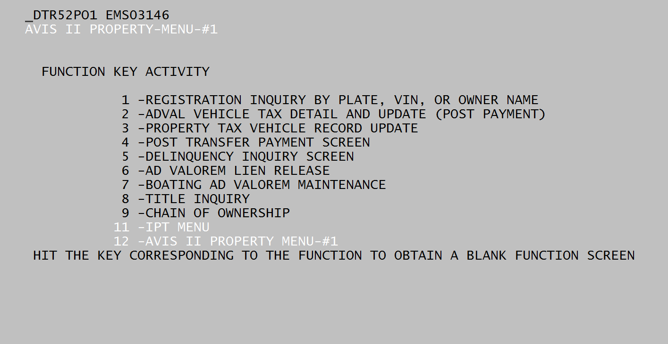
MOTAX Main Menu Screen
After logging on the MOTAX system, the MAIN MENU screen should be the first screen shown. This screen tells you which Function (F1, F2, F3, etc.) keys correspond to the appropriate screens.
Depending upon which type terminal your office contains, to view a certain screen, you need only hit the corresponding Function key to go to that screen. For example, to see the tax assessment on a vehicle, hit the F3 key. Once that screen is displayed, enter the appropriate data and hit the enter key. In some offices, instead of just hitting the Function key, it is mandatory to use the ALT and Function keys. These keys must be touched simultaneously.

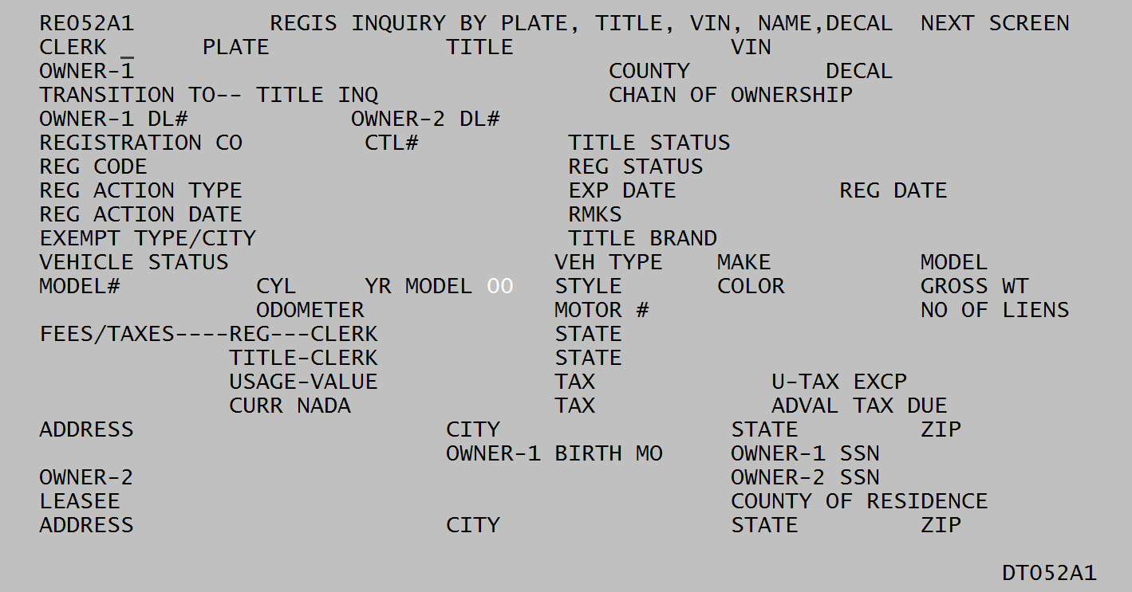
PF1 Screen – Registration Inquiry
This screen provides information only. To inquire about a vehicle you must first enter your initials after CLERK. Then you have several options to search for a vehicle: vehicle plate number after PLATE, VIN after VIN, title number after TITLE, decal number after DECAL, or if none of that information is known, you can enter the owner’s name (last name first) after OWNER-1.
To further define the search, enter the owner’s county of residence after COUNTY. If no vehicles are displayed with this search, removing the county will search through the statewide list. After pressing “enter” a list of all vehicle owned by this person will appear. To view a particular vehicle records, enter the SEQ# to the left of the vehicle plate number that you wish to view and enter “enter.”
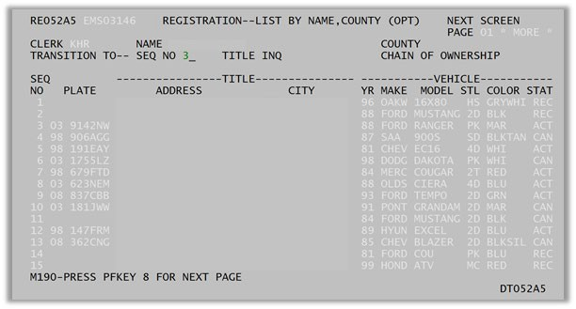

The system will only display vehicles with the exact name that was typed in. If the vehicle does not show up right away, ask the taxpayer what name was listed on the title.
If you have selected a sequence and want to return to the list of remaining vehicles, just hit “enter” and you will return to the list of vehicles from your initial search. There can be multiple pages of results for one name. F8 will take you to the next page of results. “List Complete” will appear when the end of the results are reached. F7 will take you to the previous page if needed.
This screen displays after a certain sequence is selected. F7 and F8 can be used to view previous and next pages, if needed. F8 will display the older ownership or registration, while F7 will back up to the more current information.
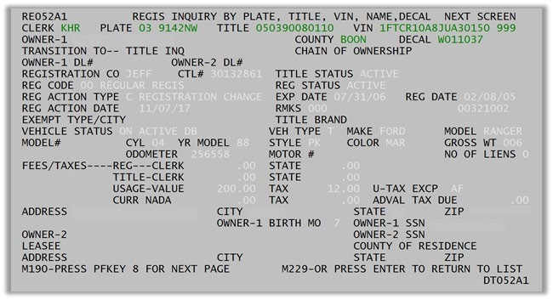
To view the title for a selection just put an “X” next to “TITLE INQ” while viewing the registration in the F1 screen. This screen is particularly helpful with older titles.

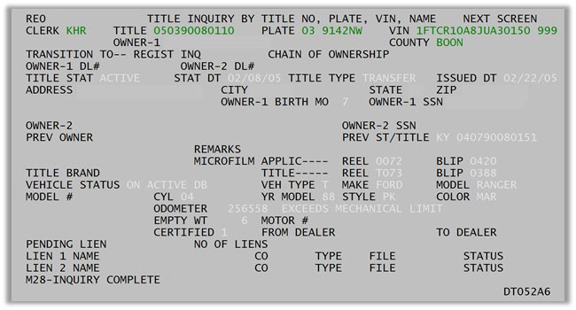

To get back to the registration screen from the title screen enter an “X” next to “REGIST INQ.” From there you can hit “ENTER” to return to the list of search results.

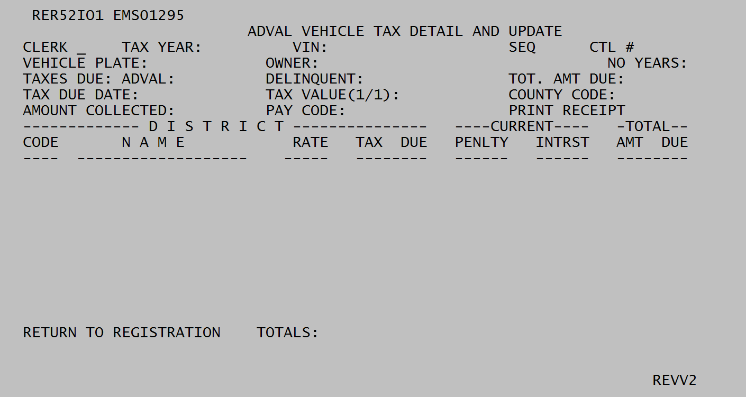
PF2 Screen – Adval Vehicle Tax Detail and Update
This screen is inquiry only and shows a breakdown on a taxpayer’s liability. The tax status, county of situs, assessment, and taxing district within the county of situs are all factors that determine the amount

of tax due. All these factors are entered by the PVA in the F3 screen. The F2 and F4 screens will show the amount of tax due to the taxing jurisdictions.
Any time that a taxpayer needs a breakdown of the taxes due, a screenshot of this screen can be provided to them. This is helpful if the taxpayer has lost the reminder card. This original notice card cannot be reprinted by the Department of Revenue.
To look up a certain vehicle follow these steps: 1.) enter clerk initials, 2.) enter tax year, 3.) enter VIN or plate number, then 4.) Hit enter.
Following these steps should show the tax liability on the screen. The “AMOUNT COLLECTED” line will show if the tax has been paid or not. If there is nothing in this line, the tax has not been paid. If an amount is in this line, the tax has been paid.
If the January 1st owner is not the current owner of the vehicle, “Tax year exists, title is not current with VIN” will appear at the bottom of the screen. In this instance, you will need to go to the F4 screen to view the tax liability. The F4 screen does require the January 1st title number to be entered, that can be found on F1.

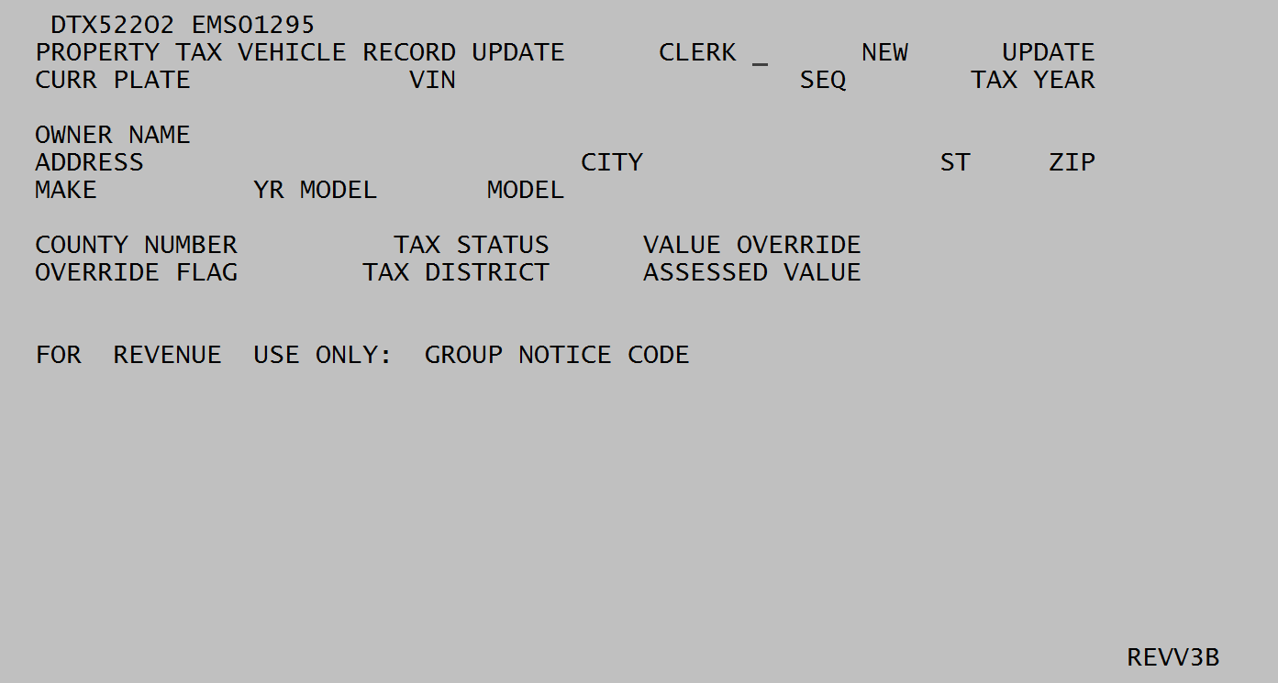
PF3 Screen – Property Tax Vehicle Record Update
This screen is used for creating a tax liability, exonerating a tax liability, or correcting the situs or value of a vehicle.
The PVA override code is always “1.” This number should be entered any time a vehicle is reassessed. The system will not allow PVA staff to use any other number in this area.
The mandatory fields, such as the override flag, prevent unauthorized personnel from using this tax screen. If you do receive a “Mandatory Field” error after entering data onto this screen, just move your

cursor that contain an “*” and enter the requested data. After completing this line, hit enter. The message should not read “Transaction Completed.” If this message does not appear, recheck the data to ensure it is correct and that no fields are missing.
If a plate number is entered and the message “Requested Information Not Found,” the search can be redone with the VIN, and vice versa. If the same message appears, there is usually no segment or the wrong sequence number was used. The sequence number can be found on the F1 screen, it is typically 999.
Each month you will receive an “On-Line Transaction Report” which lists all transactions performed by your office. The PVA is required to check these transactions for accuracy and retain the report for possible audits. Each change of tax status and/or assessment should be checked regularly against your exonerations. The Department has the authority to rescind any non-documented or illegal transactions.

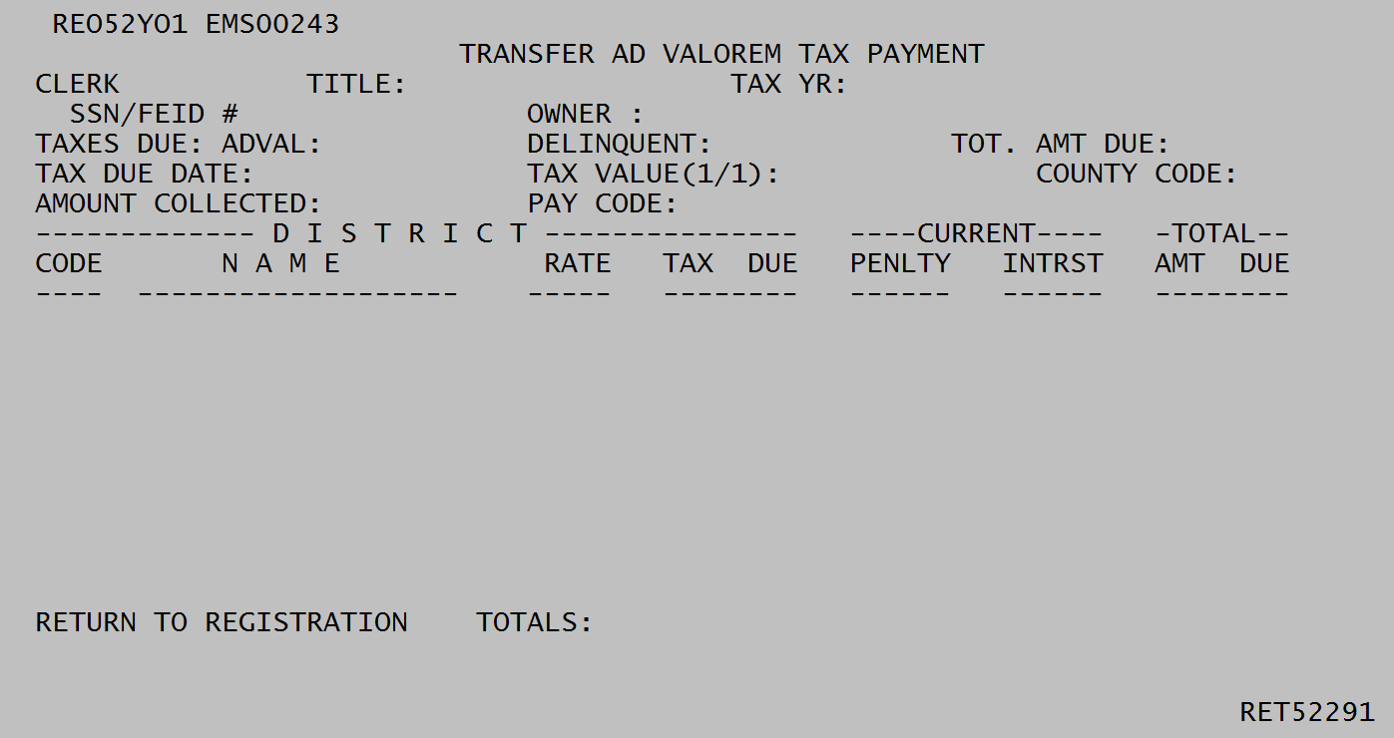
PF4 Screen – Transfer of Ad Valorem Tax Payment
This screen is used to show a breakdown of the January 1 owner’s tax liability on a vehicle that has been transferred to a new owner. The factors that determine the amount due are tax status, county of situs, assessment, and taxing district within the county. All of these factors are keyed into the PF3 screen by the PVA.
When the January 1 owner needs a breakdown of the tax due, it can be obtained from this screen with a screen print. Taxpayers will often request this breakdown for tax purposes when their original notices were either lost or given to the Clerk when they paid the tax. The tax notices are computer generated and cannot be reprinted by the Department, this screen is the only way to give the taxpayer another copy of the tax breakdown.
This screen works differently than the other screens. The title number that was active on the vehicle in the taxpayer’s name and tax year is needed in order to view the tax liability on the transferred vehicle.

To look up the tax liability, with the title number of the transferred vehicle, follow these steps: 1.) enter clerk initials, 2.) enter title number, 3.) enter tax year in which the vehicle was owned on January 1, then
4.) Hit enter.

PF5 Screen – Delinquency Inquiry
This screen is inquiry only and shows any delinquency in the MOTAX system. If the clerk has released the lien on a delinquent amount, it will show up on this screen.
Delinquencies can be looked up with the social security number of the taxpayer. This screen will show a listing on any delinquent tax under that SSN that was entered. Sometimes it may be necessary to check the title of a particular vehicle that you know to be delinquent, because a wrong social security number could be listed on that title.
If there is more than one page of delinquencies, simply hit enter and the next page will appear. “No more delinquencies” will appear at the bottom of the last page when all of the delinquencies have been displayed.
If the title was surrendered with a wrong social security number and the Department has corrected the SSN, the delinquent tax will show up differently than usual. Only the VIN, title number, and a “P” will appear in the DI screen. There will be nothing under “Delq Amt,” “Owner Name,” “Make,” “Model,” or “Yr.” In order to view the tax liability and the responsible party, use the title number on the DI Screen and go to PF4 to look it up. There may be more than one tax year delinquent, so check all available years.
The taxpayer may have delinquencies other than those appearing on the ad valorem delinquency inquiry screen. The computer program will prevent the user from viewing any further delinquencies when the user receives the message “No Title Record Found, Collect Tax on TT Screen.” To view or print a

complete list of delinquencies for a taxpayer please contact the county clerk. The county clerk may release the tax liens on vehicles that have social security number corrections to the title. This will allow the user to view or print all delinquencies due under that taxpayer. After printing the list, the county clerk should contact the Department to place the tax liens back on the vehicle.

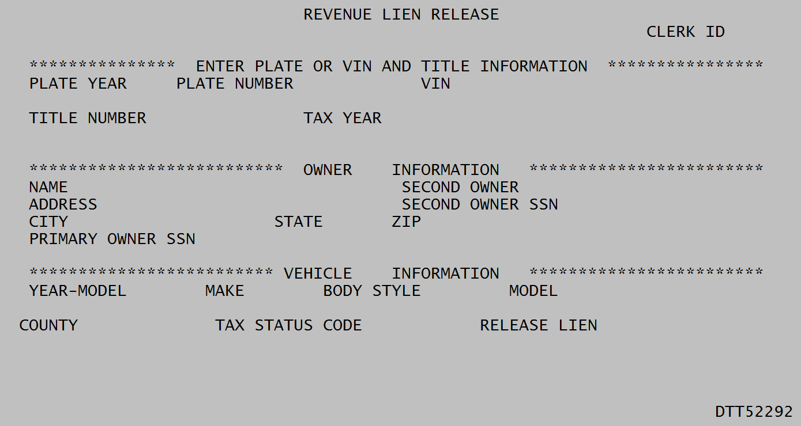
PF6 Screen – Revenue Lien Release
This is a data entry screen, which allows the county clerk to release an erroneous lien on a particular vehicle. The procedure of releasing a lien should be used to comply with bankruptcy proceedings, KRS 186.021(2), or when a correct social security number cannot be found.
Bankruptcy
When property taxes of a motor vehicle are listed on the Petition for Bankruptcy, the clerk shall release the lien to allow the registration of any other vehicle that the petitioner may have.
House Bill 40 (KRS 186.021(2))

KRS 186.021 Issuance of replacement plate, decal, registration certificate, or renewal for motor vehicle on which ad valorem taxes are delinquent or which is uninsured – Option of purchaser to pay delinquent taxes.

(1) Except as provided in subsection (2) of this section, a county clerk shall not issue a replacement plate, decal, or registration certificate as provided in KRS 186.180, or a registration for renewal to any person who on January 1 of any year owned a motor vehicle on which state, county, city, urban-county government, school, or special taxing district ad valorem taxes are delinquent.
- Pursuant to KRS 134.810(4), the owner, as defined in KRS 186.010(7) (a) and (c), on January 1 of any year shall be liable for taxes due on a motor vehicle. A person other than the owner of record who applies to a county clerk to transfer the registration of a motor vehicle may pay any delinquent ad valorem taxes due on the motor vehicle to facilitate the county clerk's transferring registration of the motor vehicle. The person applying shall not be required to pay delinquent ad valorem taxes due on any other motor vehicle owned by the owner of record from which he is purchasing his motor vehicle as a condition of registration.

When a vehicle is being transferred and only the buyer is present, the clerk shall change the account number on the transferable vehicle to that of the buyer. This will allow the buyer to pay any delinquent property taxes on the vehicle being transferred to facilitate the transfer.
If both the seller and buyer are present at time of transfer, this statute does not apply.
Once the buyer’s social security number is placed on the record of the transferable vehicle and if the buyer has any delinquencies, the buyer shall be responsible for payment of these delinquencies to facilitate the transfer. If current year taxes are not due at the time of transfer, the clerk should contact the Department after the transfer has been made to correct the current year’s tax liability to the seller’s social security number.
Erroneous Social Security Number
If the clerk cannot find the social security number after exhausting all means, the clerk may release the lien on the vehicle that is preventing the registration renewal or transfer. If the delinquency is a liability of the customer being waited on, the clerk may not release the lien but instead must collect the liability. The Department can sometimes assist in finding the correct social security number. Any questions regarding the use of this screen should be directed to the Motor Vehicle Section at 502-564-8180.
If a vehicle has a surrendered title and the social security number is wrong, the clerk should contact the Motor Vehicle Section with the correct social security number.

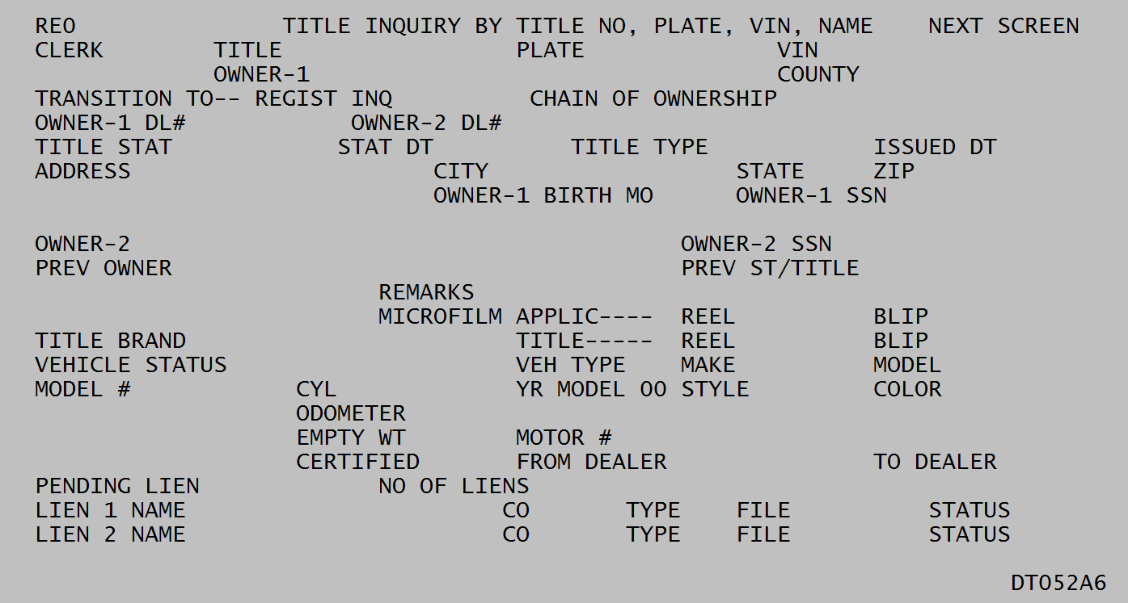
PF8 Screen – Title Inquiry
This screen is inquiry only and shows the title information for a particular vehicle. This screen can be used to verify, or contradict, whether a taxpayer did or did not own a certain vehicle on a certain date.

There are various ways to pull up a vehicle’s information with this screen. You can search by title number, plate number, VIN, or owner’s name.
One of the most important bits of information on this screen is the issue date of the title, the status date, and the status. This screen will assist in the enforcement of the salvage title law (KRS 186A.520).

KRS 186A.520 Salvage titles - Conditions for issuance - Operation of vehicle with salvage title.
- Except as provided in KRS 186A.555, a salvage title shall be obtained by the owner of a motor vehicle that meets the following definition of a salvage vehicle:
  - A vehicle which has been wrecked, destroyed, or damaged, to the extent that the total estimated or actual cost of parts and labor to rebuild or reconstruct the vehicle to its pre-accident condition and for legal operation on the roads or highways, not including the cost of parts and labor to reinstall a deployed airbag system, exceed seventy-five percent (75%) of the retail value of the vehicle, as set forth in a current edition of the National Automobile Dealers Association price guide.
  - The value of repair parts for purposes of this definition shall be determined by using the current published retail cost of the parts equal in kind and quality to the parts to be replaced or the actual cost of the repair parts used in repair.
  - The labor costs of repairs for purposes of this section shall be computed by using the hourly labor rate and time allocations which are reasonable and customary in the automobile repair industry in the community where the repairs are performed.
  - Airbag reinstallation costs which are excluded from the seventy-five percent (75%) computation as set forth in paragraph (a) of this subsection shall be included by an insurer in the computation of the total physical damage estimate according to the terms and conditions of individual policies, provided that the total costs payable by an insurer do not exceed the total retail value of the vehicle.
- The owner or an authorized agent of a motor vehicle that meets the definition of a salvage vehicle as set forth in subsection (1) of this section shall, within fifteen (15) days from the receipt of all necessary paperwork required by this chapter, submit an application to the county clerk, on a form prescribed by the Department of Vehicle Regulation, for a salvage title, accompanied by a properly endorsed certificate of title and any lien satisfactions, if any appear, as may be required.
- The county clerk shall retain a copy of each salvage title application received and shall forward the original and its supporting documents to the Department of Vehicle Regulation in a manner similar to that for handling of an application for a title.
- The Department of Vehicle Regulation shall process the salvage title application in a manner similar to that used in processing a title application and the salvage title shall be delivered in a like manner of a title. Salvage titles shall be construed as proof of ownership of a vehicle in a state as to be unusable upon the highways of the Commonwealth. A vehicle shall not be issued a registration for highway use as long as a salvage title is in force.

- The only time a vehicle with a salvage title may be operated upon the highways of the Commonwealth is when it is in route to or from an inspection by the certified inspector prior to obtaining a certificate of title after having been rebuilt as per KRS 186.115.

If a branded title has been issued, it will be indicated on this screen beside “Title Brand” as a rebuilt or water damaged vehicle.

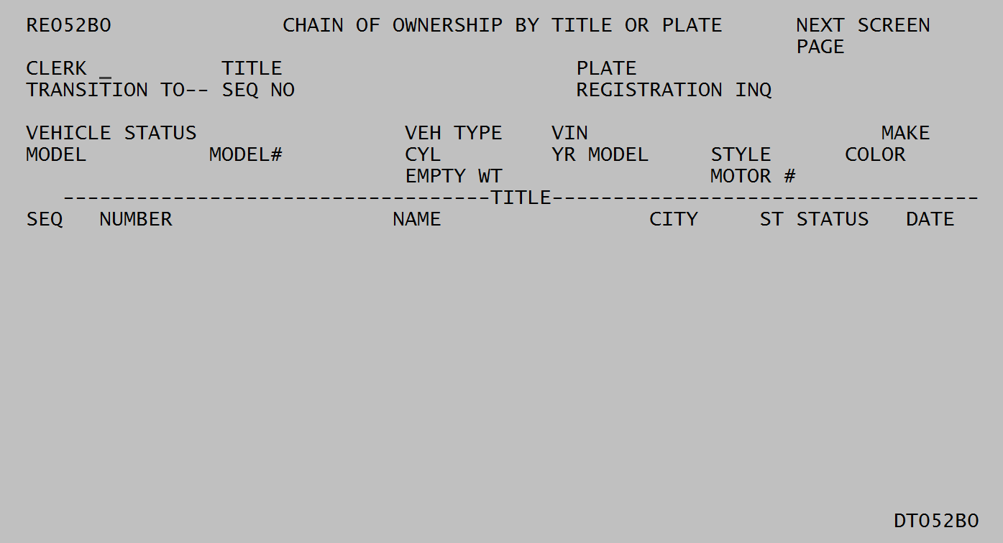
PF9 Screen – Chain of Ownership by Title or Plate
This screen is inquiry only and shows the transfer records of a particular vehicle. Using this screen will allow you to view every Kentucky owner of a certain vehicle.
To search for a vehicle follow these steps: 1.) enter clerk initials, 2.) enter title number or plate number, and 3.) hit enter. This should bring up a listing of the owners. The title of any owner can be viewed by dropping the cursor beside the “SEQ NO” and typing in the appropriate “SEQ” that appears to the left of the owner’s name and then hitting enter.
You can also key in the “Seq No,” put an X by “Registration Inq,”and hit enter to go to the PF1 screen.

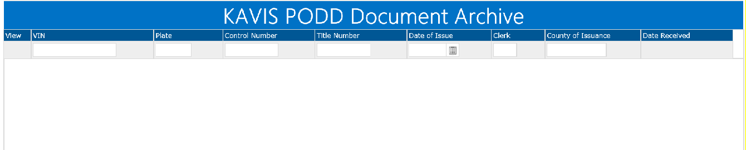
PODD – Print on Demand Decal

PODD (Print on Demand Decal) is where the clerks scan in all paperwork dealing with vehicle transactions. This is a great tool to use when looking for end of year transfers, to help find purchase price when valuing a vehicle, identify the actual sale dates of vehicles sold and lots of other valuable information. You can search by VIN, Plate, title, County, etc.

Every office should have access to PODD. Below are the links for PODD. State Network
https://kavispoddarchive.kytc.ky.gov

Non-State Network

https://kavispoddarchivepva.kytc.ky.gov

Section IV

Reports
The Department sends monthly reports to the PVA in order to maintain proper data in the MOTAX database. There are also annual projection and tax roll reports for motor vehicles and boats. Some of the PVA offices work with Commonwealth Office of Technology (COT) in transportation to receive electronic files to match the addresses and input the correct district code. The file is then returned to COT to upload the correct district to the database. The offices participating with the (COT) in the computer match would not receive all the reports via Move-it.

On-Line Transfer Report – R5532

The transfer report is a listing of all motor vehicle records that have been transferred into a PVA’s county from another jurisdiction. During the month, PVAs and clerks will correct the designation for county of ad valorem by changing their own county code to that of another county. This should only be done when the taxpayer’s address was actually in another county and the vehicle was located in that other county as of January 1 of the tax year. Whenever a taxpayer of another county purchases a vehicle that was in a PVA’s county on January 1 that record should not be transferred. Transfers can only be made from your county to another county. PVAs can never change another county’s code.
The purpose of the Transfer Report is to alert a PVA that a vehicle record has been assigned to that county by means of a change on line from another county. County code changes made directly on county terminals do not appear on the regular monthly update report. PVAs must correct the tax district for records received via the transfer report. Whenever a county code is changed, tax districts automatically revert to 00; therefore, districts must be correctly entered by the receiving county.

This report is uploaded to Move-It, under the specific county folder monthly.
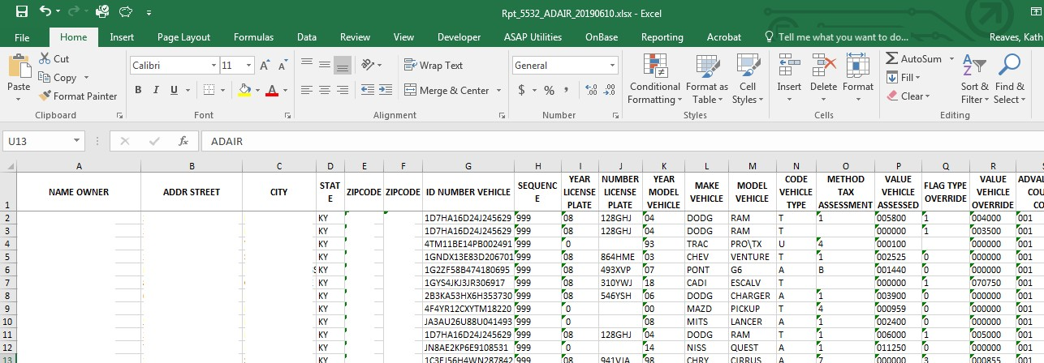

On-Line Change Report –R5537
The change report informs PVAs of all changes to value, tax status, county code, or taxing district. The report also informs PVAs of the date of transaction and the initials used by the one who performed the transaction, but it does not include changes made by the Office of Property Valuation. All transactions should be verified for accuracy and compared to their documentation. The Department of Revenue may rescind any transaction that is not properly documented.
This report is uploaded to Move-It, under the specific county folder monthly.
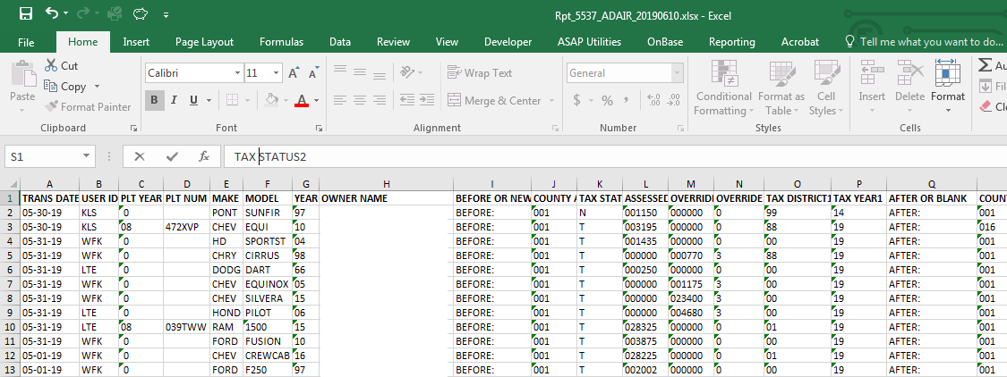

Vehicle Batch Update – R5504 –Vehicle 88
This report lists all address changes that have occurred within the AVIS systems. The PVA shall properly assign the new situs county and/or district to all vehicles listed on this report. The vehicles on this report need to be properly districted upon receipt by the PVA. These transactions are updated for the future year.
Note: As long as the customer notifies the County Clerk of an address change within 15 days of moving, the PVA will be informed of the address changes via this report.
This report is uploaded to Move-It, under the specific county folder monthly.

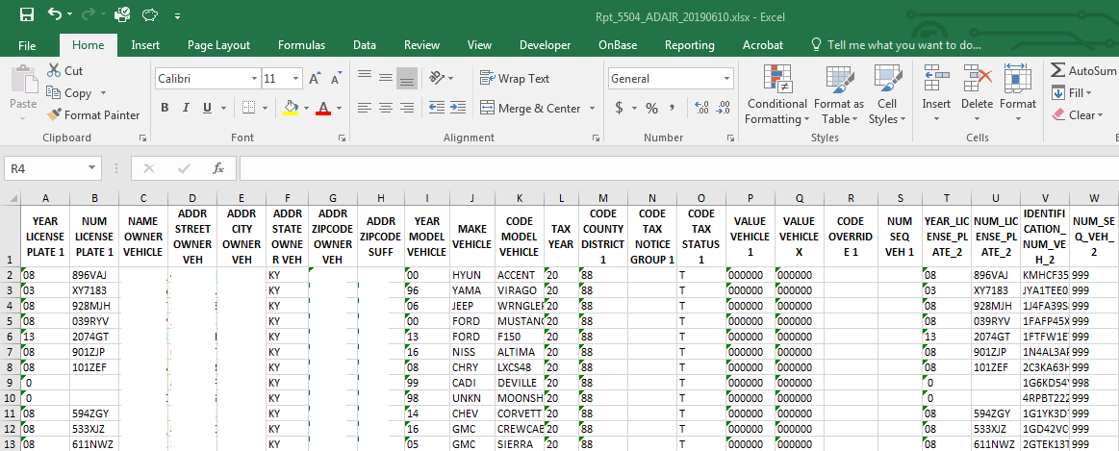

Ad Valorem District “88” Report (BOAT)
This report has been discontinued and the 88 watercraft is included in the KAVIS BTR module under the Tax District Assignment Queue. The transactions are in real time and can be worked daily, weekly or monthly. Once the transaction is worked it will be removed from the list. No taxes can be collected as long as this “default” district remains on the tax segment. If a segment has a district 88 listed, the Department of Revenue will mail a notice with only an assessment. The tax will not be calculated. No registration may be renewed as long as district 88 remains on the tax segment. The PVA would need to place the vehicle in the proper taxing district in order for the clerk to collect the property tax.

Motor Vehicle Tax Roll
This report contains an alphabetical listing of all vehicles with a tax liability in your county. This listing is sent via Move-It annually by the Office of Property Valuation. There is a tax roll for motor vehicles, which is broken down by county, and a tax roll for boats, which is one report for the whole state.
This tax roll must be kept in the PVA office for public viewing. Any time the public wishes to see this listing, the PVA is required under the Open Records Law, KRS 133.047(3), and KRS 61.870 et seq. to allow the viewing of this listing.

This report is uploaded to the specific county folder on Move-It annually in May.
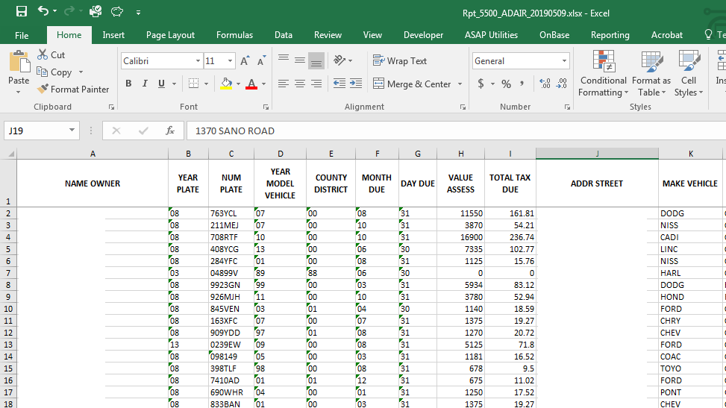

Boat Tax Roll
The boat tax roll will be produced by KAVIS beginning with the 2020 year. The PVA offices can download
from the reports section of KAVIS.

Utility Trailer Report
This report is sent quarterly from DOR and uploaded to MOVEIT. This report includes trailer (UT) title applications that were made in the Clerks offices for that quarter that need a value inputted for the next year. The trailers do not have values and there is not a computer match for them. The reports should be worked to determine an appropriate value. The report includes the VIN, title, make, model, and year to assist in finding an accurate value.
DOR has sent a Trailer Guide to assist offices in finding comparable values. The guide is based on data collected from several sales websites and can be helpful if there is little information known about the trailer’s purchase price. PODD can also reviewed for more specifics about the trailers. Occasionally the bill of sale or an invoice can be found in PODD. To determine the value this way, in accordance with the KY Constitutional mandate of fair cash value, 90% of the sales price could be used to reflect the next year’s value.
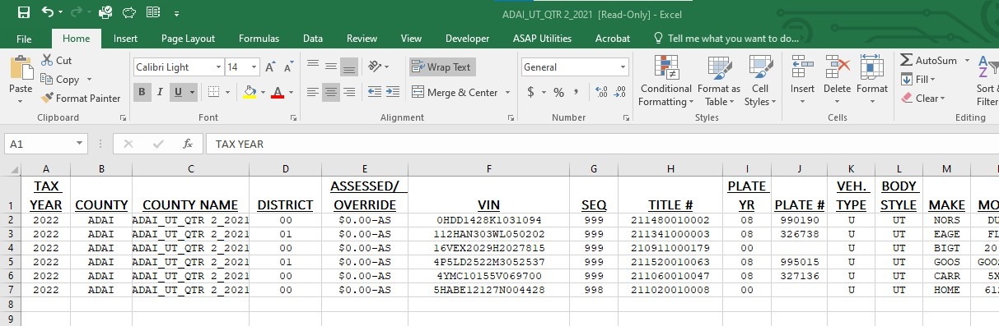

Recreational Vehicle Report

This report is sent quarterly from DOR and uploaded to MOVEIT. This report includes recreational vehicle title applications that were made in the Clerks offices for that quarter that need a value and district code inputted for the next year. These vehicle types are coded in AVIS as Vehicle Type: “H” and Style: “TV”. The recreational vehicles do not have values and there is not a computer match for them. The reports should be worked to determine an appropriate value. The report includes the VIN, title, make, model, and year to assist in finding an accurate value from JD Power and or PODD.

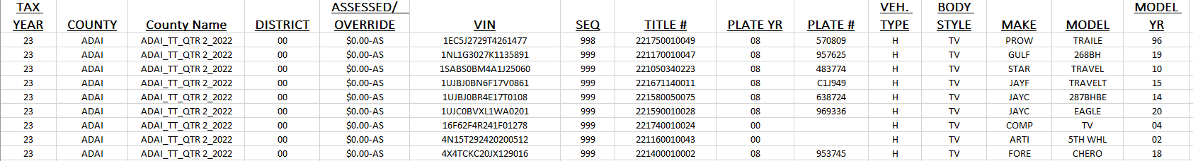

Projected Monthly Collections
This report has the assessments broken down for each taxing jurisdiction within the county. This is the assessment that taxing jurisdictions use for setting the succeeding year’s tax rate. This report is also used in the local County government allocation to PVA for budget purposes.
Due to exonerations and changes in tax situs and assessment, this report is only a projection
For purposes of informing the taxing jurisdictions of the approximate assessments of their localities, the PVA should release the projected assessments to the taxing jurisdictions upon receipt. This report will be released by the Department on or after May 15 of each year. There is a report for motor vehicles and a separate report for boats. Be sure the taxing jurisdictions get both report totals.
The motor vehicle reports are uploaded on Move-It, under specific county folder annually in May. The boat projection report beginning in 2020 will be produced by KAVIS and will be available for PVA offices to download.
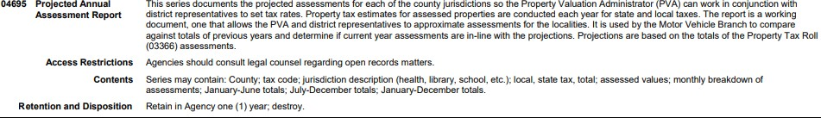
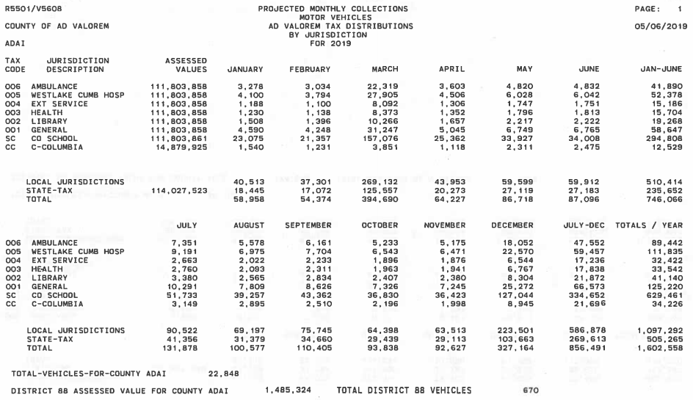

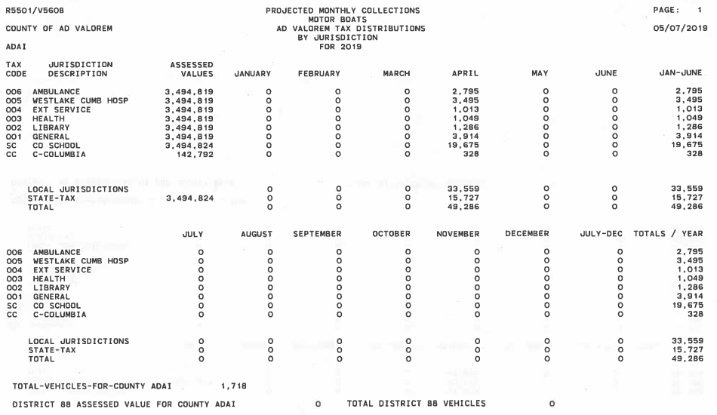

Annual District “88” Report
This report includes all remaining transactions for the current year that are remaining in district “88” including the December monthly transactions (no monthly report is received in January for December). The PVA shall properly assign the new situs county and/or district to all vehicles listed on this report. The vehicles on this report need to be properly districted upon receipt by the PVA. The annual “88” report is uploaded to Move-it the first of the year at the conclusion of year-end valuation.
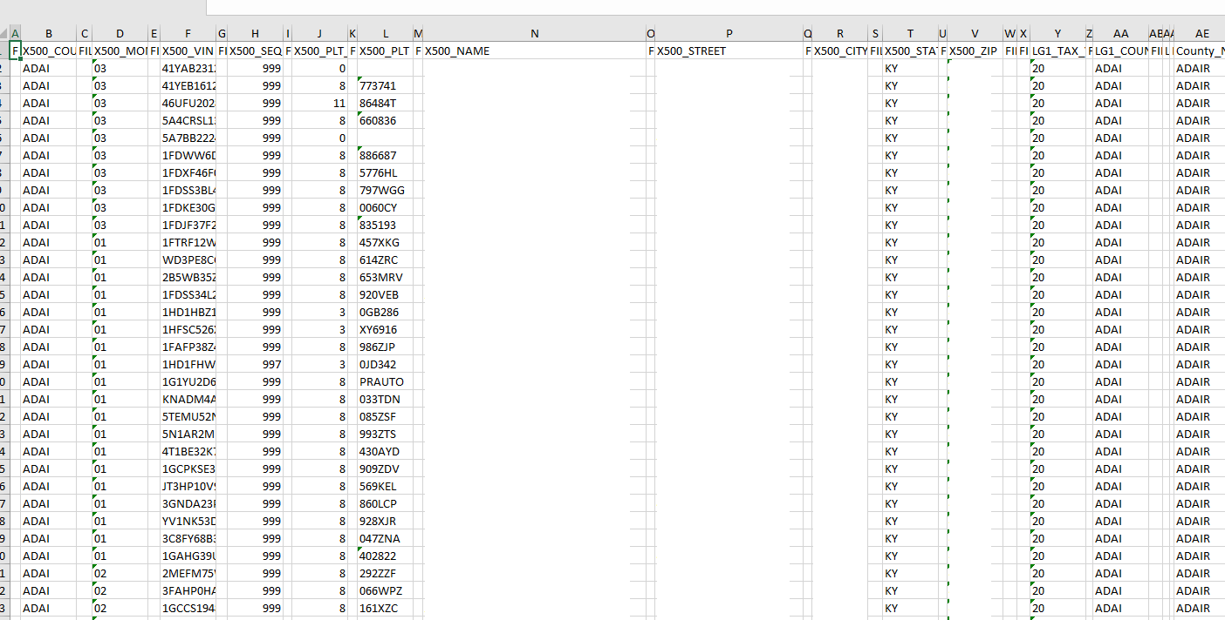

Annual District “00” Report
This report includes transactions due in renewal months January and February that are included in tax district “00” that the PVA needs to verify the correct district and correct if needed. The annual “00” report is uploaded to Move-it the first of the year at the conclusion of year-end valuation.
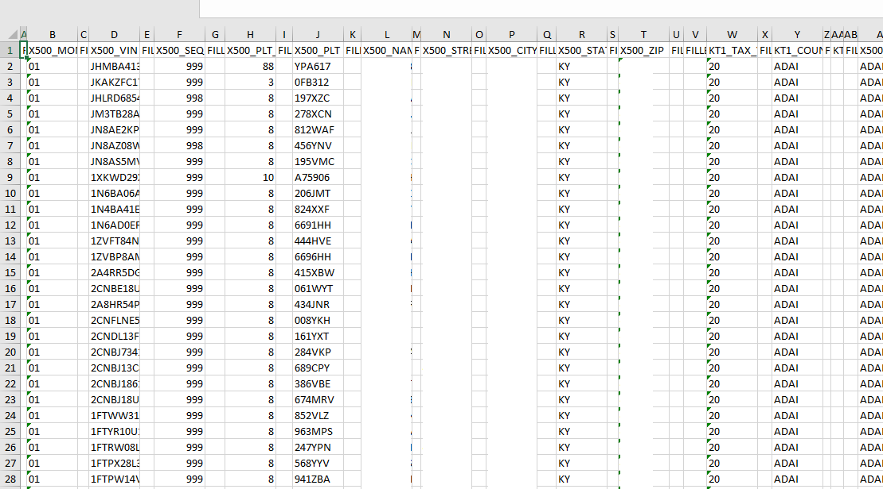

Advance Tax Listing Obligation Report
This report is available to taxpayers and provides a listing of all vehicles owned by the taxpayer on the assessment date of the current tax year along with the corresponding amount of property tax due. The report is normally requested by leasing companies. It may be ordered from the Department of Revenue using the taxpayer’s name or federal identification number (FEIN), the Department recommends the report be ordered by FEIN. The Department requests this report from Commonwealth Office of Technology, Office of IT Services and Delivery.

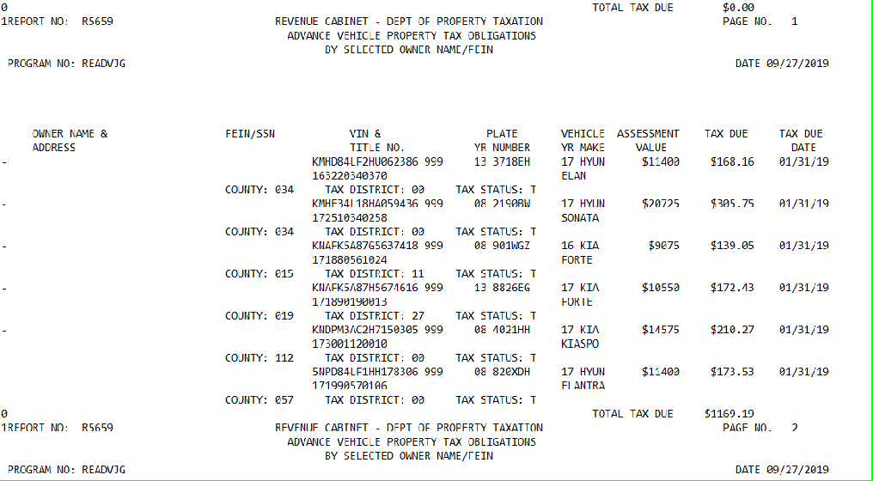

Section V

Forms Used by PVA and County Clerk

Form 62A044 Affidavit for Correction/Exoneration of Motor Vehicle/Boat/Trailer Property Tax
Found on DOR forms page and PVA network, form 62A044
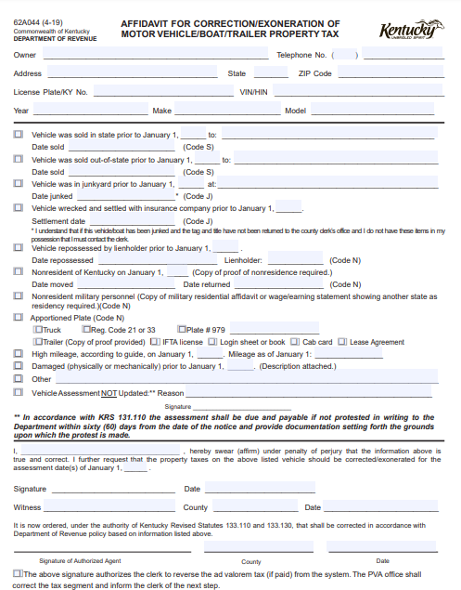

Form 62A044-T Affidavit for Correction/Exoneration of Fleet of Trailers
Found on DOR forms page and PVA network, form 62A044-T

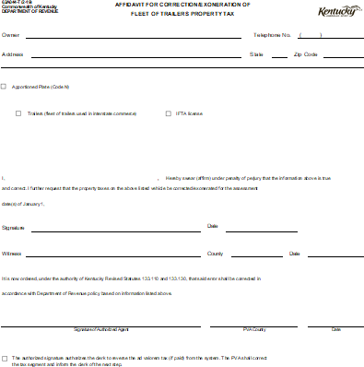
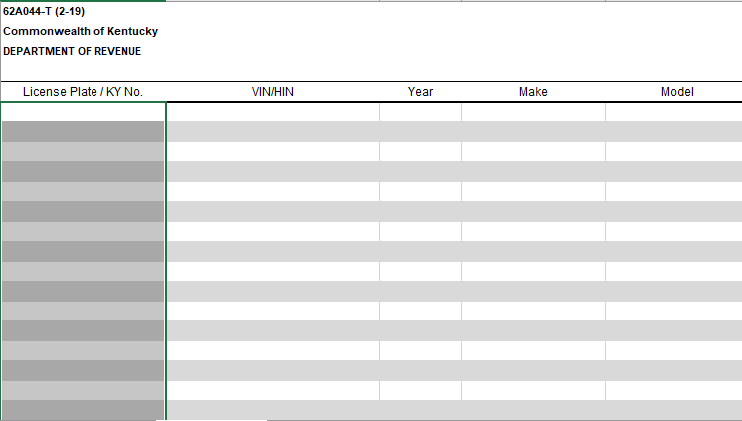

Form TC 96-182 Application for Kentucky Certificate of Title or Registration
Found on Transportation Cabinet’s website, form TC 96-182

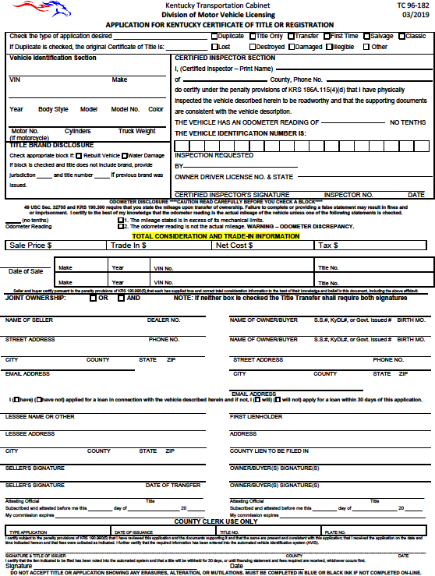

Form TC 96-215 Affidavit of Motor Vehicle Assembled from Wrecked or Salvaged Motor Vehicles
Found on Transportation Cabinet’s website, form TC 96-215

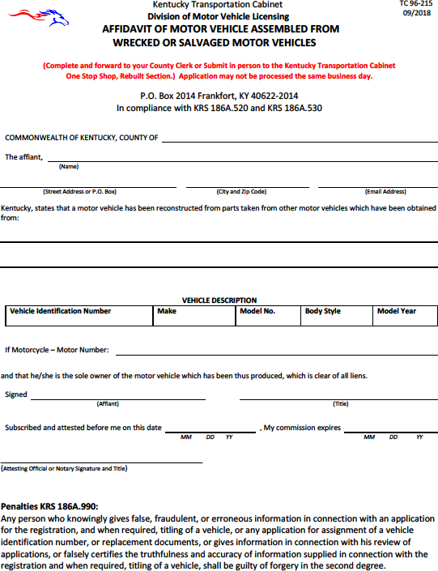

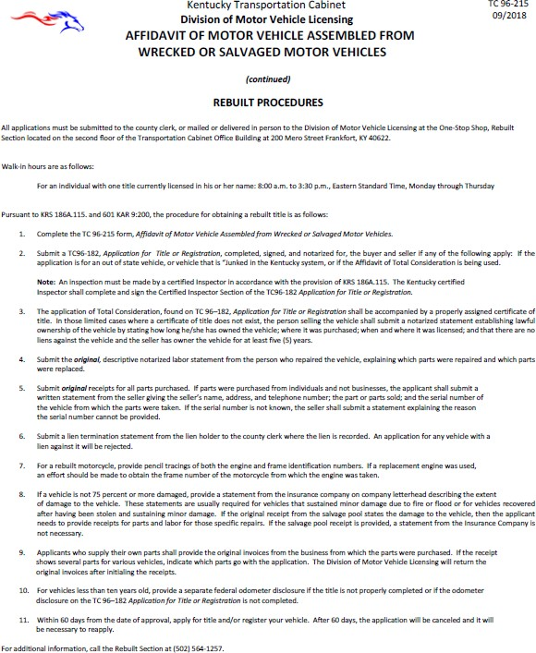

Form TC 96-192 Affidavit Supporting Repossession and Disposition of a Vehicle
Found on Transportation Cabinet’s website, form TC 96-192

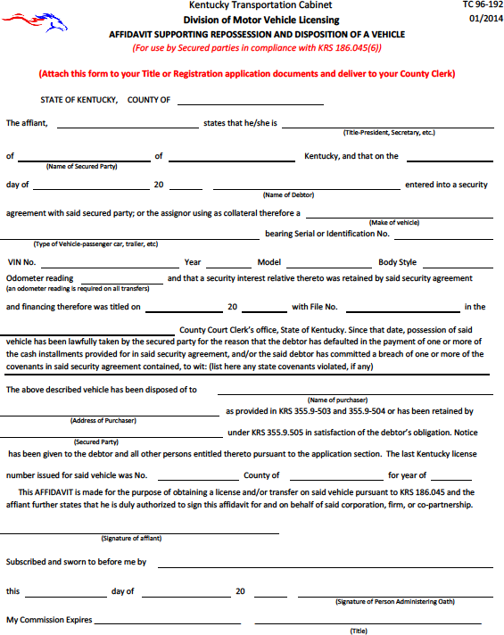

Form TC 96-3 Affidavit of Incomplete Transfer
Found on Transportation Cabinet’s website, form TC 96-3
This form does not have any effect on taxable segments.

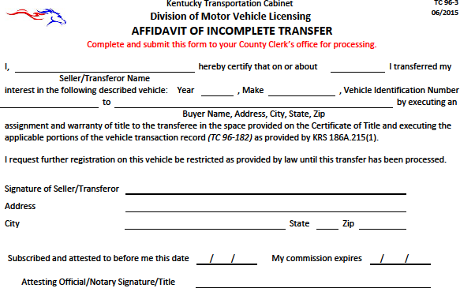

Form TC 96-183 Notice to County Clerk of Vehicle Acquisition
Found on Transportation Cabinet’s website, form TC 96-183

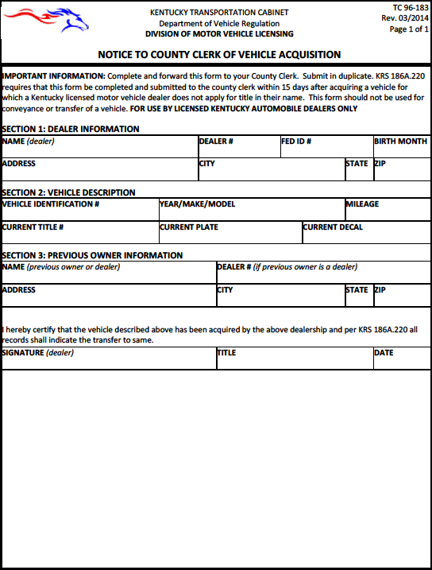

Form 62A645- End of Year Motor Vehicle Transfers not Titled Until Next Year
Found on Clerk Network
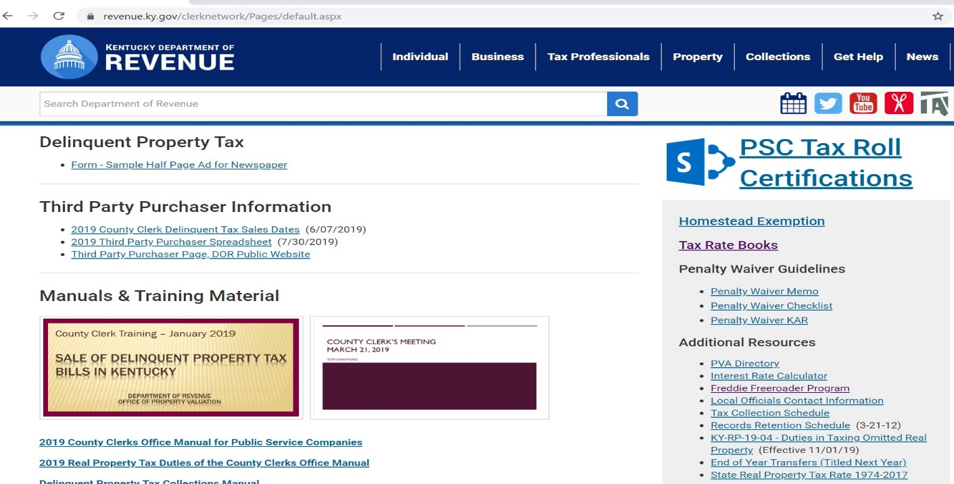
https://revenue.ky.gov/clerknetwork/Pages/default.aspx

This form is completed by the County Clerk and provided to the PVA regarding vehicles purchased prior to January 1st but transferred in the system after the January 1 assessment date. When the PVA receives this list, they need to go in and create the current year segment for the January 1 owner. If a current year segment shows up in the previous owner’s name then the PVA can then call DOR for a segment switch.

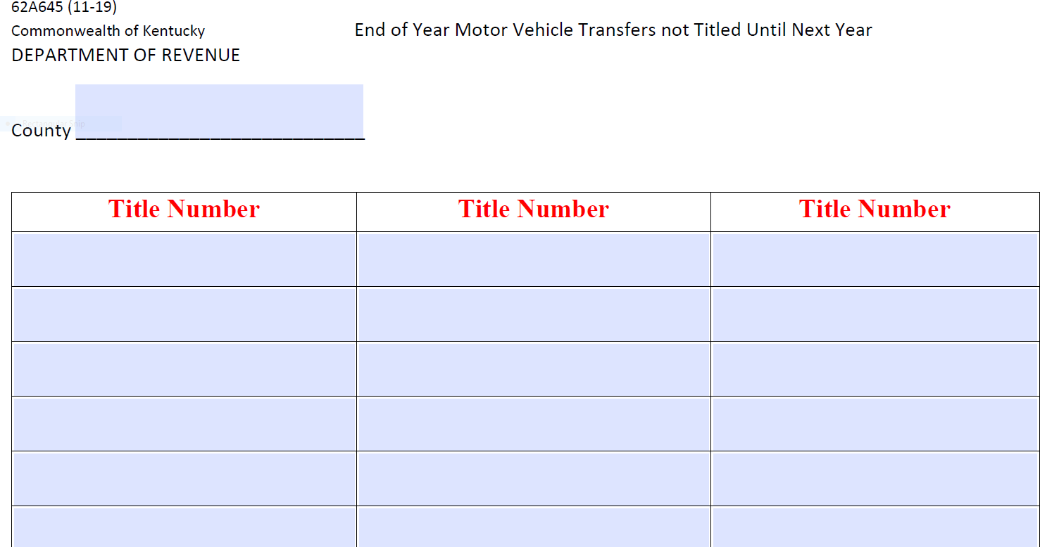

Section VI

Assessment of Motor Vehicles

Valuing of All Motor Vehicles
Motor Vehicles are assessed utilizing a mass appraisal.
The Uniform Standards of Professional Appraisal Practice (USPAP) provides mass appraisal as its own specialty through its STANDARD 6. It defines mass appraisal as “the process of valuing a universe of properties as of a given date using standard methodology, employing common data, and allowing for statistical testing.”

Revenue Cabinet v. Gillig, 1998 Supreme Court of Kentucky
- Upholds the use of mass appraisal techniques.
- Under mass appraisal approach, while individual characteristics of each property are considered, not all of a particular property’s characteristics are considered-just those factors which allow the assessor to make a logical estimated of the property’s value.
- Kentucky courts recognize the level of accuracy achieved by a private fee appraiser is not practical by state tax assessors nor is accuracy required by Section 172 of KY Constitution, which specifically provides that fair cash value will be “estimated”.

132.485 Motor vehicle registration as consent to assess -- Exceptions -- Assessment of vehicle twenty years old or older -- Ownership -- Assessment of vehicle purchased and registered in different years -- Exemptions.

- (a) 1.The registration of a motor vehicle with a county clerk in order to operate it or permit it to be operated upon the highways of the state shall be deemed consent by the registrant for the motor vehicle to be assessed by the property valuation administrator from a standard manual prescribed by the department for valuing motor vehicles for assessment unless:
  - The registrant appears before the property valuation administrator to assess the vehicle; or
  - The motor vehicle is twenty (20) years old or older, in which case paragraph (b) of this subsection applies regarding its valuation.
2. The standard value of motor vehicles shall be the average trade-in value, not the rough or clean trade-in values, prescribed by the valuation manual.
3. The property valuation administrator may adjust the value of a motor vehicle when the registrant has provided evidence that the standard value does not reflect the motor vehicle’s condition, options, mileage, or certificate of title issued.

Vehicle Valuation

All assessments must be derived from the guides and procedures adopted by the Department of Revenue if available.
- If available all automobiles, pickups, boats, boat trailers, motorcycles and recreational vehicles must be assessed at the JD Power trade-in value as of January 1 of each year. If no adjustments, the AVIS assessment should match the January 1 J.D. Power average trade-in value, or the equivalent in conjunction with KRS 132.485. (as amended in 2022).
- All large (medium and heavy duty) trucks are assessed at the wholesale value from the JD Power Commercial Truck Guide. Much of the equipment on these vehicles, such as dump trucks, qualifies to be listed on the Tangible Personal Property Tax Return (form 62A500). The truck shall be assessed in MOTAX but the equipment must be listed on the Tangible return (62A500).

Vehicles 19 Years Old or Less
The assessments of automobiles, pick-ups, small trucks, and vans that are nineteen (19) years or less are derived from the J.D. Power Official Used Car Guide. All motor vehicles assessed by this guide shall be assessed at the average trade-in value, less any applicable.

Vehicles 20 years or Older
KRS 132.485
- In the case of motor vehicles that are twenty (20) years old or older:
  - It shall not be presumed that a vehicle has been maintained in, or restored to, the original factory or otherwise classic condition or that its value has increased over the previous year;
  - In assessing motor vehicles under this paragraph and calculating the taxes due thereon, through the AVIS or otherwise, if the registrant does not appear before the property valuation administrator to assess the vehicle, the standard value shall be as follows:
    - The actual valuation of the vehicle as was assessed in the vehicle's nineteenth year, if the vehicle was assessed for taxation in the Commonwealth in that year; or
    - The average trade-in value prescribed by the applicable edition of the valuation manual for the vehicle in its nineteenth year, if the vehicle was not assessed for taxation in the Commonwealth in that year; reduced by ten percent (10%) annually for each year beyond nineteen (19) years; and
  - In the case of any motor vehicle for which the assessment procedure provided in subparagraph 2.b. of this paragraph would apply but cannot be carried out because the applicable edition of the valuation manual is unavailable, the property valuation administrator shall conduct an assessment of the vehicle to determine the value thereof for the given taxable year. The assessment under this subparagraph may be done in person if the vehicle's owner presents the vehicle at the property valuation administrator's office, or the assessment may be done through a review of photographs and other documentary evidence. In subsequent years, that valuation shall be reduced by ten percent (10%) annually.

CAUTION: High mileage is not an applicable deduction for this category of vehicle.

Large Trucks (Heavy and Medium Duty)
All medium and heavy-duty trucks shall be assessed at the trade-in (wholesale) value of the J.D. Power Official Commercial Truck Guide. The Department does allow the use of the High Mileage Table, located at the beginning of this guide. The high mileage deduction shall not exceed 15 percent of the average retail value. Any damages incurred prior to January 1 of the tax year may be deducted from the trade-in
value. A combination of the high mileage and damage deductions shall not reduce the assessment to 25 percent or less of the average retail value. Any vehicle assessed at 25 percent or less of the average retail value shall be considered salvage and removed from Kentucky highways. The owner shall apply to the County Clerk for such title.

Recreational Vehicles (RVs), Travel Trailers Campers, Motor Homes, and Van Conversions
The assessment of RVs, travel trailers, and motor homes is derived from the January J.D. Power Recreation Vehicle Appraisal Guide. All motor vehicles assessed by this guide shall be assessed at the used wholesale trade-in value, less any applicable deductions. The estimate of repair may be deducted from this value. The guide also contains optional equipment, which should be added to the value when so noted.
Each of these types of vehicles is contained within their own section of the guide. Sometimes in order to better facilitate using this guide, the taxpayer should be asked for more details about their vehicle. The Department does allow a deduction for high mileage for RVs based on the chart included in the guide.
Deductions for high mileage are not allowed for diesel engines per JD Power.

Mileage MAY be taken into consideration for gas engine only. DO NOT use for diesel engines.

Choose M-2151S Ford E350 Options Below

There is no deductions for mileage on travel trailers or campers because they do not have an odometer for recording such mileage.

Recreational vehicles require a manual valuation by the local PVA office as there is no tape provided on these specialty vehicle types for the mass appraisal as with motor vehicles. Reports are provided quarterly via Move-it to assist with valuation and districting for the next year.

Van Conversions
The base value of a van derives from the J.D. Power Official Used Car Guide. When a van has been customized or a conversion has occurred, the value of the van should be increased accordingly. The Motor Vehicle Section can assist in the valuation of these types of vehicles.

Motorcycles
Motorcycle assessments are derived from the J.D. Power Motorcycles/Snowmobile/ATV/Personal Watercraft Appraisal Guide.

All motorcycles assessed by this guide shall be assessed at the rough trade-in, less any applicable deductions. In the absence of a rough trade-in, the clean trade-in shall be the assessment. Currently there is no average trade-in value available to use.

Boats
Boat assessments are derived from the J.D. Power Marine Guide or the E-Valuator (online version). The
J.D. Power Marine guide is divided into multiple sections including: Boats, Outboard Motors, Trailers and Inboard Motors. It is important to review the headings for each manufacturer to determine what value option is used for their models. If you are reviewing a boat model using the E-Valuator that doesn’t include the combination options it will be necessary to use the Marine Guide to determine an individual value for the boat, motor and trailer to complete the assessment. All boat assessed by this guide shall be assessed at the used trade-in value, less any applicable deductions.

Section VII

Adjustments to J.D. Power Value

Adjustments to Assessment
In accordance with KRS 132.485, the property valuation administrator may adjust the value of a motor vehicle when the registrant has provided evidence that the standard value does not reflect the motor vehicle's condition, options, mileage, or certificate of title issued.
Adjustment for condition may be one of a combination of the following:

Deduct if:
- Vehicle had high mileage on assessment date (January 1). Maximum deduction: 40% of trade-in value.
- Vehicle has been wrecked and damage has not been repaired prior to assessment date (January 1).
- Vehicle value includes options which customer’s vehicle does not contain.
- Vehicle has a “branded” or rebuilt title. The assessment shall be 60% of the trade-in value.
- Vehicle has salvage title on January 1 of tax year. The assessment of salvage title vehicles should not exceed 25% of retail value. The PVA should determine this assessment.

As of January 1, 1998, no override shall be lower than 26% of the January J.D. Power retail value unless a salvage title has been obtained.
Caution: Any vehicle assessed at 25% or less of the clean trade-in value shall be considered salvage and removed from Kentucky highways, pursuant to KRS 186A.335. The owner shall apply for such title with the County Clerk.

Add if:
- Vehicle has options that are not included in J.D. Power value.
- Vehicle has low mileage.
- Vehicle is in superior condition (restored older vehicles).

Documentation Required for Reduction of Assessment

To adjust for physical or mechanical damage, the PVA must receive an estimate for cost of repairs needed to put the vehicle in average condition. A copy of the estimate should be retained by the PVA. Be reminded that the condition of the vehicle as of January 1 of the tax year may be the average for such model (depending on age of vehicle).
To adjust for high mileage, evidence of high mileage on January 1 of the tax year must be provided. A service order of approximate January mileage or an affidavit of the January mileage are two acceptable means of documentation. Any vehicle assessed by the J.D. Power Official Used Car Guide may be allowed a mileage deduction by using the High Mileage Table in the guide. The high mileage deduction should be deducted from the J.D. Power trade-in value, but it may not exceed 40% of the trade-in value.

Diesel engines are identified within the VIN. Refer to the J.D. Power guide, since the presence of a diesel engine may add to the assessment.
Vehicles that have a salvage title on January 1 of the tax year shall be assessed at no more than 25% of the January J.D. Power retail value. Owner should present the salvage title to PVA for review.
Vehicles with a “branded” title shall be assessed at 60% of the average trade-in value. The owner should present the title to the PVA to receive this reduced assessment. The PVA must retain a copy of the title as documentation.
Errors in assessment due to incorrect Vehicle Identification Number (VIN) shall not require any documentation. However, to alleviate the problem of an incorrect assessment each year, the PVA must instruct the owner to contact the Clerk for correction of the VIN.

Examples of Assessment Adjustments
Vehicles 18 Years Old or Less

High Mileage
The Cabinet recognizes the use of the High Mileage Table in the J.D. Power guide. The PVA may consider high mileage as a basis for value adjustments. However, pursuant with J.D. Power guidelines, the high mileage deductions shall not exceed 40% of the J.D. Power average trade-in value as of January 1 of the tax year.
The following example are calculated for the 2022 tax year. Average Trade-in is utilized for the examples
as that will be the valuation utilized going forward.

Example #1
2017 GMC Light Duty Acadia Utility 4D SL 2.5L
75,000 miles
Average Trade-In Value $18,375 (January 2022 Online Guide)
High mileage deduction $ 275
Fair Cash Value $18,100

Example #2
2018 Toyota Corolla Sedan 4D LE 1.8L
108,000 miles
Average Trade-In Value $16,650 (January 2022 Online Guide)
High Mileage Deduction $ 2,050
Fair Cash Value $14,600

Damaged Vehicle
Damage to a vehicle on January 1 of the tax year may be deducted from the trade-in value for that year. Damage deductions for parts, materials, and labor shall not exceed a professional estimate. A combination of the deductions shall not reduce the assessment to 25% or less of the average trade-in value.
Example #3 | 2017 BMW 3 Series Sedan 4D 320i 2.OL
65,500 miles
Damage estimate of $3,000
 | Average Trade-In Value | $18,500 | (January 2022 Online Guide)
 | Mileage deduction | N/A
 | Damage deduction | $ 3,000
 | Fair Cash Value | $15,500
Example #4 | 2011 Nissan Altima Sedan 4D SL FWD 2.5 | Retail: | $6,500
200,000 miles
Damage estimate of $2,000
 | Average Trade-In Value | $4,050 | (January 2022 Online Guide)
 | High Mileage deduction | $ 875
 | Damage deduction | $ 2,000
 | Fair Cash Value | $ 1,175

In example #4, the adjusted assessment of this vehicle with the high mileage and damage deduction is $1,175. If the assessment stays at this amount, this vehicle is required to be removed from Kentucky highways due to being worth less than seventy-five percent of the average retail value. In order for the owner to be legal and retain the registration for this vehicle, the PVA should assess this vehicle at $1,690, which is 26 percent of the retail value.
.

Section VIII

Tax Status Codes and Account Numbers

Tax Status Codes
Tax status may be created or changed to one of the following for the reasons indicated after providing proper documentation.
T Taxable
E Exempt
M Mobile Home
S Sold out-of-state, moved out-of-state, sold to KY resident but has not been transferred in AVIS, or sold to non-Kentucky auto dealer (all sales must have occurred prior to January 1 of the tax year in question)
N Nontaxable
J Junk (not road-worthy)
V Stolen
The only codes that may be used in the boat screen are T, N, and E.

Tax Status Codes Explained
T Taxable, used for any vehicle with Kentucky situs on January 1 of the
assessment year and not exempted by the Kentucky Constitution. Vehicle does not qualify for any other tax status.
E Exempt, used for vehicles that are exempted by the Kentucky Constitution or statute (KRS 65.948 and 186.010(2)) and owned by:
- Any federal, state, or local government.
- Any educational institute whose income is devoted solely for educations purposes.
- Any religious organization.
- Any purely public charity – PVA may contact the Division of Local Valuation if there is a question as to whether a charity qualifies for this exemption.
- Any boat trailer titled in MOTAX but assessed along with the boat in the boat system.
- Tangible agricultural property.
- Mobile home, used for all mobile homes, modular, or manufactured homes.
S Sold to an out-of-state owner prior to January 1 of the tax year, sold to a Kentucky resident prior to January 1 of the tax year but has not been transferred in AVIS, or taxpayer moved out-of-state prior to January 1.
- Non-taxable
  - Non-resident military personnel under Soldiers’ and Sailors’ Relief Act.
  - Motor vehicles held for resale by licensed Kentucky motor vehicle dealers.

  - No Kentucky situs on January 1 of the tax year.
  - Taxes discharged through bankruptcy proceedings.
  - Past the five-year statute of limitations.
  - Apportioned vehicles (see explanation at end of section)
J Junked, vehicle is not road worthy prior to January 1 of the tax year and owner is not planning to restore or sell vehicle or vehicle is in a junk yard.
NOTE: The “J” junk code may be used for vehicles that are still in the taxpayer’s possession but the owner does not plan to rebuild or restore the vehicle. This includes vehicles that have been pulled to the back of the farm or sitting in a field or yard and generally are not road-worthy, nor will they ever be road-worthy. If the vehicle meets the requirements for a salvage title and the owner plans to rebuild the vehicle, the PVA may reduce the assessment to salvage value after the owner secures a salvage title. Once the “J” code has been entered onto the tax record, this vehicle may not be titled or registered again unless the “J” code is removed from the tax record. The PVA is responsible for placing appropriate tax status code on the segment.
V Stolen, vehicle was stolen prior to January 1 of the tax year and not recovered. Documentation must be provided to the PVA such as police report and a letter from the insurance company showing the date of settlement.

Apportioned Vehicles
All apportioned trucks and tractors will not have tax segments created since they have specific registration coding, (21 or 33). Only trucks or tractors having first time apportioned registration will have to be coded locally, and an “N” must be used. Kentucky-owned trucks and tractors leased to out-of-state companies must provide their apportioned certificate to the PVA before those taxes are removed and they should also be coded “N”. Semi-trailers operated in interstate commerce should also be coded “N”.

Apportioned vehicles registered through another states IRP plan will not be in the AVIS system since they are not titled or registered with Kentucky.

Junk, Sold Out-of-State, Mobile Homes, and Stolen Codes
CCO Vehicle in junkyard
CCG Vehicle sold out-of-state
CCL Incomplete transfer/transfer not complete in AVIS
These codes can be entered into the “REMARKS” area of the County Clerk’s RC screen. When a clerk received information on a vehicle that will require the use of these codes, they should notify the PVA for proper coding in MOTAX. Any time the clerk attempts to code AVIS with the CCL, CCG, or CCO code and taxes are owed on that vehicle, either the clerk must collect the taxes or the PVA must exonerate the tax (only in instances of junking or sale occurring prior to January 1 of the tax year) before entering that

code into the “REMARKS” area of the RC screen. Failure to follow these steps will cause MOTAX to create a tax segment in future years.

Transfer of Ownership of Vehicle
The Department acknowledges that a transfer of ownership occurs when the title has been signed by the seller. The date of this transaction is very important in determining who is liable for the property tax in a particular year.
When a taxpayer informs the PVA or Clerk that they have sold a vehicle to a dealer prior to January 1 of the tax year, follow the procedure outlined in this section.
Ask the taxpayer if the vehicle was traded in.
If yes, the taxpayer needs to provide a copy of the Vehicle Transaction Record (VTR) or applicable documentation to the PVA. A copy of the VTR can be obtained from the County Clerk.
Once the applicable documentation is provided, the PVA shall:
- Code the tax segment on the traded vehicle as “N.”
- Create a tax segment for the newly purchased vehicle.

If no, the taxpayer is still required to provide a copy of the Vehicle Transaction Record (VTR) or applicable documentation to the PVA. A copy of the VTR can be obtained from the County Clerk.
Once the applicable documentation is provided, the PVA shall:
- Code the tax segment on the vehicle as “S” if the transfer has not occurred in AVIS.
- Instruct the taxpayer to inform the Clerk of the transfer of ownership.

If a vehicle has been sold prior to January 1 of the tax year, but the transfer did not occur within the AVIS system until after January 1 of the tax year, AVIS will demand collection of the property taxes from the incorrect January 1 owner. In this situation, contact the MOTAX Section for a correction of the tax segment to the January 1 owner.
Change of Situs (County Code Change)
Only the PVA in the county of situs on January 1 of the tax year may alter a tax record. The PVA in the county of situs shall not allow another county to alter their tax roll.
If a vehicle has acquired situs as of January 1 of the tax year in a county other than that of the tax segment, the PVA shall:
- Contact the PVA of the county of the previous situs and have the county code changed to their county.
- Assign the vehicle segment the proper district code.
- Inform the Clerk of the completion of this task.

Account Numbers
All vehicles within the MOTAX system must have the owner’s social security number (SSN) for individuals or federal identification number (FEIN) for companies on the AVIS record. The number is used as the account number to comply with KRS 186A.145 and KRS 186.230 and will determine if a vehicle may be registered, titled, or transferred.
No vehicle shall be titled without an owner’s identification number. A social security number is used for an individual and a federal identification number is used for a corporation or business. No vehicle shall ever be titled with an artificial SSN or FEIN.
All leased vehicles shall be assigned the FEIN of the leasing company on the title. If the leasing company is delinquent, this number shall temporarily be changed to the lessee’s SSN for registration renewal.
Upon completion of this transaction, the clerk is required to assign the leasing company’s FEIN to the title, via the RC screen.
Any title within AVIS with an incorrect account number should be corrected upon discovery. If the clerk discovered any record on which the title has been surrendered and the account number is incorrect, the clerk shall contact the MOTAX Section at 502-564-8180 with the correct account number. The MOTAX Section will correct the tax record. If the title and/or registration is active, the clerk shall correct the account number by using the RC screen.

Section IX

Exonerations

Exonerations on MOTAX
Assessment of property, correction of tax status, taxing district, and exonerations are the responsibility of the PVA (per KRS 132.487(5) and 133.110). The PVA may not delegate these responsibilities to the county clerk.
Once the request for a refund is received, the PVA in the county of taxable situs may authorize the county clerk to refund a portion or the whole amount of tax paid depending on the situation.
The PVA shall require proper documentation from the taxpayer before exonerating or refunding any tax. The PVA shall keep all documentation on file for at least six (6) years. The Department may periodically request certain documentation for review. Failure to submit this documentation to the Department may result in a rescission (voiding) of the exoneration in accordance with KRS 133.110.
The Department informs each PVA monthly as to all exonerations performed by their staff. This notification is called the “On-Line Change Report.” This is report 5537 and is uploaded monthly onto Move-It into each county’s folder. For accuracy and confirmation, the PVA is responsible for comparing documentation on file with these reports.
The Clerk is required to document every 006 (Ad Val reversal) resulting in a refund. Revenue form 62A044 provided by the PVA shall serve as approval documentation.
All changes or exonerations are subject to audit review by agencies of the Commonwealth.
Taxpayer sold vehicle out-of-state prior to January 1 of tax year
When a vehicle is sold out-of-state prior to January 1 of the tax year, a copy of the bill of sale is preferred. Alternatively, an affidavit stating the new owner, their home state, and the date sold can be provided.
Remember: code this vehicle with an “S” on the tax segment and advise the taxpayer to notify the clerk of the sale.
Military Exemption
Kentucky residents in the military are required to pay Kentucky property taxes. Non-resident military personnel shall provide a current copy of their leave and earning statement (LES) or Affidavit of Residency, which is filed with the Armed Services.
A copy of the residency status of this Act is located in Section II of the manual.

Non-Resident of Kentucky on January 1
If an owner has moved to another state prior to the assessment date, the owner’s motor vehicle shall not be taxed in Kentucky, provided that the owner has moved the motor vehicle to the new state.
Proper documentation can include:

- Copy of income tax returns of new state of residence for the tax year in question
- Proof of out-of-state registration or property tax payment to another state on vehicle in question.
- Proof of ownership of real estate in new state. Remember, taxpayer could own property in Kentucky and may be considered a Kentucky resident and liable for the Kentucky tax
- Copy of out-of-state title issued prior to assessment date of the tax year for vehicle in question

Upon receipt of proper documentation, the PVA should code the tax segment with “S.” A tax segment for the succeeding year will not be created.

Special Types of Vehicles or Transactions
All property with Kentucky situs is taxable unless exempted by the Kentucky Constitution.

Salvage Titled Vehicles
A salvage title must be issued on a vehicle that has lost, due to damage, at least seventy-five percent (75%) of the average retail value of the J.D. Power guide.
If the owner of a vehicle has obtained a salvage title in accordance with KRS 186A.335, the owner shall pay property taxes on an assessment of no more than twenty-five percent (25%) of the average retail value from the January J.D. Power guide.
The property taxes on salvage vehicles are due in July of the tax year. The registration fee is not due, but the property tax must be paid with any applicable penalty and interest.
If these salvage title vehicles are sold to a junk yard, a transfer of ownership should occur within the County Clerk’s office. If the transfer occurs prior to January 1 of the tax year, the PVA shall code the tax segment with a “J.”
If the customer did not pay the ad valorem taxes when due, penalty and interest shall not be waived.

Leased Vehicles
Leased vehicles shall be taxed to the owner of records as of January 1 of the tax year. Most leasing companies pass this tax obligation onto the lessee as part of the lease agreement.
All payments of property tax shall be made to the County Clerk.
All titles shall be issued under the Federal Identification Numbers (FEIN) of the leasing company.
According to KRS 134.810(7), the clerk is authorized to renew the registration of any leased vehicle, even if the leasing company has a delinquent property tax account. Follow these steps:
- Temporarily change the account number (FEIN) to the lessee’s social security number (SSN) to allow renewal of the lessee’s vehicle.
- Once the renewal has been complete, the clerk shall correct the record by replacing the SSN with the FEIN on the RC screen.

If the lessee’s SSN is pulling up delinquencies when these steps are followed, all of the lessee’s delinquent taxes must be paid prior to the registration renewal of the leased vehicle.

Apportioned Vehicles

Trucks, tractors, and buses operating partly within and partly outside Kentucky which is operated on a route or as part of a system that is partly within and partly outside Kentucky shall be subject to an annual fee at the time the vehicle is registered with and the registration fee is paid to the Transportation Cabinet pursuant to KRS 186.020 and 186.050(3) and (13). The fee shall be imposed on the vehicle's owner or the owner's legal designee as of January 1 of each year. Such payment shall be made to the Transportation Cabinet either directly, in the case of a vehicle based in Kentucky, or indirectly, through the International Registration Plan, in the case of a vehicle based outside of Kentucky.

The fee imposed replaces the state and local ad valorem property tax the Department of Revenue previously imposed and centrally collected against trucks, tractors, and buses operated on a route or as part of a system that is partly within and partly outside Kentucky.
The Department of Revenue provides the Transportation Cabinet with the information needed to collect the fee.
The Transportation Cabinet forwards the money it collects from the fee to the Department of Revenue on a monthly basis. The Department of Revenue divides and distributes the money among the state, counties, cities, urban-counties, charter counties, consolidated local governments, school districts, and special taxing districts utilizing the annual projection report valuations on a quarterly basis.

It is important the PVA offices code all vehicles appropriately to implement this legislation. All apportioned trucks and tractors will not have tax segments created since they have specific registration coding, (21 or 33). Only trucks or tractors having first time apportioned registration will have to be coded locally, and an “N” must be used. Kentucky-owned trucks and tractors leased to out-of-state companies must provide their apportioned certificate to the PVA before those taxes are removed and they should also be coded “N”. Semi-trailers operated in interstate commerce should also be coded “N”.

In March 2019 a procedure was put in place to clarify the documentation required from taxpayers to verify an apportioned trailer or trailer fleet qualifies for exemption under KRS 132.760(2). The procedure established the following:

Single Apportioned Trailer:

MOTAX Form 62A044: Affidavit for Correction/Exoneration of Motor Vehicle/Boat/Trailer Property Tax, must be filed with the local PVA’s office in the county of the situs of the trailer. The affidavit must be accompanied by documentation to verify the trailer is entitled to the exemption under KRS 132.760(2). PVAs shall only require one form of documentation to verify the trailer is apportioned and entitled to the exemption. Acceptable forms include the following:
- A current cab card
- A login sheet or book
- An IFTA license, or
- A Lease Agreement with a trucking company

Fleet Apportioned Trailers:

MOTAX Form 62A044-T: Affidavit for Correction/Exoneration of Fleet Trailer Property Tax, must be filed
with the local PVA office in the county of the situs of the fleet trailers. The filed MOTAX Form 62A044-T shall include an apportioned trailer listing with the following identifying information for each trailer receiving the exemption:
- License Plate/KY No.
- VIN/HIN
- Year
- Make
- Model
The affidavit must be accompanied by an IFTA License for the licensee owning the apportioned trailers to receive the exemption under KRS 132.760(2).

Historic Registration
An owner of any twenty-five (25) year old or older vehicle may apply with the County Clerk for historic registration. There are certain restrictions, such as mileage allowed during a one (1) year period.
Taxes are due in December and are at the rate of $0.25/$100 of value, state rate only. To qualify for this lower rate of taxation, the vehicle must have a historic registration on January 1 of the tax year. Historic vehicles are registered and licensed by the Transportation Cabinet in accordance with KRS 186.043.
Complaints on historic plate use should be directed to Transportation Cabinet.
The county code on historic registered vehicle should be the county of situs as of January 1 of the tax year.

Motor Vehicle Dealers
Licensed Kentucky motor vehicle dealers are not required to pay property tax on any vehicle that has been properly “dealer assigned” within the clerk’s office. These vehicles shall be listed for property taxation on the Tangible Personal Property Tax Return (Revenue form 62A500).
Vehicles that are driven for personal use shall be taxed through the MOTAX system at full state and local rates.
All vehicles leased through a motor vehicle dealer are taxable through the MOTAX system. The owner of record, the dealer, is responsible for property tax on the vehicle (KRS 134.810(6)).

Divorce
When a divorce occurs, property is awarded to one party or the other. In compliance with laws regarding ownership, the Department will honor a divorce decree if signed by a judge prior to the assessment date of the tax year in question. The divorce decree must be signed by a judge prior to January 1 of the tax year in question.
Important: divorce decrees can only be accepted when signed by a judge. They cannot be accepted if signed by attorneys or notaries only.
Failure of either party to transfer the title properly to the other party does not justify an exoneration of the tax. It simply forces the Department to instruct the Clerk of other procedures. On a title with joint ownership, pay close attention to whether and/or is circled. If AND is circled, it takes both signatures to do any title transaction. If OR is circled, then it only requires one signature for a title transaction. If neither is circled then you must have both signatures.
No transaction regarding a divorce shall be processed without presentation of a copy of the divorce decree and property settlement signed by a judge prior to January 1 of the tax year in question. This copy shall be kept on file. Sometimes the divorce decree will include the property settlement already.
As a rule, divorce decrees entered into after January 1 will not be accepted to absolve either party of their tax liability. However, since there may be extraordinary circumstances present in a particular case, please contact the Department if you have any questions at 502-564-8180.
As an example, vehicle A has a title with joint ownership of both parties. Upon receipt of a copy of the divorce decree and property settlement involving the joint owners of the vehicle, the clerk may delete from the tax record the SSN of the party that was not awarded ownership of vehicle A by the divorce decree. The SSN removal can be done by using the RC screen. The SSN removal from the tax record in no way relieve either party of their financial obligation to the financial institution.

Public Service Company Vehicles
Public service companies (PSC) pay taxes on their vehicles in the same manner as other taxpayers, that is, locally. These vehicles are also sitused locally. Many of these vehicles show ownership by out-of-state companies. The situs, therefore, would be the domicile of the branch or driver. Some drivers routinely maintain these vehicles at their home.
Vehicles of in-state companies, such as Kentucky Utilities with their main office location in Fayette County, may have a different situs than that of the business location.
Per KRS 136.132, public service companies report motor vehicles and trailers that are owned, operated, or leased by them to the Department of Revenue each year on the Public Service Company Schedule of Owned and/or Leased Motor Vehicle Listing. The report shows the plate number, vehicle identification number, situs address of each vehicle, and whether it is owned or leased.
These vehicles are tracked in the MOTAX system using ground notice codes (GNCs). This numbering system is unique to the Public Service Branch with each public service company assigned a separate GNC. The GNC is entered into the MOTAX system by Motor Vehicle Section employees and is located on the PF3 screen. Local officials should not remove or change a GNC.
PVA office personnel are responsible for putting these vehicles in the proper taxing jurisdictions.

If you have any questions, call the Public Service Branch at 502-564-8175.

Bankruptcy
A debtor in bankruptcy must list all creditors on their petition for bankruptcy with the bankruptcy court to give the creditor time to file a proof of claim. Failure to list a creditor prohibits the debt to such creditor from being discharged through bankruptcy proceedings.
Motor vehicle property taxes are not dischargeable through bankruptcy proceedings if the tax is less than one (1) year delinquent at the time the petition was filed. However, the Department must comply with the steps provided in the bankruptcy laws. That is, if a taxpayer lists the County Clerk or the Department of Revenue on their petition for bankruptcy, the taxpayer has an “automatic stay” against the enforcement of any taxing laws regarding their property. The Department will comply with this requirement. However, the PVA or Department may not exonerate the tax liability at the time of the “automatic stay” or even after the bankruptcy is discharged unless the tax is discharged.
Failure to list the County Clerk or Department of Revenue as a creditor eliminates the “automatic stay” status for tax purposes. The County Clerk shall not release a lien for such cases.
The Department recommends that the PVA and Clerk contact the Collections Branch of the Department of Revenue directly at 502-564-4921. Additional individuals at the Department that can be contacted in regards to Bankruptcy are Thomas Wolfe at 502-564-4028 or Jennifer Howard at 502-564-4416.

Seized Vehicle
When a vehicle is seized for drug enforcement or by local officials, it should be marked exempt. If there are back taxes from the previous owner showing up it may stop the vehicle from being transferred. The paperwork can be sent to DOR to bypass the taxes so the transfer can occur. Then the taxes will be placed back in the name of the previous owner.

Section X

Collection and Refund of Tax

Collection and Refund of Tax
The MOTAX system was developed to enhance and improve the collection of property taxes on motor vehicles. The County Clerk is responsible for such collection. The clerk is also responsible for the collection of any applicable penalty and interest. Any overpayment shall be refunded through the clerk after the PVA or Department of Revenue grants authorization. The County Clerk who collected the original payment shall make the refund.
KRS 132.590(2) requires that all refund requests be filed within two (2) years from the date of payment. All refunds shall be authorized by the PVA on Revenue Form 62A044. The PVA must send a copy of the form to the County Clerk of the county in which the tax was paid for processing of the refund. Upon receipt, the clerk shall reverse the ad valorem payment with the 006 pay code. Revenue Form 62A044 shall serve as the clerk’s authorization for this activity.

Penalty and Interest Waivers for Local Officials.
https://revenue.ky.gov/ClerkNetwork/Documents/FINALPenaltyWaiverMemoRELEASED11172009.pdf

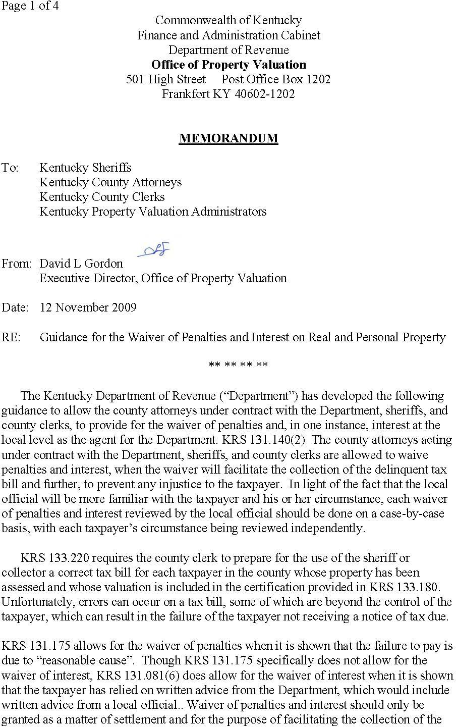

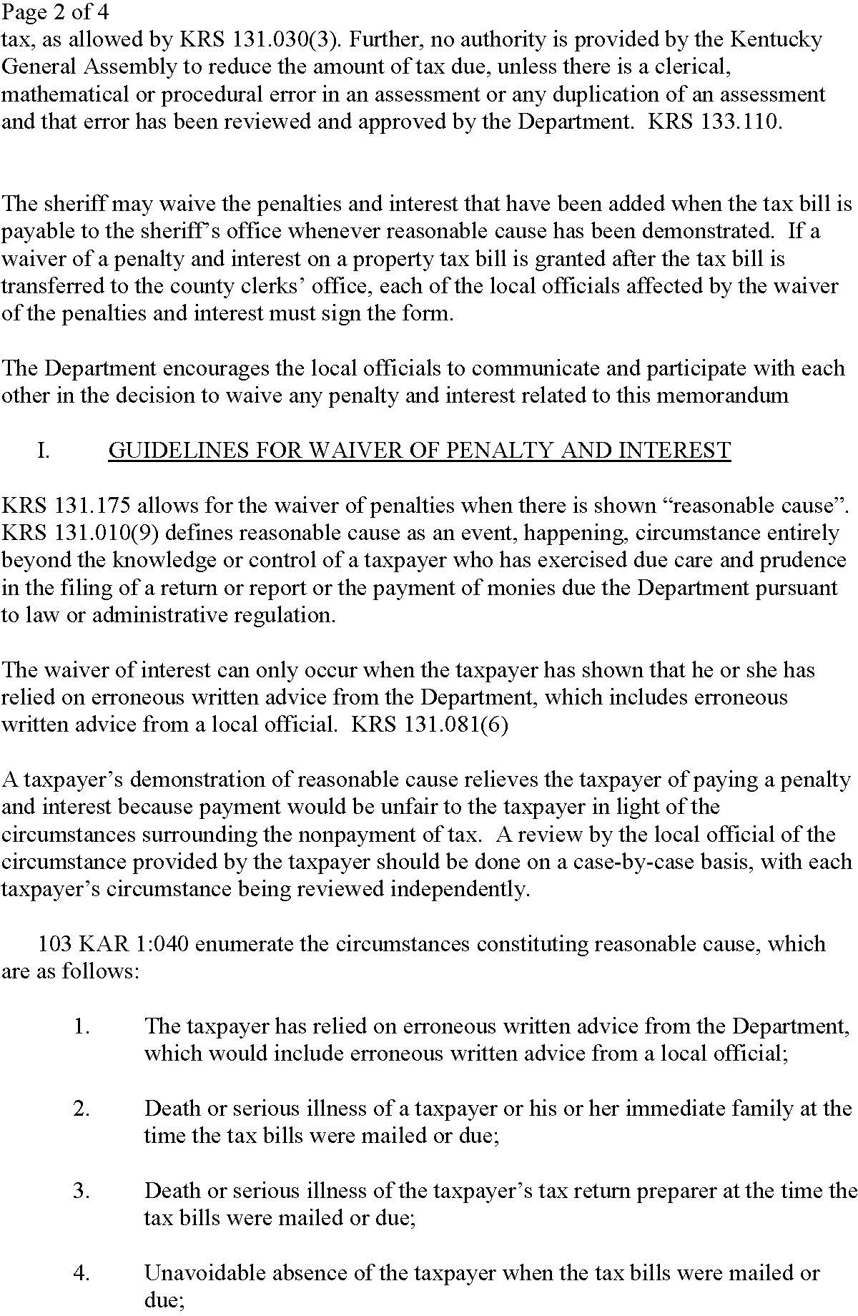

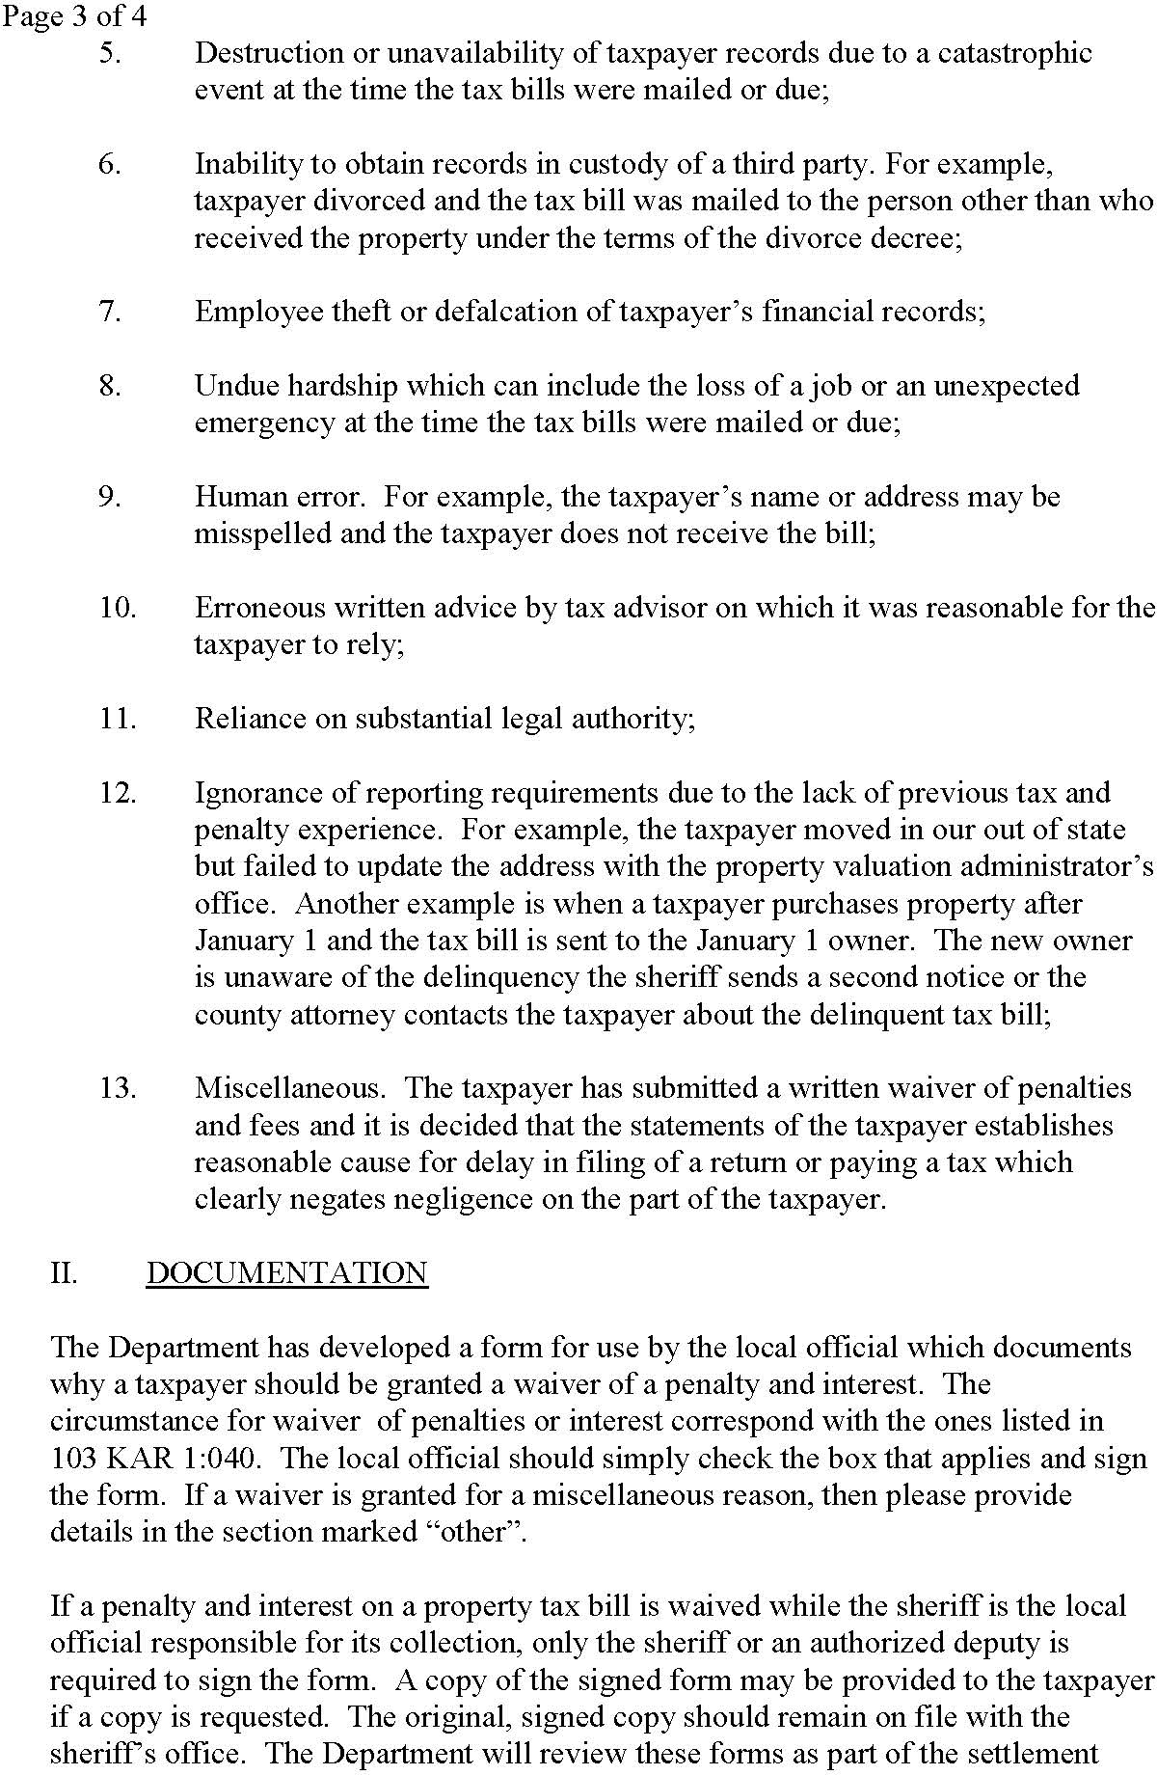

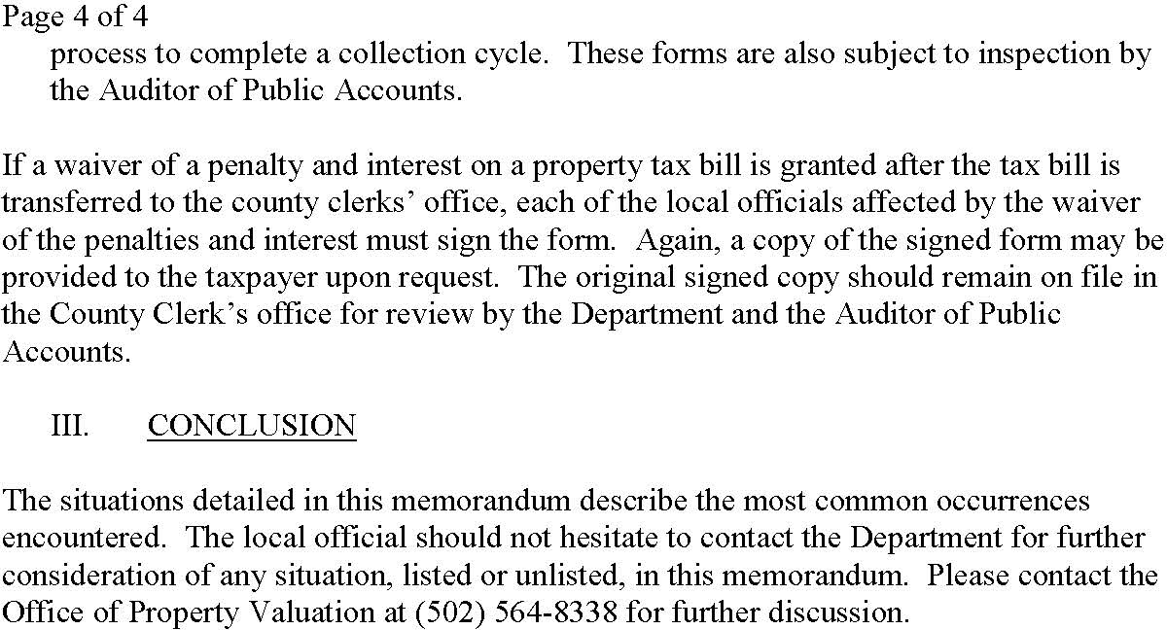

Guidelines for Waiver of Penalty

KRS 131.010(9) defines “reasonable cause” as “an event, happening, or circumstance entirely beyond the knowledge or control of a taxpayer who has exercised due care and prudence in the filing of a return or report or the payment of monies due the Department pursuant to law or administrative regulation”.

A taxpayer’s demonstration of reasonable cause relieves the taxpayer of paying a penalty that the Department of Revenue has properly assessed against the taxpayer because payment of the penalty would be unfair to the taxpayer in light of the circumstances surrounding the nonpayment of tax. The reduction or waiver of penalty for reasonable cause acts as a safety valve to prevent an injustice to a taxpayer when “an event, happening, or circumstance” has occurred that is “entirely beyond the knowledge or control of a taxpayer” and has prevented the timely payment of tax.

The penalty may be waived by the County Clerk in the following circumstances:

- Taxpayer moved (in or out of state), but failed to update address on vehicle at Clerk’s office. Taxpayer unaware of requirement to report this information.

- Taxpayer divorced. Ex-spouse retained marital residence and notice is mailed to ex-spouse.

- Taxpayer sold vehicle, junked vehicle, moved out-of-state or had vehicle repossessed prior to renewal date. Discarded notice as unaware of requirement to pay tax even though no longer owned vehicle.

- Leased vehicle: Notice mailed to leasing company. Lessee states notice was never mailed or was mailed late.

- Taxpayer was unable to pay taxes timely due to financial hardship.

- Unavoidable absence of the taxpayer.

- Death or serious illness of taxpayer or immediate family.

Guidelines for Waiver of Penalty and Reduction of Interest

KRS 131.030(3) states, in part, “. . . The Department of Revenue is encouraged to settle controversies on a fair and equitable basis and shall be authorized to settle tax controversies based on the hazards of litigation applicable to them.”

When it can be verified or logically concluded that the Department or the County Clerk has given incorrect information to the taxpayer, or the taxpayer has been a victim of a human or system error causing him to incur interest which could have otherwise been avoided, the Department should seek to prevent such an injustice by granting a waiver or reduction of penalty and interest as part of a settlement of the matter.

Both penalty and interest may be waived by the Clerk in the following circumstances:

- Penalty and interest has been discharged through a court order. Examples: bankruptcy, settlement of a deceased person’s estate, etc.

- The taxpayer paid or attempted to pay taxes on a timely basis. Examples:
  - Taxpayer mailed in payment. It was postmarked timely.
  - Taxpayer took payment to clerk’s office on a timely basis. The clerk’s office did not process the payment upon receipt.
  - Taxpayer attempted to pay taxes, but terminals were down.
  - Taxpayer goes to clerk’s office and attempts to pay his taxes on a timely basis, but cannot because the PVA’s office is closed. The taxpayer may need a tax segment created, an assessment entered, or a tax situs change.
  - Department of Revenue extends the tax deadline. (Example: tax notices mailed late.)
  - Tax deadline may be extended in a clerk’s office if the clerk’s office closes down. A clerk’s office may close down for bad weather, construction or repairs, a funeral, etc.
  - Programming problems. Examples (a) MOTAX system charges penalty and interest when the Kentucky statutes or Department of Revenue policies indicate no penalty or interest should be charged. (Taxpayer may change the renewal month and the MOTAX system does not update the tax due date to match the renewal month.) (Title is surrendered and taxpayer still owns the vehicle. A title surrender updates the tax due date in the MOTAX system. The title may be canceled for various reasons. The Title Branch may lose the paperwork, the customer did not fill out the paperwork correctly, the clerk’s office failed to file all necessary documents with the Title Branch, etc.). (b) MOTAX system failed to collect taxes at time of renewal.
  - Clerk errors. Examples: (a) Clerk applied taxpayer’s payment incorrectly. Clerk does not apply the payment to the correct vehicle or tax year. (b) Clerk may forget to reverse a tax payment entered by mistake. When this occurs there is no tax due when the taxpayer registers his vehicle because the taxes have already been marked paid.
  - Poor communication between the Clerk and the taxpayer. Confusion of the taxpayer. Taxes were not applied the way the taxpayer intended or thought they were being applied. (Sometimes the customer pays a tax notice assuming it is for another vehicle or tax year.)
  - The clerk remembers providing the taxpayer with erroneous information. Examples: (a) Clerk states the taxpayer has no taxes due when the taxpayer actually does. (b) Taxpayer asks the clerk’s office what the due date is for the payment of taxes and the clerk’s office provides an incorrect date. Usually there is no proof that the clerk’s office provided the taxpayer with erroneous information.
  - Taxpayer requests a partial refund of taxes already paid. Taxes are reversed from the MOTAX system so the PVA can make an adjustment to the assessment, county of tax situs or district. Clerk then recollects taxes, waiving any penalty or interest accrued since the date of the original payment.
  - The clerk faces a dilemma on how to process delinquent tax payments from taxpayers that do not reside in their county. A clerk may quote the tax and penalties due in the MOTAX system at the time the taxpayer contacts them. When the payment arrives several days later the clerk may accept the amount previously quoted to the taxpayer, waiving any penalty or interest charges that accumulated after the date the taxpayer originally contacted the clerk.
  - Taxes were not collected at the time a vehicle was registered because a taxpayer purchased a vehicle prior to the assessment date, but did not title the vehicle until after the assessment date.

https://revenue.ky.gov/ClerkNetwork/Documents/FINALPenaltyWaiverChecklistRELEASED11172009.pdf

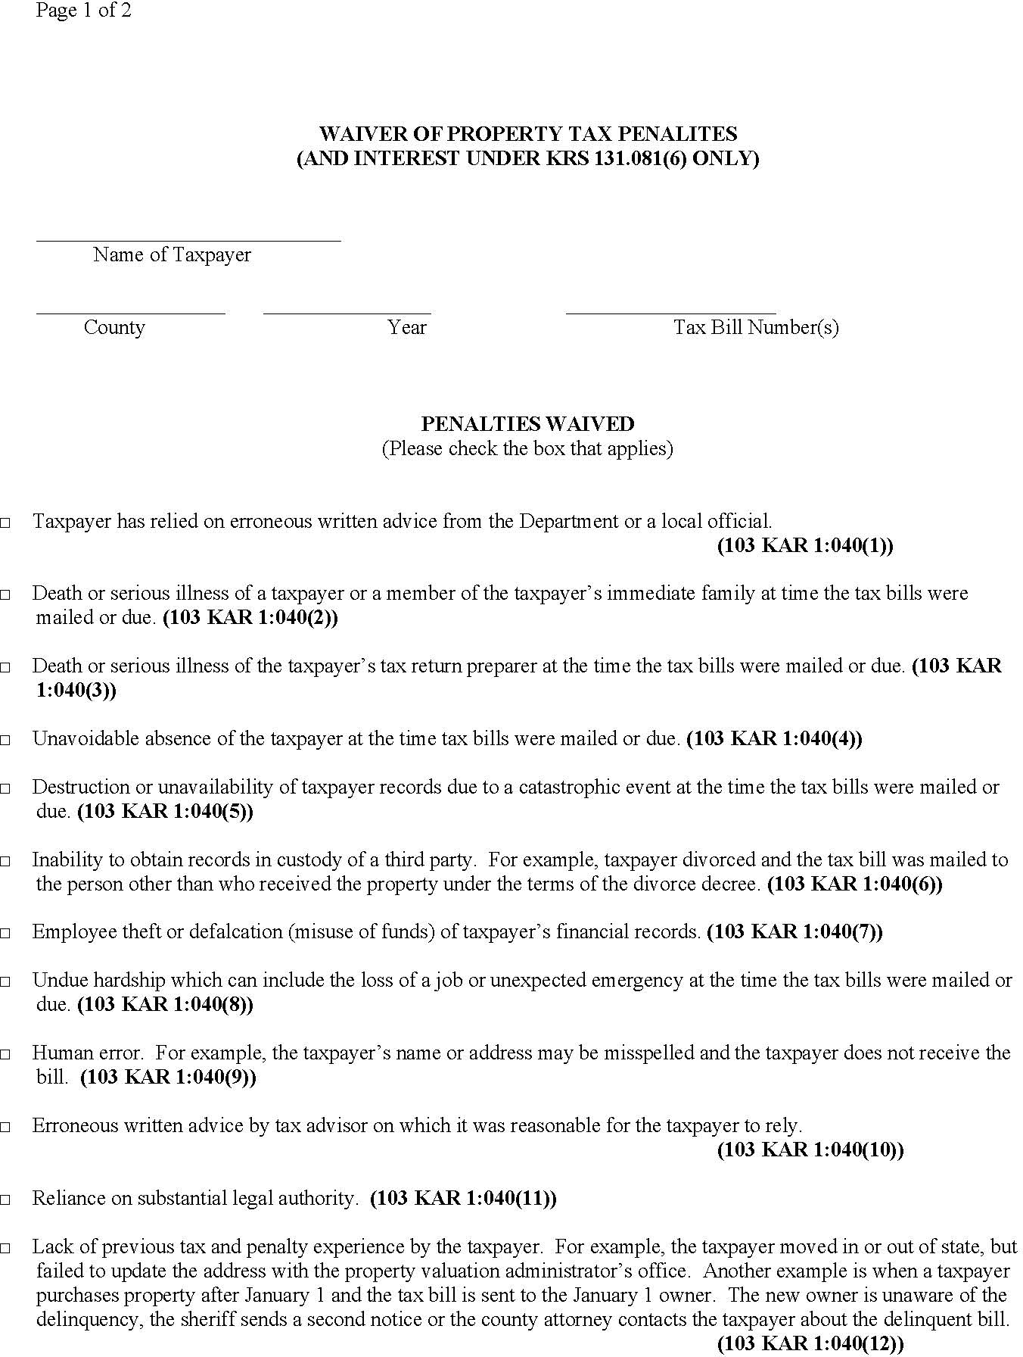

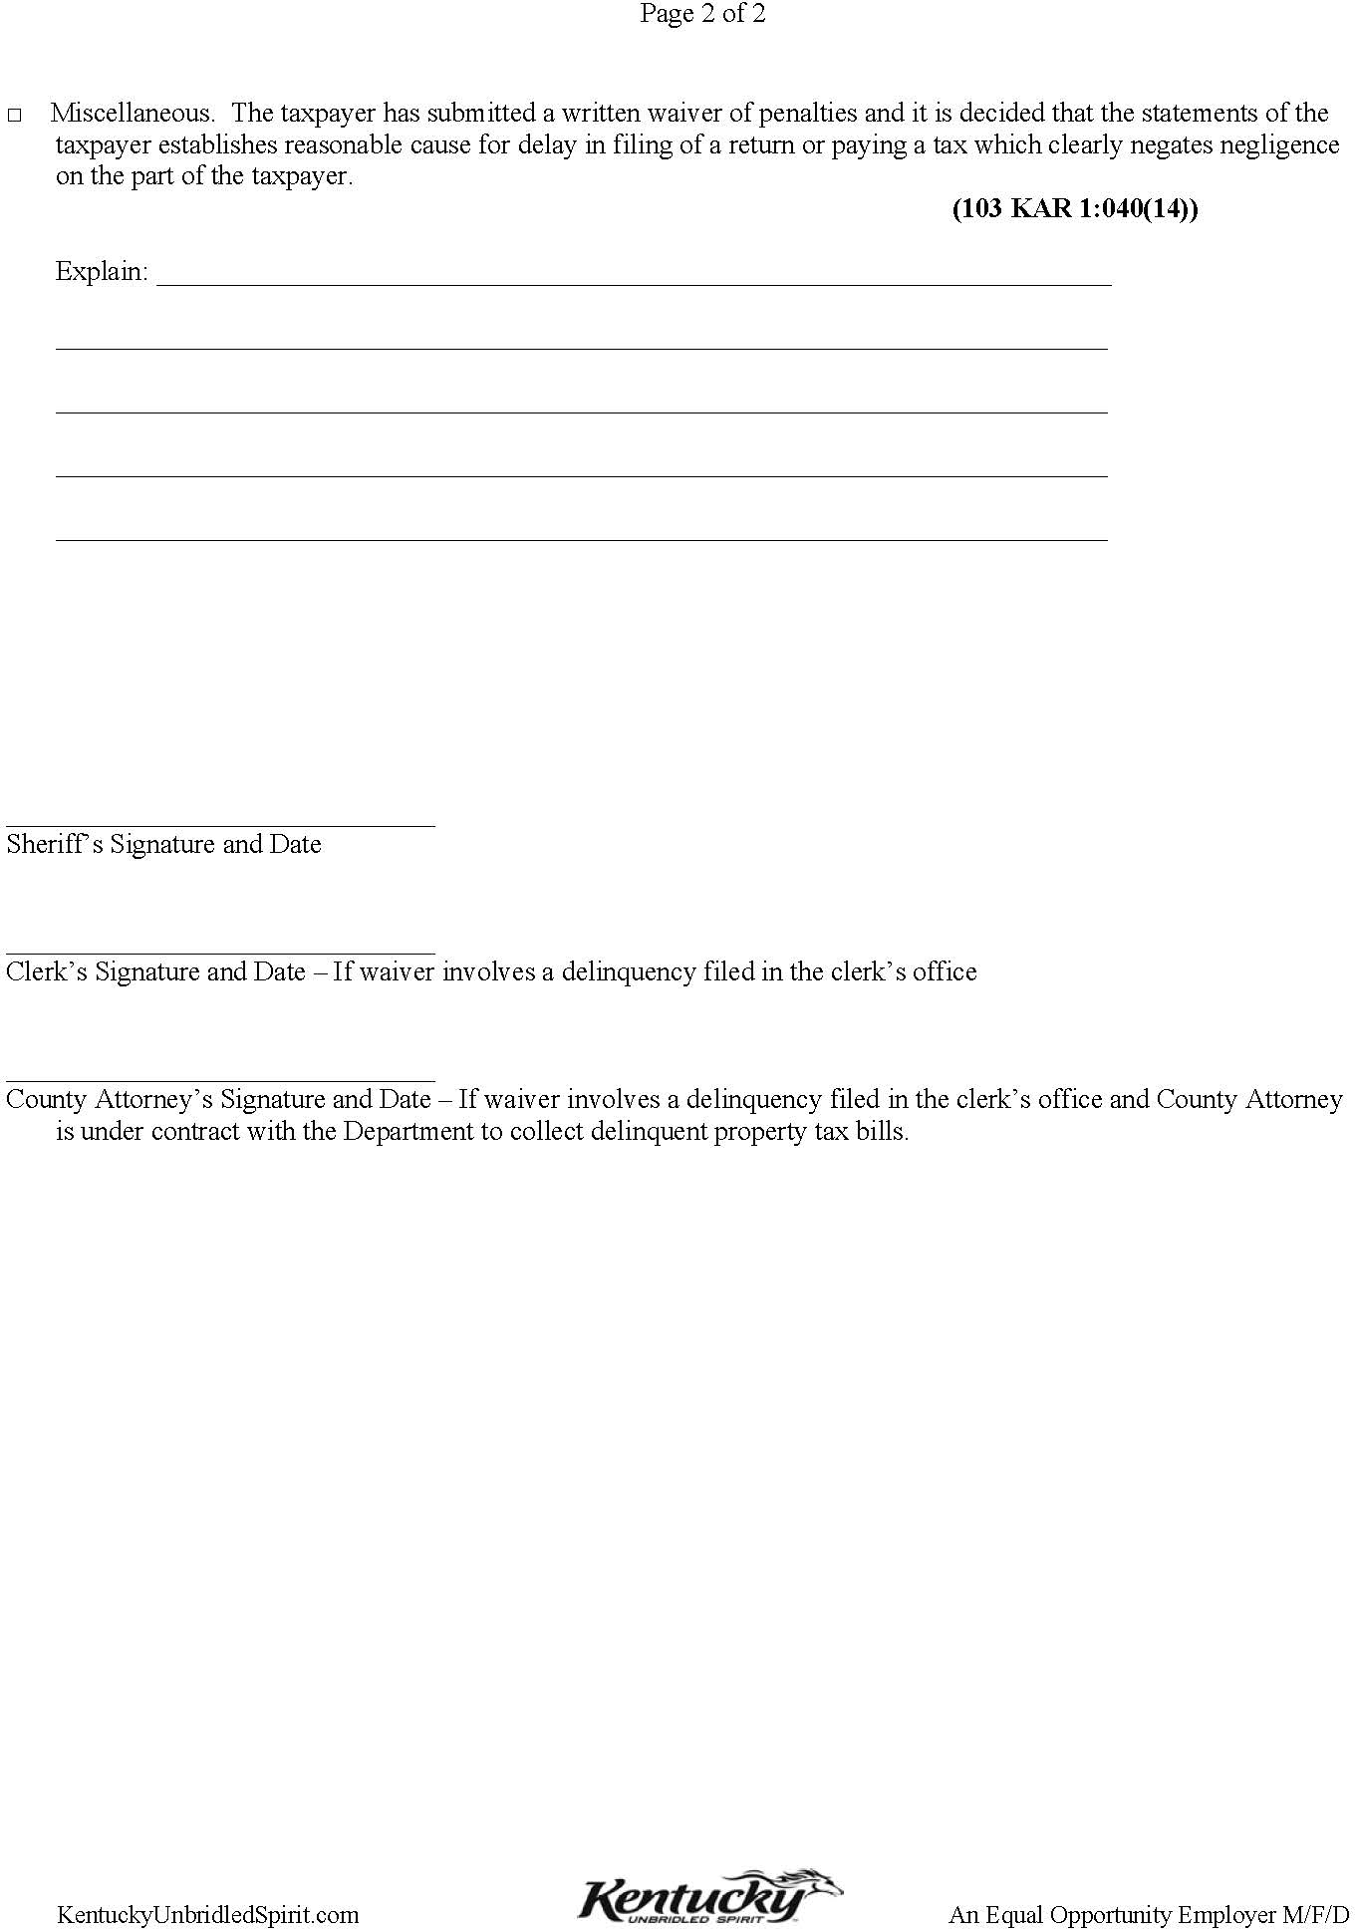

Statute of Limitations
KRS 134.420 provides that the state and each taxing district shall have a lien on the property assessed for taxes due them for eleven (11) years from the date when the taxes become delinquent.
KRS 134.810(1) states that “All state, county, city, urban-county government, school, and special taxing district ad valorem taxes due on motor vehicle shall become delinquent following the earlier of the end of the month in which registration renewal is required by law or the last day of the second calendar month following the month in which a vehicle was transferred.”
If a property tax liability in the MOTAX system meets the qualifications for exoneration, i.e., older than eleven (11) years, the PVA should exonerate the tax. In the event the segment has been purged from the PF3 screen, the PVA or clerk should contact the Motor Vehicle Section at 502-564-8180.
Example #1: In October 2018, the 2007 property taxes were due by September 1, 2007. The 2007 taxes may be exonerated.
Example #2: In October 2018, the 2007 property taxes were due by January 1, 2008. The 2007 taxes must be collected.
Example #3: In October 2018, the 2007 property taxes were due by November 1, 2007. The 2007 taxes must be collected.
132.290 Omitted property, what constitutes -- Periods within which it may be assessed retroactively -- Penalties and interest.
- Any real property which has not been listed for taxation, for any year in which it is taxable, by the time the board of assessment appeals completes its work for that year shall be deemed omitted property. Any personal property which has not been listed for taxation, for any year in which it is taxable, by the due date of that year shall be deemed omitted property.
- All omitted property shall be assessed retroactively in the manner provided by law at any time within five (5) years from the date when it became omitted, but the lien thereby accruing on any such property, except real property, shall not prejudice the rights of bona fide purchasers acquired in the meantime.

Example #1: Taxpayer buys a vehicle/boat on 12/26/2016, the title is not applied for until 1/15/2017. The system will not automatically create a tax segment for the 2017 since the title was applied for after the assessment date January 1. Manual intervention from DOR or PVA can create the tax segment for the 1/1/2017 assessment date, which creates the bill.

Example #2: Taxpayer buys a vehicle/boat on 12/26/2012, the title is not applied for until 1/15/2013. The system created a tax segment beginning with the 2014 year based on the 2013 title. This omitted property is discovered in year 2020 by the PVA or DOR, a tax segment should not be created for 1/1/2013 as it is outside the five (5) year statute of limitations under KRS 132.290.

Tax Due Date
Property taxes are typically due in the month of registration. If a transfer has occurred, the situation is unique. Additionally, certain classes of vehicles and plates have special due dates.
If a vehicle has been transferred within AVIS, the taxes become delinquent following the earlier of the end of the registration renewal month or the last day of the second calendar month following the month in which the vehicle was transferred.
If the customer changes the registration renewal month, the taxes are due and payable within the new registration month. The registration month is the birth or anniversary month of the new owner. This applies to regular plates, personalized plates, and specialty plates.
Large trucks are due in March, boats are due in April, trailers and title only are due in July, and historic and collegiate are in December.
If the system is picking up a wrong tax due date, contact the Motor Vehicle Section for a correction.

Section XI

Frequently Asked Questions

How do I create an ad valorem tax segment?
A tax segment is the format on the PF3 screen that allows a property tax liability to exist. On the PF3 screen if the county code, tax status, assessment, or district does not exist, there is no tax liability in the system.
If you have checked the PF3 screen by using the VIN or the plate #, and there is no tax segment in the system for the vehicle, you must create the segment. Follow these steps:
  - Go to the PF3 screen, Property Tax Vehicle Record Update
  - Type clerk initials
  - Put an “X” beside new
  - Type the plate number or VIN and sequence number (which are the three numbers following the VIN on the PF1 screen)
  - Type the year of the tax segment that is to be made
  - Hit “Enter.” The system should respond “Inquiry complete, ready for data entry.”
  - Type county number
  - Put a “T” for taxable
  - Put January 1 assessment
  - Put override flag #1 for PVA
  - Put the appropriate taxing district in
  - Hit “Enter.” The system should respond, “Transaction completed.”

The property taxes have now been put into the system.
Note: If you are creating a tax segment for the succeeding tax year based on the Bath Vehicle Record Updated information (88 vehicle report), the assessment and override flag is not needed. Enter only the county number, tax status, and district before you hit “Enter.”

How do I change an ad valorem tax segment in the system?
If an ad valorem tax segment exists in MOTAX, follow these steps:
- Go to the PF3 screen
- Type clerk initials
- Type an “X” beside update
- Type the plate number or VIN and sequence number (which are the three numbers following the VIN on the PF1 screen)
- Type the tax year to the changed
- Hit “Enter.” The system should respond “Inquiry complete.” If the system responds “Cannot update, taxes already paid.” Changes cannot be made until the payment is backed out by the clerk.
- Correct the item you wish to change.
- Hit “Enter.”

The changes have now been made in the system.

How do I find a delinquency in the MOTAX system?
When property taxes on a motor vehicle have not been paid by the due date, the system should prevent the taxpayer from registering or transferring any vehicle. All delinquencies must be paid before renewal of the registration on a vehicle can be performed by the clerk. When a taxpayer inquires about delinquencies, their SSN should be screened to see if they are delinquent. The clerk may circumvent this procedure to comply with KRS 186.021(2).
As long as all their vehicles have the same SSN on the title, you can find out if they are delinquent. If a vehicle is jointly owned, both SSNs should be screened. Follow these steps to inquire about a delinquency:
- Go to the PF5 screen, Ad Valorem Delinquency Inquiry
- Type clerk initials
- Type SSN
- If the party is delinquent, this screen will tell exactly which vehicle property taxes have not been paid on.

What if a delinquency of someone else displays on the screen?
- Go to the PF1 screen
- Bring up the vehicle showing delinquency
- If a wrong SSN is on record, contact the clerk who made the error and have it corrected
- If the taxpayer is using the wrong SSN, have the clerk correct their record.

The SSN may be correct and the delinquency may be the customer’s liability. The spouse may have had a different last name when the delinquency occurred. If so, the delinquency shall be paid.

How do I find a social security number?
Sometimes an incorrect SSN is entered into the tax record and must be corrected. The PVA has access to AVIS and tangible property tax screens. The Department suggests that if the clerk cannot locate the correct SSN within AVIS or voter registration records, the PVA should search the screens that are

accessible to them. The clerk does not have access to the tangible screens, so they should work with the PVA to find correct SSNs. SSNs may also be found by pulling up the original title application. A clerk may have made a data entry error or the SSN may have been changed after the title was issued (such as under House Bill 40).
Many times a wrong SSN in AVIS will prevent an applicant from registration renewal or title transfer from completing their transaction. If the applicant was not the owner of the delinquent account, the SSN on such account shall be corrected. If it is not corrected, the delinquency will continue to show up against this number.
Once the correct SSN has been located, follow these steps:
- If title and registration on the delinquent account is active, the number can be corrected by anyone. It is not necessary to contact the county clerk of issuance.
- If the title and registration is cancelled or surrendered, contact the Motor Vehicle Section for assistance. Please try and locate the correct SSN before contacting the Department.

Upon completion of either of the two steps above, the applicant may complete their transaction.

How do local jurisdictions set motor vehicle and watercraft tax rates?
Annually, the Department provides a Projected Monthly Collections Report to each PVA. This report includes a breakdown by tax jurisdiction of total assessment and taxes to be collected for the current year.
The tax roll for motor vehicles and watercraft are printed separately from all other property to allow the taxing jurisdictions to obtain the assessment from the PVA prior to the certification process. When a taxing jurisdiction inquires as to its assessments to set the succeeding year’s tax rates, the PVA should inform them of such assessments from the Projected Monthly Collections Report. The Department attempts to have this report in the PVA’s possession by mid-May. The Department has separate tax rolls for vehicles and for watercraft. They are both uploaded onto Move-It.
Per KRS 132.487(2), “All counties, schools, cities, and special taxing districts proposing to levy an ad valorem tax on motor vehicles shall submit to the department on or before October 1 of the year preceding the assessment date, the tax rate to be levied against valuations as of that assessment date. Any district that fails to timely submit the tax rate shall receive the rate in effect for the prior year.”
KRS 132.487(2) also limits the tax rate on motor vehicles to not exceed the rate that could have been set by the jurisdiction on January 1, 1983 assessments.
The Department of Revenue and the PVA do not set tax rates. Nor is either party responsible for policing of the jurisdictions in setting these tax rates.

How do I determine legal owner for property tax purposes?
As required by the Kentucky Constitution, all property with situs in Kentucky on January 1 shall be assessed for ad valorem tax. When dealing with tangible property such as motor vehicles and trailers, it is often difficult to procure proper information to clarify the legal owner for tax purposes. Therefore, KRS 134.810(4) requires the Department of Revenue to assess the owner of record as of January 1. The Department assumes that if the title is active in a person’s name that they own the vehicle. If they do

not own the vehicle, then they have not legally transferred the vehicle. Therefore, the burden of proof of non-ownership is upon the owner of record.
Failure by the owner of record to provide proper documentation as outlined in this manual shall require the clerk to collect payment of the tax liability.

Transactions prior to January 1 where title is not requested until after January 1.
At the end of each year, mainly December, when owners are trading vehicles with dealers, the PVA needs to make sure that when the owner of record provides proof that the vehicle was traded in prior to January 1 of the tax year that the Vehicle Transaction Record (VTR) is secured from PODD or the clerk’s office. When the VTR is presented, the PVA should exonerate the ad valorem tax on the PF3 screen on the vehicle that was traded in. However, the PVA must create an ad valorem tax segment for the newly purchased vehicle, since the taxpayer did own it on January 1 of the tax year. The PVA and Clerks office should attempt to work together on behalf of the taxpayers to make sure transactions where vehicles were purchased prior to year-end and not titled until after the assessment date are properly recorded in the system. The Department attempts to check VTRs for proper payment of tax but it would be more efficient when the title is requested if the date of sale was prior to January 1 the Clerk would send to PVA or provide copies so the segments could be corrected.
For steps on exoneration of property tax, refer to Section IX that outlines the steps and proper documentation needed for sold out-of-state, military exemptions, and non-resident of Kentucky on January 1.

Why does the Department of Revenue create tax segments on vehicles that were coded “N” (non-taxable) for the previous year?
The Department is required to create ad valorem tax segments on any vehicle that is legally titled and registered in the Commonwealth. A vehicle that may not have been in Kentucky on January 1, 2017, may be in Kentucky on January 1, 2018.
The allowance of the “N” status code for non-resident military requires the Department to make segments. Due to residency changes, such as military personnel who decide to remain in Kentucky after completion of their military service, the Department cannot assume that all variables will remain the same from year to year. The burden of proof for such exoneration is upon the taxpayer. Only upon proof of non-residency or location of the vehicle shall the PVA exonerate the ad valorem tax liability.
However, the Department does understand the problem of having to exonerate the same vehicle taxes every year. Use of the tax status codes “J” for junk, “S” for sold, “M” for mobile homes, and “V” for stolen and not recovered can help alleviate the continuous use of the “N” code.

How does the taxpayer remove a junked vehicle from the system?
KRS 186A.335 requires that a salvage title be obtained by any owner of a vehicle which is deemed to have damages of seventy-five percent (75%) or more of the J.D. Power average retail value. Such a vehicle shall be removed from the highways of Kentucky.
The County Clerk is forbidden to issue a registration for a salvage title vehicle. However, the Department of Revenue and PVA are required by the Kentucky Constitution to assess all property in the Commonwealth on January 1 of the tax year. If a salvage title is obtained in accordance with KRS 186A.335 prior to January 1 of the tax year, the Department will automatically assess the vehicle at

twenty-five percent (25%) of the average retail value of the January J.D. Power guide. If the owner of the property feels that this is not the fair cash value of the vehicle, they should provide documentation to support the FCV.
To avoid liability for property tax on a salvage title vehicle, the owner must inform the PVA that they have no plans to rebuild or restore the vehicle. Using the tax status code “J” on the PF3 screen will eliminate the tax liability.
Once a “J” code has been entered on the PF3 screen, the system will not electronically create a tax liability on the vehicle. When the vehicle has been repaired or rebuilt, or when the owner applies for a new registration, the applicant will be required to pay all previous years’ taxes. AVIS is currently programmed to stop the application for title and/or registration until the “J” code is removed from the tax segment(s). This will require the PVA to determine who the legal owner of such property is during the tax years in question and the value for each year. No penalty or interest will be waived for such occurrences.

What is the proper procedure for eliminating a tax on a vehicle that was sold out-of-state or sold to a Kentucky resident prior to January 1 of the tax year?
The Department and PVA must assess all vehicles in the state as of January 1 of the tax year. When a vehicle is sold out-of-state, it sometimes takes months to surrender the title in AVIS. To alleviate this problem, the Department recognizes the County Clerk’s codes for vehicles sold out-of-state.
If a taxpayer says they sold a vehicle out-of-state or have moved out of state, they need to provide the proper documentation. If a vehicle was sold out-of-state prior to January 1 of the current year, the current tax year tax segment should be coded an “S.” If the vehicle was sold out-of-state after January 1, the succeeding year’s tax segment should be created and coded with an “S.”
If the vehicle was sold out-of-state after January 1 of the tax year in question, instruct the taxpayer that they are liable for the tax and should pay the County Clerk. After payment of the tax liability, the clerk should properly code the system with “CCG.” This statement in no way eliminates the Transportation Cabinet’s requirement for the clerk to enter the “CCG’ on the record.

Why do mobile homes continue to have taxes in MOTAX?
By law, all mobile homes are required to be titled and transferred through AVIS. Without a proper way of identifying a mobile home to be able to delete such property from the system before the creation of ad valorem tax segments, the Department continues to create tax segments within MOTAX for mobile homes. However, mobile homes are considered real estate and should not be taxed through MOTAX.
Utilizing the “M” tax status code will help the Department, clerks, and PVAs to avoid the creation of ad valorem segments for future years. The Department suggests that the PVA be notified when a clerk transfers or titles a mobile home. The PVA can then create the succeeding year’s tax segment and code it with an “M.” The will eliminate the creation of a tax segment by the Department in the future.

Why are most property tax values different from the usage tax value?
KRS 138.460 requires the Department of Revenue assess the motor vehicle usage tax with the value based on the month in which the vehicle is purchased or sold. KRS 138.450 sets the valuation. The valuation depends upon the month of the purchase or sale, relationship of both parties involved in a transfer or ownership, whether previously Kentucky licensed, and whether a trade-in was involved.

The property tax is a constitutional tax that requires the PVA to assess as of January 1 of each year. The January 1 value is determinative even though the tax is paid within the renewal month. The Department must adhere to the Constitution and continue to enforce the Department’s policies.
The Motor Vehicle Usage Tax Section of the Department of Revenue can be reached at 502-564-4455.

What do I tell the taxpayer to do if their vehicle has been repossessed prior to January 1 of the tax year?
KRS 134.810(4) provides the new owner of record is liable for the property taxes on a vehicle. KRS 186A.215 requires the new owner to transfer a vehicle within fifteen (15) days.
Per KRS 286.10-275, the original vehicle owner has twenty (20) days “...to redeem the titled personal property by paying all principal, interest, and fees owing to the title pledge lender, including all repossession and storages fees…” If this is not completed within the provided time frame, the title is transferred to title pledge lender, typically a financial institution.
The taxpayer is only absolved from liability if they did not redeem the motor vehicle by fulfillment of all obligations secured by the motor vehicle. If the vehicle was repossessed after January 1 of the tax year, the taxpayer remains liable for the property tax and should advise the clerk of the incomplete transfer.
If the vehicle has not been legally transferred, through AVIS, to the financial institution or new owner’s name prior to January 1 of the tax year, the taxpayer should provide a letter from the financial institution stating the date of repossession.
If the title has been transferred through AVIS into the financial institution or new owner’s name after January 1 of the tax year, the tax liability for such tax year should be that of the financial institution as long as the proper documentation is supplied. The PVA may contact the Motor Vehicle Section to correct the tax segment.
If no transfer has occurred through AVIS, the taxpayer should notify the clerk in accordance with KRS 186A.215(4). The clerk shall properly code the AVIS system that will eliminate the creation of a tax segment in the taxpayer’s name.

How does a taxpayer protest an assessment?
KRS 131.110 requires a protest of assessment be handled by the Department of Revenue. The PVA is considered an employee of the Department of Revenue and is required to expedite the protest on behalf of the Department. The PVA may reassess a vehicle based upon high-mileage or condition of the vehicle.
- The taxpayer must speak with their local PVA regarding the value and provide relevant documentation to the PVA.

- If this cannot be resolved locally, they can file a written protest with the Department within 60 days of the notice.

Note: 60 days ends on the last day of the renewal month. (Ex: Renewal is due in March, March 31st is the last day to file a written protest with the department.)

What should be submitted for the protest?
- A letter indicating what they are appealing and their justification.
- Verifiable documentation to support the claim. Taxpayers must provide documentation to support their claims, or it is not a valid protest in accordance with KRS 131.110.
- Form 62A044 from the PVA stating reason why no valuation adjustments made. Without a signed 62A044 the taxpayer will be referred to the PVA as the form lets the Department know that the taxpayer completed the 1st step of the protest procedure. The PVA should sign and provide the form to the taxpayer with instructions to send in with protest and documentation. Form 62A044 can be found on the DOR website.
- The protest must be postmarked within 60 days, as indicated in #2 above.

Mail to: Department of Revenue
Motor Vehicle Section, Division of State Valuation 501 High Street, Station 32
Frankfort, KY 40601
Protests may also be faxed to 502-564-8192.
Many times, taxpayers wait until the last day of the renewal month to protest their vehicle value to the PVA, which can result in additional delinquency fees if the property tax and registration fees are not paid timely. The taxpayer should remit payment of the full amount of property tax and registration fees owed to the County Clerk prior to the last day of the renewal month. Payment of the taxes and registration fee does not extend the protest period. Sometimes it may take weeks to settle the protest in Frankfort, and if the taxpayer has not timely paid the tax liability and registration for their vehicle, not only are they are subject to delinquent tax charges, but they can also be cited by law enforcement for having an expired registration.
Upon receipt of the written protest, the Department will review the documentation and send a letter to the taxpayer with the Department’s decision. If the taxpayer prevails, they can then receive a refund from the office in which the tax was paid. The County Clerk will be notified of the valuation adjustment and will be provided authorization to refund any applicable overpayment.
Any request for a penalty waiver shall also be in writing to the Department. KRS 134.805(5)(d) states: “Non-receipt of the notices required herein shall not constitute any defense against applicable penalty, interest, lien fees, or costs recovery.” The notices mentioned in this statute are the motor vehicle property tax notices.

How does the Department of Revenue program AVIS once the PVA codes the tax segment with “T”, “E”, “M”, “S”, “V”, or “J”?
Depending upon which code is on the segment at the time of the creation of the succeeding year’s tax segment, the Department will proceed with the following procedures:
A 2018 tax segment is being made at the end of the 2017 calendar year.
If the 2017 tax segment has an “M”, “E”, or “V” code, the 2018 segment will not be created. However, upon change of ownership the current code shall be overridden for the next year. In becomes necessary for the PVA to watch for the change of ownership on the Batch Vehicle Record Update report.

If the 2017 tax segment has “T” code, then as long as the title is active, the Department will create a 2018 segment.
If the 2017 segment has an “S” or “J” code and there has been no transfer of ownership the Department will not create a 2018 segment. Upon transfer of this vehicle, the transfer will be halted so that the PVA can correctly code the “back” year tax segment. At that time, the PVA must make a determination if the vehicle is taxable or not for the years that have been coded “S” or “J.”

What are the tax codes that may be used in the MOTAX system? What are their purposes?
Code Purpose
T Taxable
E Exempt
M Mobile Home
S Sold out-of-state, moved out-of-state, sold to KY resident but has not been transferred in AVIS, or sold to non-Kentucky auto dealer (all sales must have occurred prior to January 1 of the tax year in question)
N Nontaxable
J Junk (not road-worthy)
V Stolen

Can the PVA set a minimum value on a vehicle which has a salvage title?
Yes, the PVA shall assess the motor vehicle at fair cash value. If the owner has secured a salvage title in accordance with KRS 186A.335, which requires the loss of at least seventy-five percent (75%) of the J.D. Power value, then the vehicle may not be operated on Kentucky highways and a registration cannot be issued by the County Clerk. The PVA must verify that the vehicle has lost at least 75% of its J.D. Power retail value. The PVA must assess the vehicle at fair cash value.
The Department does not wish for any PVA to interpret this procedure for allowing a set value on salvage titled vehicles as procedure for any other vehicle. The law regarding salvage titles must be complied with prior to the salvage assessment being entered into the MOTAX system.

Should the PVA exonerate property taxes on a vehicle which has been sold, but has not legally been transferred to the new owner in AVIS?
Upon receipt of proof of the sale, the PVA should code the tax segment “S” for the tax year if the vehicle was sold prior to January 1 of the tax year and not legally transferred within the AVIS system. A copy of the Vehicle Transaction Record (VTR), bill of sale, or an affidavit (Affidavit for Correction/Exoneration of Motor Vehicle/Boat Property Tax) shall serve as proper documentation for the exoneration.
If this situation occurs, the PVA must inform the customer to visit the County Clerk’s office for proper coding of the AVIS record. The clerk will use the “CCL” code, eliminating the creation of a property tax segment for the next year unless the transfer occurs.

Once the new owner transfers the title into their name, the system will automatically create the succeeding year’s tax segment. However, to collect the taxes from the new owner for the years in which they legally possessed the vehicle but did not have it titled as such in AVIS, the PVA should enter the segments in the AVIS system.

If a customer has no proof as to why a property tax should be exonerated or an assessment lowered, what is the PVA required to do?
In accordance with KRS 134.810(4) and 132.220(1) the owner of records as of January 1 of the tax year is liable for the property tax for the tax year. A person in whose name the vehicle is assessed shall provide proper documentation to the PVA before they will exonerate any tax liability.
In regard to the assessment, KRS 131.110 requires that all protests be accompanied with a supporting statement. The Department attempts to assess all motor vehicles at the fair cash value. If the customer disagrees with such value, the PVA is authorized to correct the assessment to the J.D. Power or applicable guide value, within the guidelines for assessments listed herein. If the customer does not agree with the assessment made by the PVA, they may protest in writing to the Department within the sixty (60) day protest period.

If a vehicle has ownership by a church and an individual (joint ownership), is this vehicle exempt from property taxation?
If the church is listed as “Owner 1” the vehicle is exempt from property taxation. If the individual is listed as “Owner 1” the vehicle is taxable.

Can the PVA change an apportioned vehicle to taxable on the PF3 screen?
Yes. If the segment was made an “A” by the electronic system (Frankfort) the taxes are marked paid with $0.00 payment. First, the clerk would need to reverse the $0.00 ad valorem payment. This will then allow the PVA to change the “A” to a “T.” The clerk should then be able to collect the proper tax amount.
If a customer filed bankruptcy and lists the Department of Revenue and/or the County Clerk on the petition, should the PVA exonerate the property tax?
No. The list of the Department of Revenue and/or the County Clerk only initiates an “automatic stay.” The “automatic stay” means that neither the Department nor the clerk shall enforce the taxing laws on the listed debts until the bankruptcy is discharged (complete).
The clerk is allowed to release the clerk’s lien on the vehicle listed on the petition for bankruptcy. However, the clerk or PVA should advise the customer that upon discharge of the bankruptcy, the tax, penalty, and interest as of the date of payment may be collected. See the Bankruptcy section for more information.

Can the PVA or deputy deny the use of an affidavit to exonerate or reassess property?
Yes. If the PVA has knowledge that the owner is not telling the truth, the PVA shall deny the affidavit. The PVA may also inform the customer of the penalty for making false statements under KRS 523.100.

KRS 523.100 Unsworn falsification to authorities.

- A person is guilty of unsworn falsification to authorities when, with an intent to mislead a public servant in the performance of his duty, he:
  - Makes a material false written statement, which he does not believe, in an application for any pecuniary or other benefit or in a record required by law to be submitted to any governmental agency;
  - Submits or invites reliance on any writing which he knows to be a forged instrument, as defined in KRS 516.010; or
  - Submits or invites reliance, except as provided in KRS 516.110, on any sample, specimen, map, boundary mark, or other object he knows to be false.
- Unsworn falsification to authorities is a Class B misdemeanor.

If a vehicle has been seized by a governmental agency, who is the legal owner for tax purposes? Upon seizure by any governmental agency of any motor vehicle, the owner as of the date of the seizure is the governmental agency. Since the governmental agency is exempt from property taxation, the PVA shall code the motor vehicle with an “S” if seized prior to the assessment date.
If the motor vehicle was seized after the assessment date, the owner of record shall be held liable for the property tax.

What is a documented boat?
A documented boat is any watercraft that meets the five (5) net tonnage weight requirement and is registered with the United States Coast Guard. It has to have its registered name displayed on both sides and the stern of the vessel along with its port of call.

Are documented boats required to be registered and titled with the County Clerk?
No. Documented boats are only registered with the US Coast Guard and do not need a KY#.

Are documented boats taxable?
Yes. Documented boats with Kentucky situs on January 1 of the tax year are required to be listed on the Tangible Personal Property Tax Return, Revenue form 62A500-W. The documentation provides a discounted state rate of 1 ½¢ per $100 of value instead of the standard 45¢ per $100 of value. They are also subject to any applicable local rates. If you have any questions concerning documented boats, including assessments, please contact the Personal Property Omitted Section at 502-564-2557.

Under the confidentiality rules, can the Department or PVA disclose a person’s SSN or a company’s FEIN to the County Clerk?
For purposes of correcting an account number (SSN or FEIN) in the MOTAX system, the PVA or Department may disclose the account number to the clerk.

What is to be considered household goods for MOTAX?
Property such as dirt bikes, mini-bikes, go-carts, snowmobiles, four-wheelers, and three-wheelers should not be assessed within the MOTAX system. However, an exemption from taxation in the MOTAX system does not exempt these type vehicles from being taxed as tangible personal property of a business.
Wave-runners, jet skis, boat trailers, racing cars, and trailers shall be assessed in the MOTAX system.

What is to be considered agricultural property and exempt from taxation in the MOTAX system? Farm equipment such as farm tractors, hay balers, wagons, corn-pickers, horse trailers, and stock trailers shall not be assessed in the MOTAX system.
This equipment is not subject to tax in the MOTAX system if the property is used mainly for farming purposes. Equipment as listed above used in business activity shall be assessed and taxed in MOTAX.
KRS 132.200 Property subject to state rate only.
All property subject to taxation for state purposes shall also be subject to taxation in the county, city, school, or other taxing district in which it has a taxable situs, except the class of property described in KRS 132.030 and the following classes of property, which shall be subject to taxation for state purposes only:
- Farm implements and farm machinery owned by or leased to a person actually engaged in farming and used in his farm operation…

All farm equipment and livestock owned by or leased by a person actually engaged in farming and used in agricultural or horticultural farm operations are subject to the state rate only of 1/10¢ per $100 of assessed value.
This group consists of properties such as tractors, combines, plows, disks, planters, farm tools, and domesticated animals (including race horses). Although this type of tangible personal property is not specifically exempted from taxation by the Constitution, it is the position of the Department of Revenue that the 1/10¢ state rate constitutes a de facto exemption that the General Assembly passed with the intention of removing the tax burden from owners of this type of property. Thus, taxpayers who fail to list this property on the Tangible Personal Property Tax Return are not subject to compliance programs, nor is the Property Valuation Administrator required to enter all such data that is filed locally. As a procedural matter, only very large assessments, which would justify the costs of collection, should be entered.
What is Freddie Freeroader?
Freddie Freeroader is a program in the Motor Vehicle Property Tax Section of the Office of Property Valuation which attempts to assess property tax and usage tax, if applicable, on those Kentucky residents who have failed to register their vehicle in Kentucky. It is not a system to report expired tags.
If anyone spots a Kentucky resident driving on out-of-state plates they may call (800) 590-3921 and/or access www.tipline.ky.gov to submit a tip and have the information delivered to the department. The tip should include a response to the provided questions and include the plate number, state of issuance, a brief description of the vehicle, the owner’s name and address, and how long the vehicle has been at the address in order for the staff to locate pertinent information and determine if the owner is a Kentucky resident.
https://revenue.ky.gov/Property/Pages/Freddie-Freeroader-Program.aspx

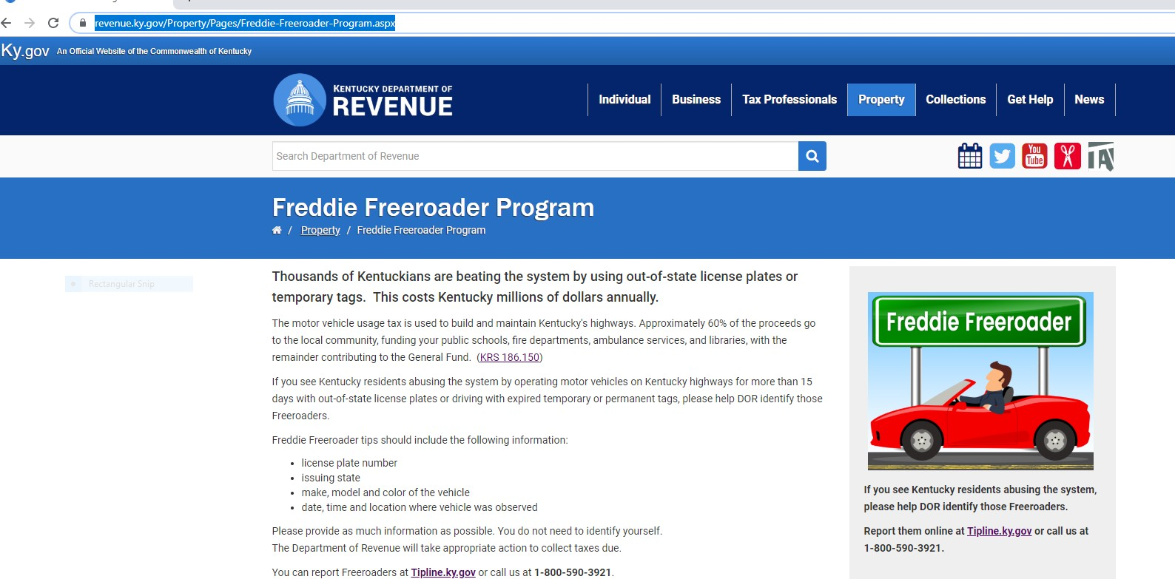

Section XII

Useful Websites

https://drive.ky.gov/ - Service of the Kentucky Transportation Cabinet. Useful for title, registration, or renewal of a vehicle or vessel. Taxpayers can look up their previous year’s tax paid.
https://revenue.ky.gov – Department of Revenue’s website.

https://revenue.ky.gov/pvanetwork/Pages/default.aspx - PVA Network

https://revenue.ky.gov/clerknetwork/Pages/default.aspx - Clerk Network

https://revenue.ky.gov/Property/Pages/Freddie-Freeroader-Program.aspx - Freddie Freeroader program.
https://revenue.ky.gov/Property/Motor-Vehicles/Pages/Motor-Vehicle-Property-Tax.aspx – Motor Vehicle Section of the Office of Property Valuation.
https://legislature.ky.gov/Pages/index.aspx – Useful when looking up specific laws or statutes.

https://www.rvt.com/price-checker/index.php?searched=true – Useful when looking up price ranges for recreational vehicles.
www.tipline.ky.gov – Commonwealth of Kentucky tip line portal for Freddie Freeroader and other fraudulent and unethical activity
https://transportation.ky.gov/motor-vehicle-licensing/Pages/kavis2-pva.aspx -- PVA Manuals and Support Documentation for KAVIS (Boats)

Section XIII
Phone Numbers
Ombudsman (Revenue) |  | 502-564-7822
Motor Vehicle Section (Property Tax) |  | 502-564-8180
 | Fax | 502-564-8923
Freddie Freeroader (Tip Line) |  | 800-590-3921
Motor Vehicle Usage Tax (Revenue) |  | 502-564-4455
 | Fax | 502-564-2906
Motor Carriers, Vehicle Services (Title and Registration) & Driver Services |  | 502-564-1257
Kentucky Transportation Cabinet General Information |  | 502-564-7925
Help Desk (Revenue) Access Issues, password resets |  | 502-564-7576
Bankruptcy (Revenue) Collections Branch |  | 502-564-4921
Thomas Wolfe |  | 502-564-4028
Jennifer Howard |  | 502-564-4416

Section XIV Access to Systems

Computer Access Form

Please find the attached updated Computer Access Form. Please complete one for each employee that needs access. This is a fill in form and the “Submit button” will send the completed form to Lori Phillips.
The fill in form is located on the PVA Network https://revenue.ky.gov/pvanetwork/Pages/default.aspx

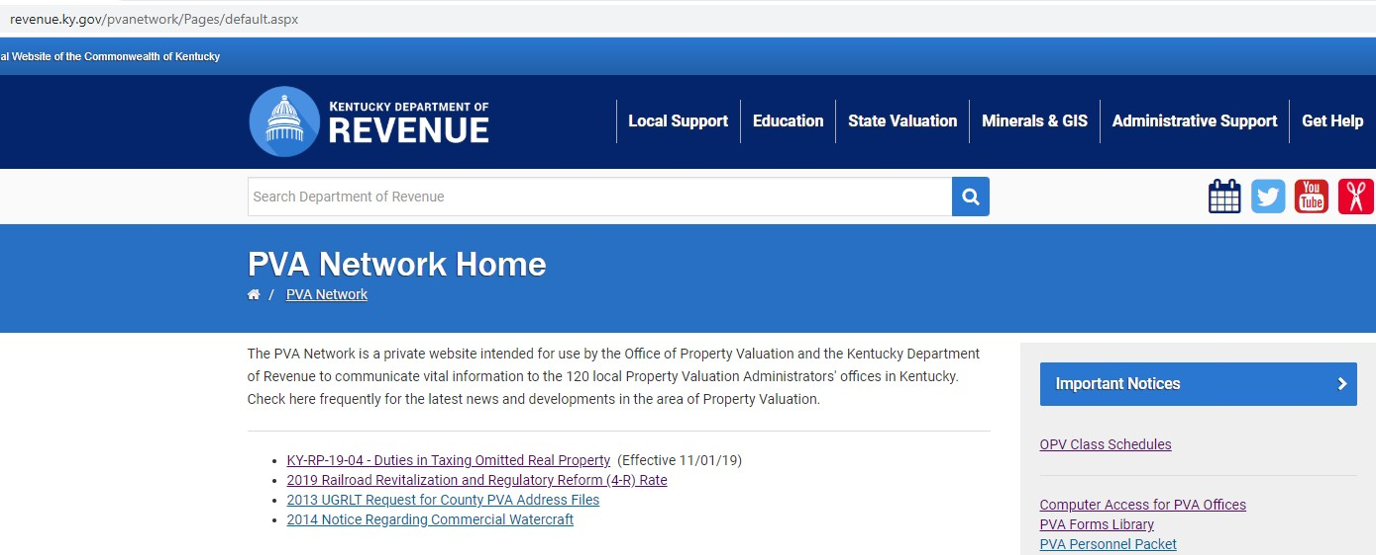
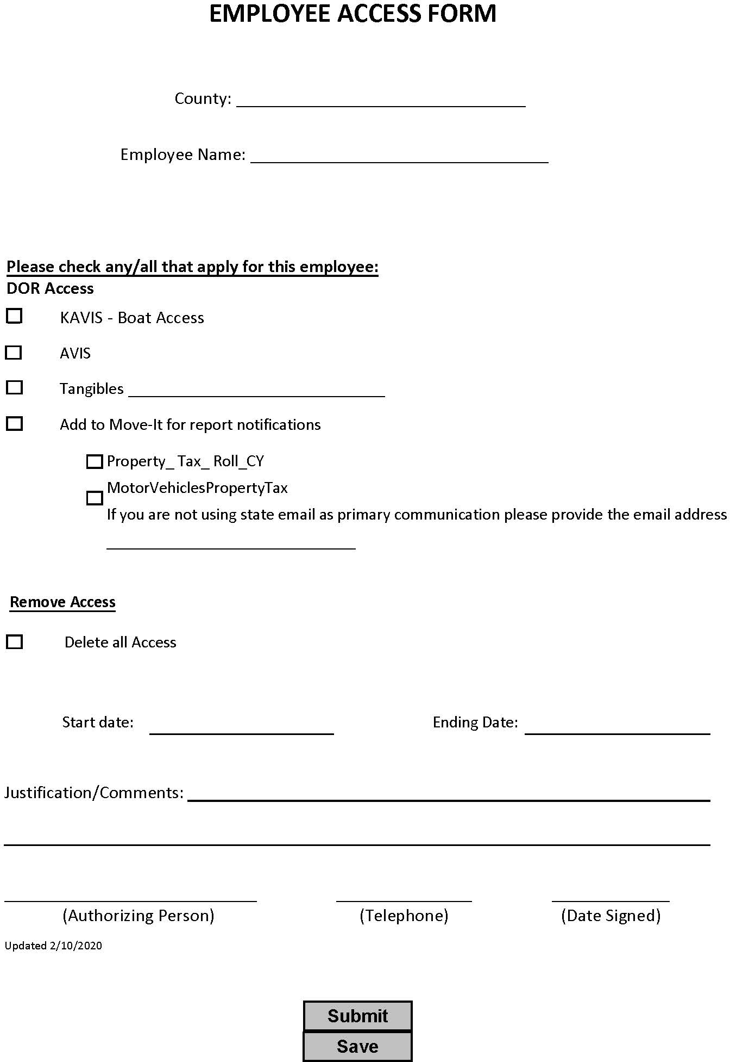

IT Cheat Sheet

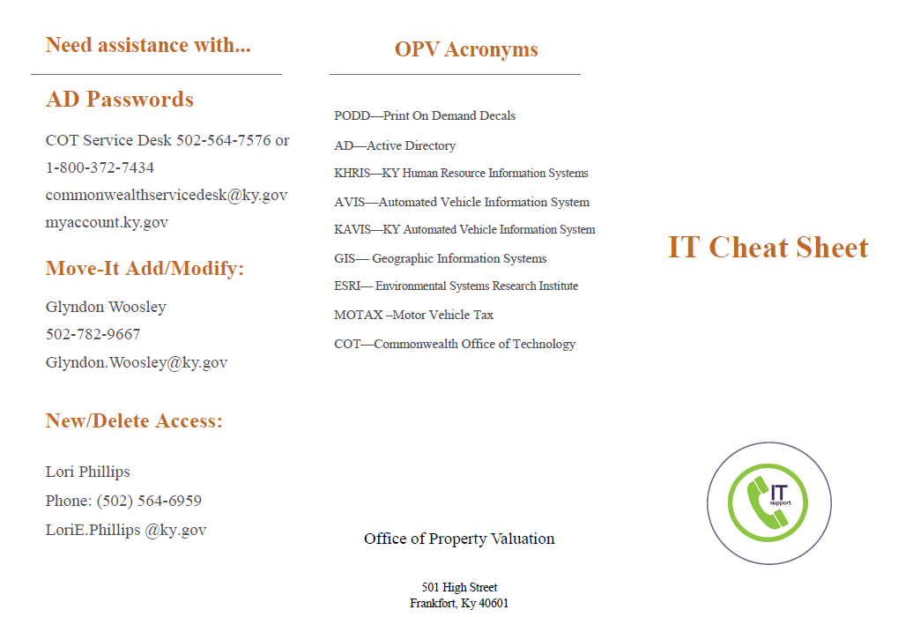

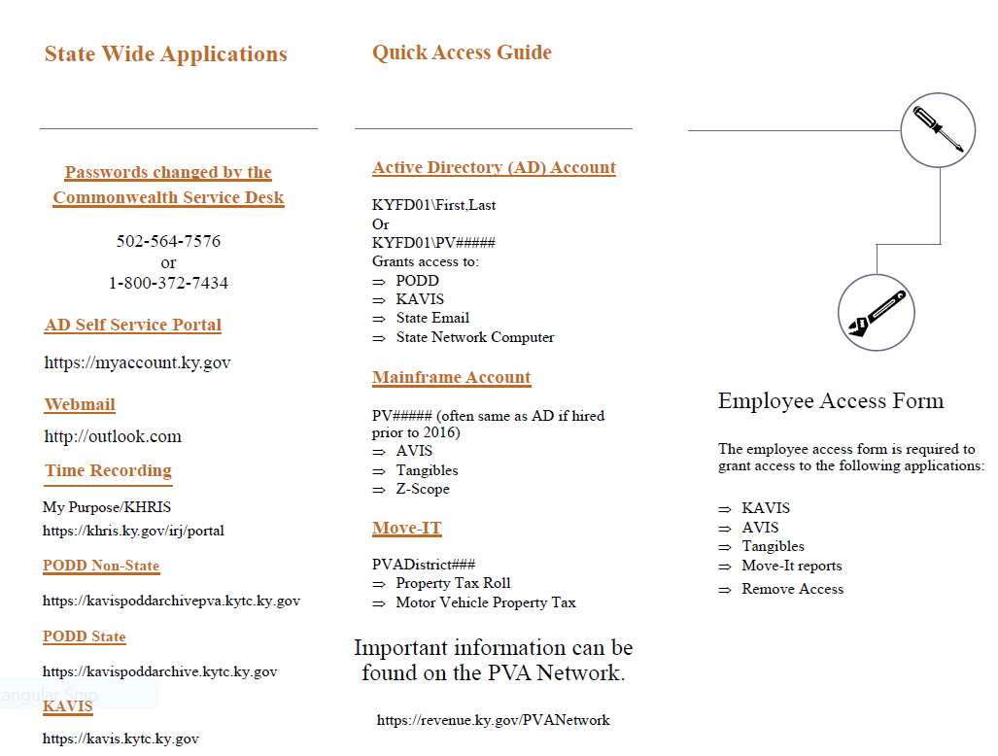

Self Service Password Management

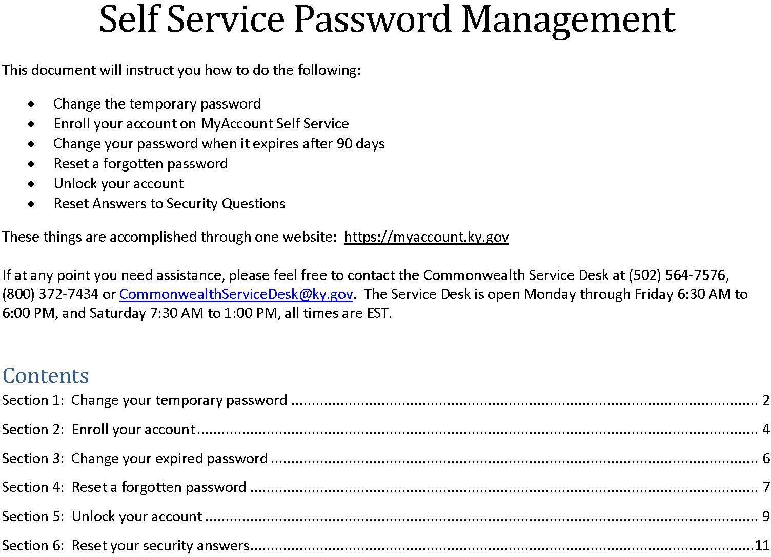

Change your temporary password

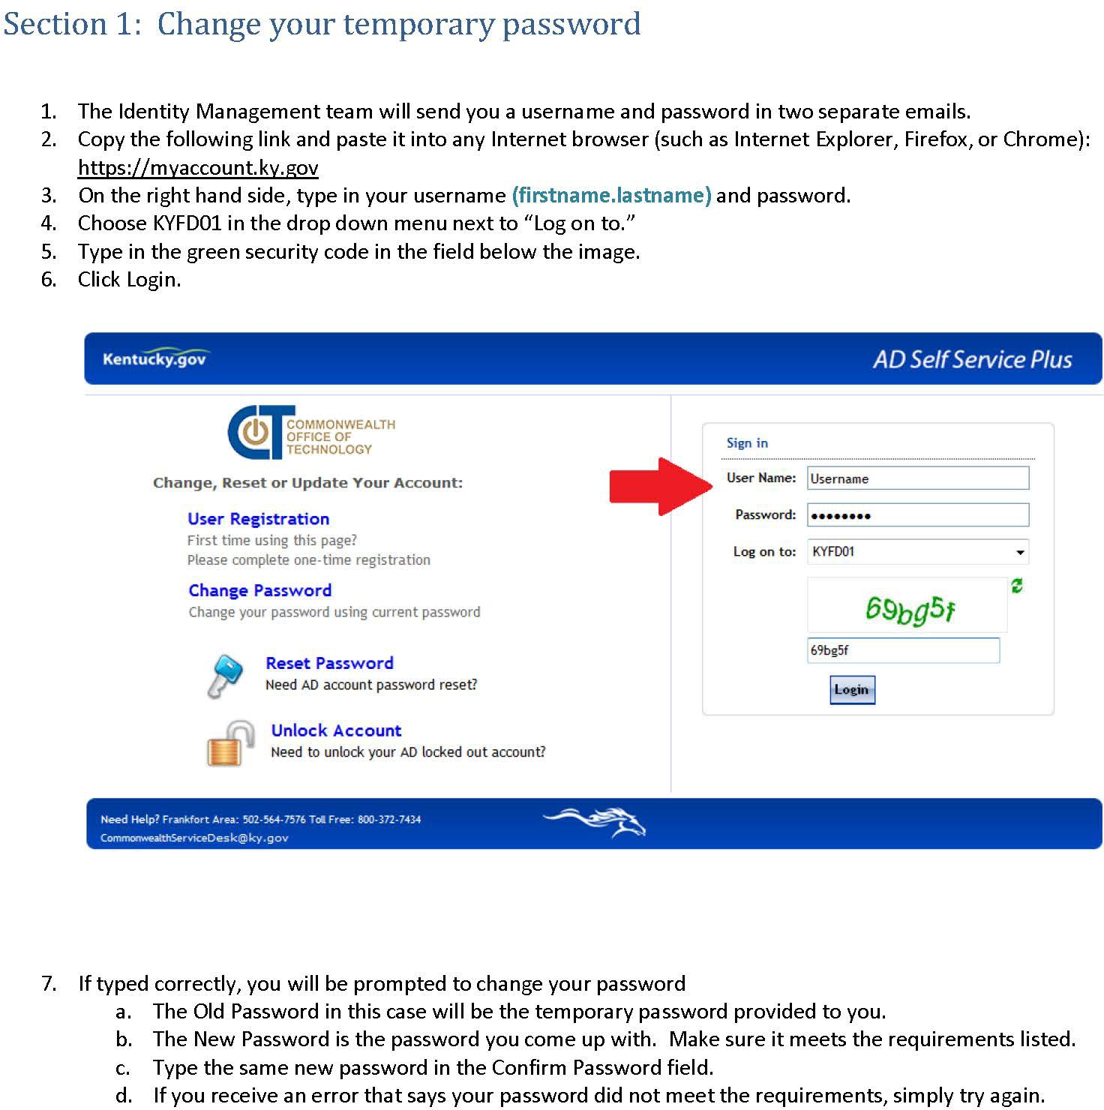

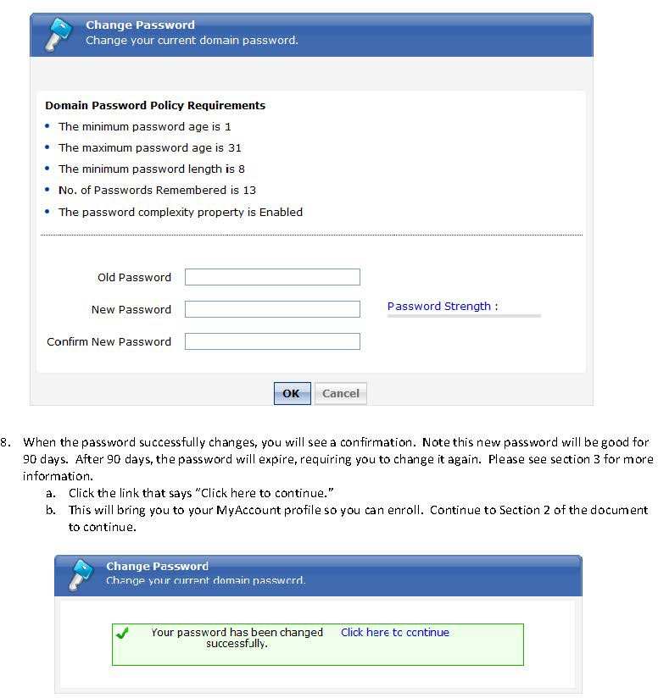

Enroll your account

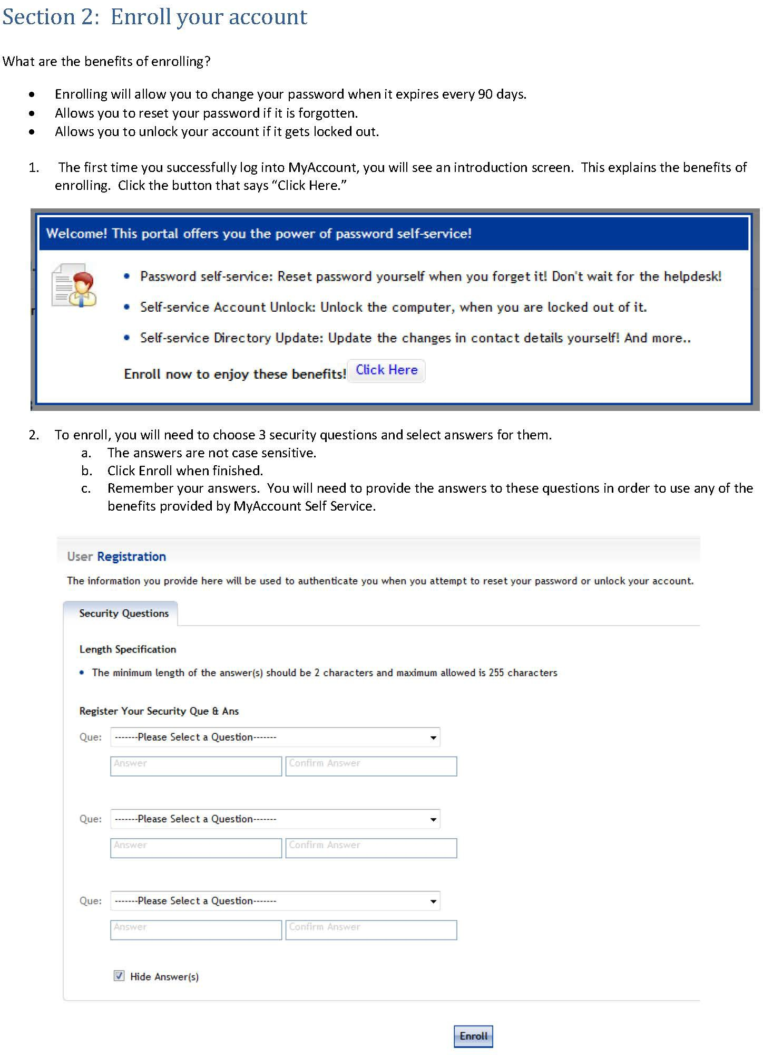

- Once you have successfully enrolled, you can log into your SharePoint, VPN, etc… and continue your business.
a. Remember the answers to your questions if you ever need to Change your expired password, reset a forgotten password, or unlock an account. See the below sections for each as you need.

Change your expired password

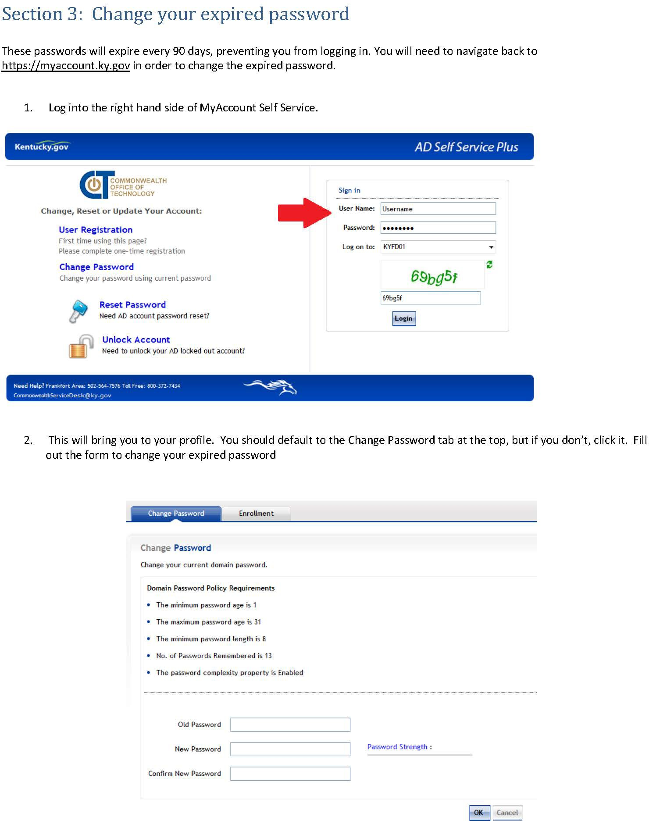

Reset a forgotten password

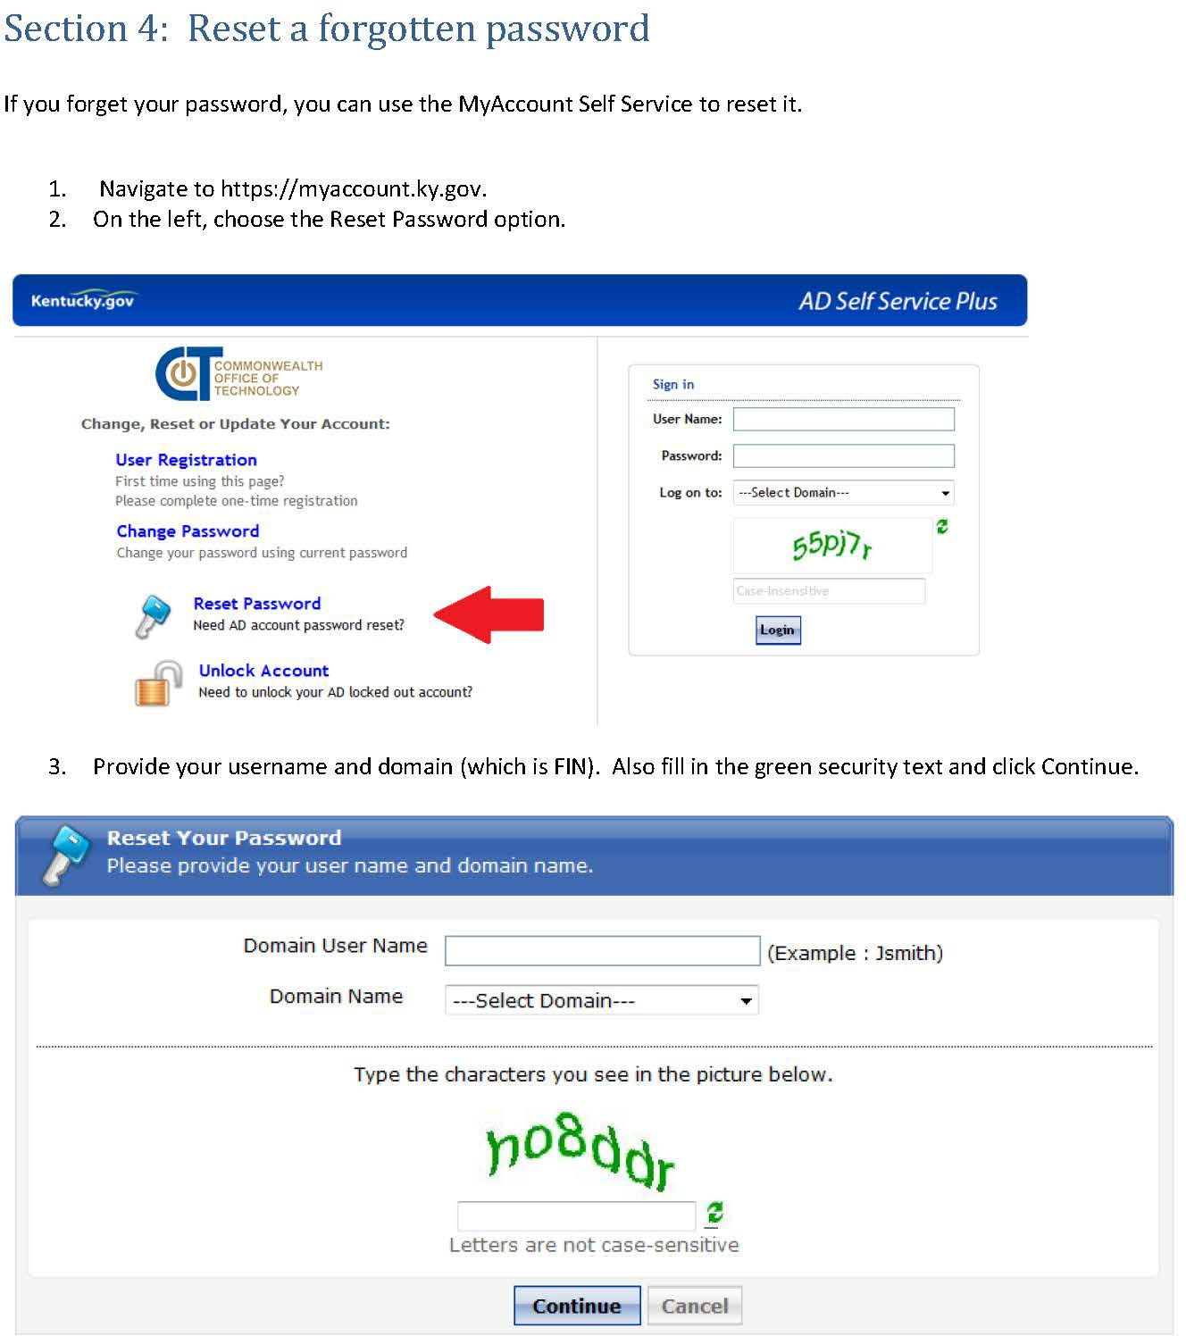

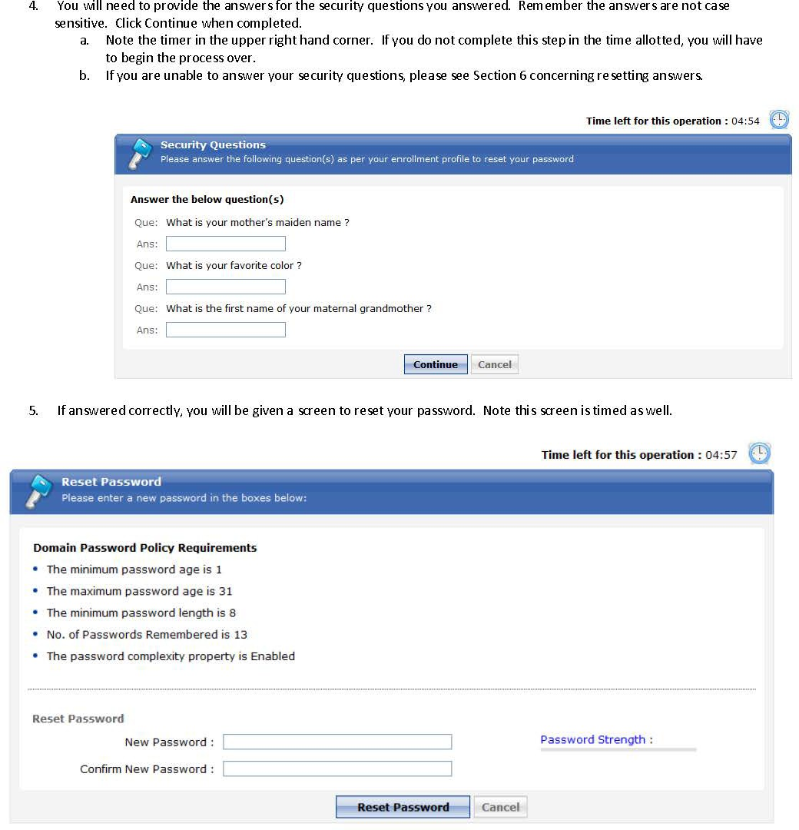

Unlock your account

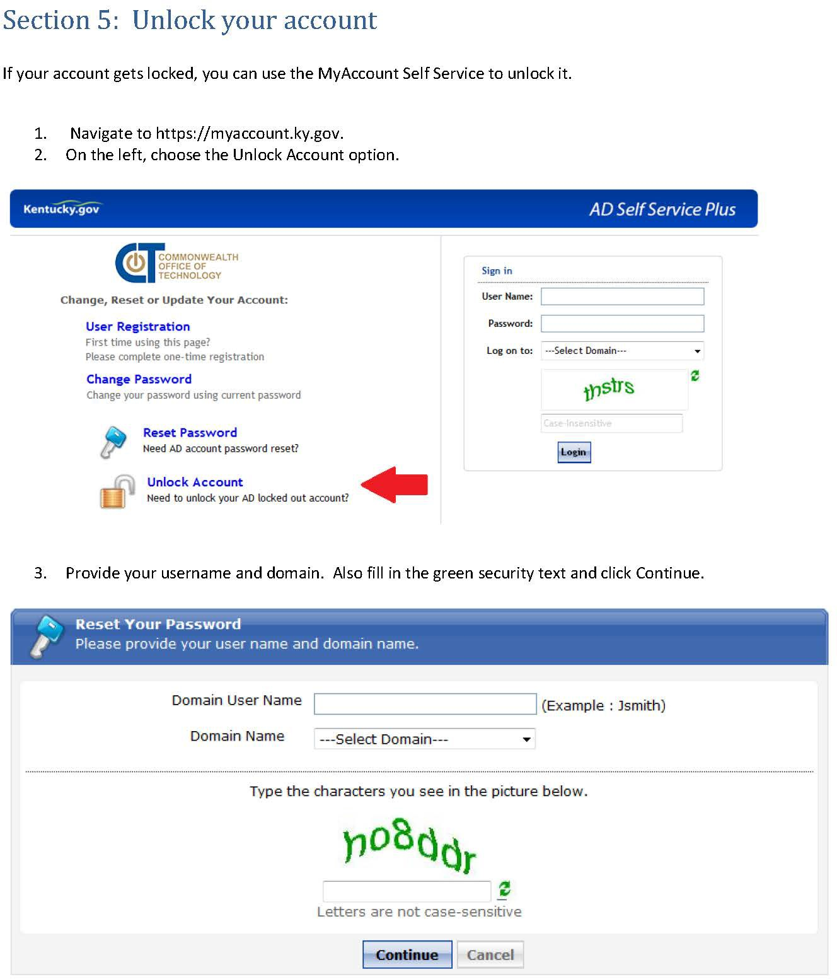

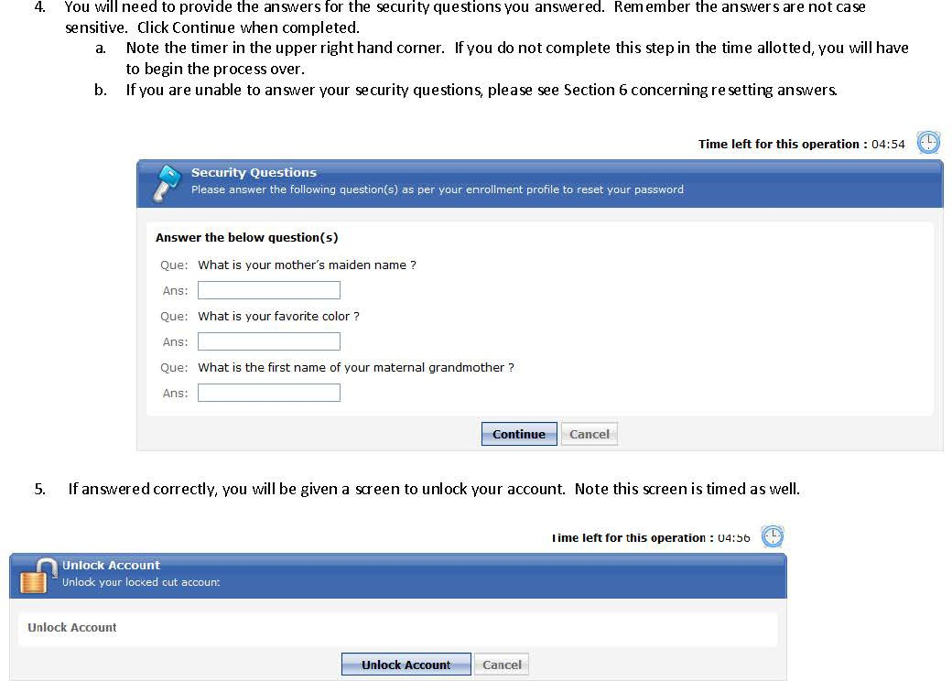

Reset your security answers

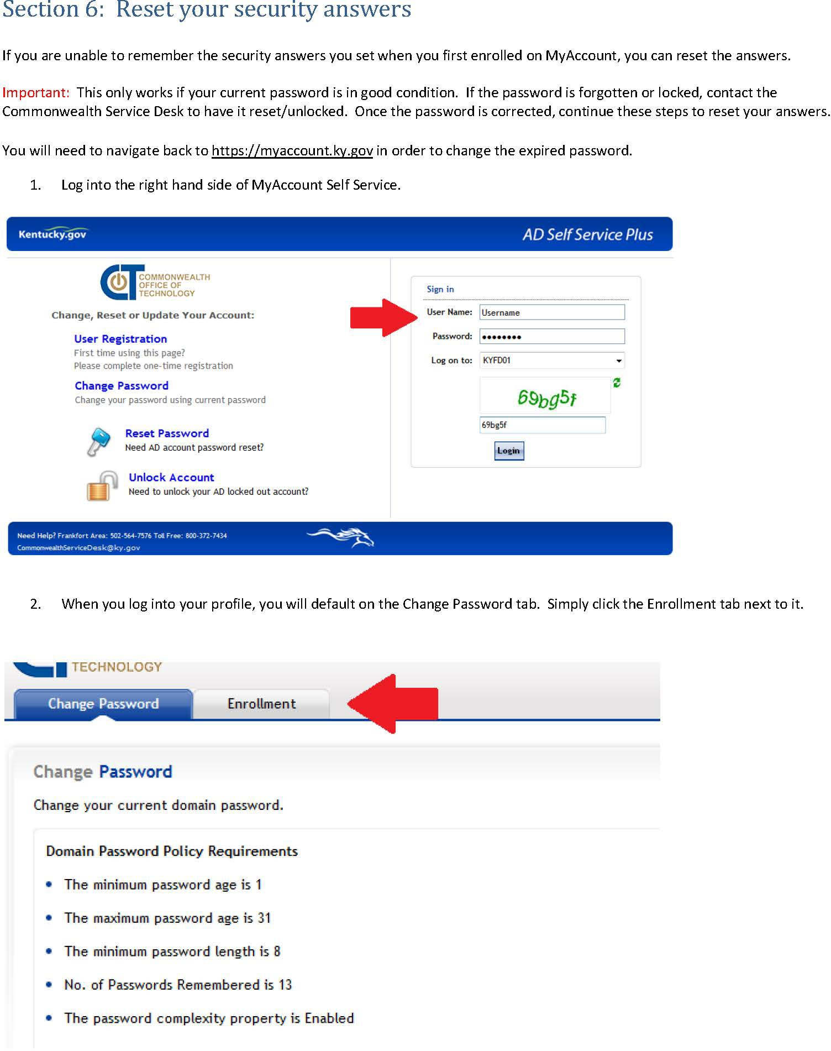

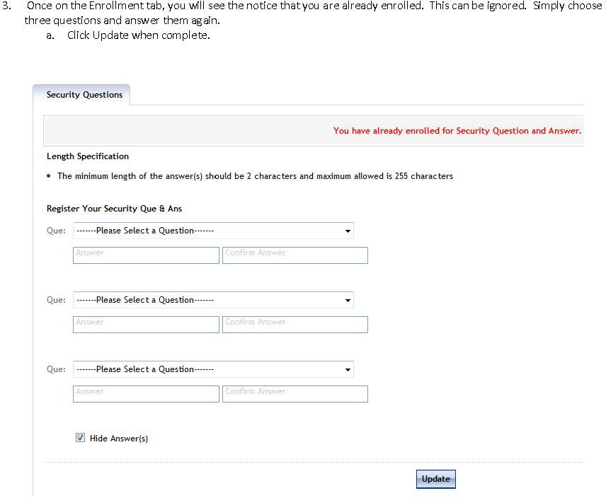

KHRIS User ID and Reset Password through KHRIS Portal Self Service

