2019
CAPITALIZATION RATE STUDY
Public Service Branch
Division of State Valuation, Office of Property Valuation
KENTUCKY DEPARTMENT OF REVENUE
502-564-8175

Background
To ensure fair and equitable assessment, taxation and allocation of public service companies (as defined in KRS 136. 120 through KRS 136.180) the Kentucky Department of Revenue (KDOR), Office of Property Valuation, Division of State Valuation, Public Service Branch turns to the following organizations that have developed standards for the unit appraisal of centrally assessed properties.
International Association of Assessing Officers (IAAO)
National Conference of Unit Valuation States (NCUVS)
The Western States Association of Tax Administrators (WSATA)
Uniform Standards for Professional Appraisal Practice Standards (USPAP)

These nationally recognized professional entities have established generally accepted appraisal principals and unitary appraisal methodologies that the KDOR looks to these organizations for general guidance and support.
The following exhibit provides the annual assessment results of Kentucky’s of Public Service Companies – Air carriers, electric utilities, privately owned water & sewer utilities, gas utilities, gas pipeline transmission, oil pipeline transmission, railroads, hydro-electric generators, and commercial solar & wind electric generators.

Introduction

In accordance with KRS 136.120 through KRS 136.180, the Kentucky Department of Revenue is responsible for the assessment of the operating tangible and intangible (including franchise) property of air carriers, fluid pipelines, gas pipelines, railroad, hydro-electric, commercial solar & wind electric providers, private water, private sewer, electric utilities, and gas utilities. The department’s Division of State Valuation, Public Service Branch annually assesses these business enterprises in part, using the income approach to valuation.
Under the income approach, the department utilizes a direct capitalization rate analysis by market segments. The department prepares this annual study for purposes of completing unitary valuations of state assessed business enterprises operating within the Commonwealth.
The goal, for Kentucky ad valorem tax purposes, is to produce an estimate of the total business enterprise value. This value is an economic measure reflecting the total market value of a business as of the lien date. Kentucky’s lien date is December 31/January 1. It is the sum of all claims by all claimants. The value of a business enterprise contains all intangible elements, no exception. The intangible elements are a result of factors such as a trained work force, operational plant, necessary licenses, systems and procedures in place. The fair cash value of the business, to a potential investor, as of the lien date, is the assessment objective.
Direct
Market Segments Capitalization Rate Capital Structure Debt
Cash Flow Rate
Air Carriers Passenger ALL 11.97% 55.00% Equity 45.00% Debt 6.40

Delta Air Lines 14.47% 73.00% Equity 27.00% Debt 5.13
Skywest Inc. 11.92% 42.00% Equity 58.00% Debt 6.40
United Continental Airlines 11.50% 43.00% Equity 57.00% Debt 6.82
American Airlines 11.52% 32.00% Equity 68.00% Debt 7.24
Southwest Airlines 10.14% 85.00% Equity 15.00% Debt 4.45

Freight Air Carriers ALL 9.68% 56.00% Equity 44.00% Debt 5.07

UPS 7.75% 79.00% Equity 21.00% Debt 4.45
Atlas Air Worldwide Holdings 10.33% 26.00% Equity 74.00% Debt 5.13
Air Transport Services 8.71% 49.00% Equity 51.00% Debt 5.00
Federal Express 10.68% 63.00% Equity 37.00% Debt 5.13

Electric Utilities 7.94% 60.00% Equity 40.00% Debt 5.13
Electric Independent Wholesale 9.46% 51.00% Equity 49.00% Debt 6.40

Natural Gas Distribution Utilities 6.62% 71.00% Equity 29.00% Debt 4.50

Natural Gas Pipelines 6.80% 53.00% Equity 47.00% Debt 5.13
Liquid Transportation Pipelines 8.42% 59.00% Equity 41.00% Debt 5.13

Railroads 6.86% 78.00% Equity 22.00% Debt 5.13

Private Water Utilities 5.00% 77.00% Equity 23.00% Debt 4.50

Income Capitalization Models

Two basic income capitalization models that appraisers may use are direct capitalization and yield capitalization.

Direct capitalization converts an estimate of a single year’s expected net operating income into an indication of value for the subject property. This conversion is based on the market-observed relationship between an income level and market value. This model assumes that the projected level of normalized income will either 1) remain constant or 2) increase at a constant rate over time. Direct Capitalization is a form of the comparable sales approach. Direct capitalization rates are based on income-to-market ratios. A direct capitalization rate is used in this model:
Free Cash Flow model Price / Earnings V = Earnings / r -g
Cash Flow model Price / Cash Flow V= CF / r - g
Net Operating Income model Price / NOI V= NOI / r –g

Growth (g) is equal to 0% when it is expected that the cash flows will remain constant into perpetuity.

Yield capitalization calculates the net present value of the anticipated series of future income by discounting cash flows using the yield (discount) rate.
Discounted Cash Flow (DCF) Model
Constant Growth Model
No Growth Model

The yield (discount) rate is estimated using one the following models:

Capital asset pricing model (CAPM)
Modified capital asset pricing model (MCAPM)
Build-up model (BUM)
Dividend Growth model
Earnings Capitalization model
Risk Premium model

A yield rate, a discount rate, and the opportunity cost of capital are all synonymous terms. However, they are different from a direct capitalization rate.

Kentucky uses a direct capitalization model utilizing cash flow.

Direct Capitalization

Direct capitalization is used to convert an estimate of a single year’s income expectancy into an indication of value in one direct step. A direct rate provides the relationship between a single year’s income and the value of a business enterprise. The attractiveness of direct capitalization is that it is relatively simple and easy:

VALUE = Income / Rate

Value = market value = fair cash value = expected sale price = business enterprise value
Income = gross cash flow EBIDAR
Rate = direct capitalization rate (the market observed direct rate)
EBIDAR = Earnings before interest, depreciation, amortization, and rent expense (after income tax and preferred stock dividends)

Cash flow is defined as net utility operating income plus depreciation and amortization expense, plus rent expense, minus preferred stock dividends. Although a cash flow direct capitalization model is less common than the traditional net operating income (free cash flow) direct capitalization model, the direct cash flow model is an acceptable and reliable valuation method. EBIDAR is a good metric to evaluate profitability – it eliminates the effects of many financing and accounting decisions.

Important aspects of direct capitalization:

- The capitalization rate used in our analysis is derived on a basis consistent with the economic income (gross cash flow) selected.
- The direct capitalization rate is a function of the market place and focuses on observable data from the market.
- The cap rate used in a direct capitalization impounds the investment community’s assumption regarding the estimated growth in earnings into the future.
- The direct capitalization model measures the current desirability of making an investment in a business.
- The direct cap method expresses a company’s value based on ratios observed in financial markets, so the approach already captures market expectations about future capital expenditures.
- Direct capitalization is used to convert an estimate of a single year’s earnings expectancy into an indication of value. A direct cap rate provides the relationship between a single year’s earnings and the value of a business enterprise.
- It is relatively simple and easy to calculate.
- Direct capitalization is not affected by the appraiser’s view of long-term future earnings streams, long-term growth projections, inflation, the improper selection or construction of a discount rate, or the appraiser’s subjectivity in the analysis of the data.
- When a direct cap model is selected, the income (earnings) are assumed to continue in perpetuity.
- Unlike yield capitalization, it is unnecessary to predict long-term growth rates.
- Under yield capitalization, if the appraiser incorrectly identifies what investors are expecting to occur long-term, the valuation estimate will not be credible.
- It is always improper to use a yield rate in a direct capitalization formula. Mismatching the benefit stream with the wrong risk rate will result in a materially incorrect valuation.
- Yield capitalization rates are always higher than direct capitalization rates.
- Yield Capitalization reliability is based on the validity of the appraiser’s assumptions of the shape and duration of future income streams.
- The yield cap model / discounted cash flow (DCF) method is generally impractical to implement in a mass appraisal environment.

The direct cash flow model is preferred because of certain advantages:

- Cash flows consider the earnings potential of the company as well as the balance sheet requirements to sustain the future earnings;
- Cash flows are what investors are seeking and expect to receive from their investments;
- Cash flows are the preferred benefit stream to use to value closely held companies;
- Cash flows can provide the assessor with a positive income stream to capitalize as opposed to the other models;
- For companies and industries that experience net operating losses, the direct cash flow model is capable of producing a meaningful income indicator as opposed to other models;
- EBIDAR is usually positive even when earnings per share (EPS) is not;
- The direct cash flow model is good when comparing firms with different degrees of financial leverage;
- The direct cash flow model is good when valuing capital intensive businesses with high levels of depreciation and amortization;
- In cases where the book depreciation does not reflect economic depreciation, the direct cash flow model is superior.

Under Kentucky law, all public service companies are appraised annually. Under the direct capitalization model, the appraiser determines projections of growth, no growth, or declining earnings during the annual re-assessment process. The one-year earnings estimate/projection, performed by the appraiser, is a critical function in the direct capitalization model. If growth is expected in the subsequent year, then the earnings projection is adjusted upwardly. If the income is declining, then the earnings projection is adjusted downwardly. If the earnings are flat and no growth is expected, then the previous year’s earnings might be appropriate. If the earnings have a history of variability then the earnings projection may be derived using a 3-year or 5-year average or weighted average.

In the income approach, an appraiser may consider the following techniques to forecast the single years’ projected income:

Last year’s income
Straight Average (5 yr or 3 yr)
Weighted Average (5 yr or 3 yr)
Regression Analysis
Analyst Forecasts
Performance Ratios

Historical income should always be adjusted to remove the effects of extraordinary income or expenses that will not be incurred in subsequent years.

Methodology

The Division of State Valuation, Public Service Branch develops a capitalization rate for each centrally assessed utility industry group using the band-of-investment technique. This technique calculates the combined rate of the debt and equity components using the capital structure indicated by the market for the specific industry.

Band of Investment

A representative capital structure is developed for each industry group using the market value of the equity and the long-term debt. The market value of debt is derived from information found in the SEC Form 10-K. Preferred stock is included in the debt portion of the capital structure. Preferred stock is generally a small percentage of the capital structure. In most market segments, preferred stock was materially insignificant or nonexistent. Some states do not account for preferred stock at all.

The rates of debt and equity are weighted by the respective amounts of such capital deemed most likely to be employed by a prospective buyer. The result is a representation of typical capital structure of an industry group of companies, not that of the present owner. An optimum capital structure is created from the perspective of a potential investor.

It should be noted that the capital structure of corporations versus master limited partnerships do vary. Master limited partnerships tend to trend towards higher debt and less equity. Partnerships cannot finance expansions and other capital projects using retained funds (since they must distribute all cash flow in distributions) like corporations. They must obtain funds issuing debt and/or more additional partnership shares.

The band-of-investment technique is used for both direct cap models and yield cap models.

Guideline Companies

The guideline companies used as comparables are selected from the appropriate industry group in the Value Line Investment Survey. The department reviews the guideline companies for relevancy and comparability in their market segments to companies conducting business in the Commonwealth of Kentucky. Certain guideline companies may be excluded from the study if they underwent a merger or acquisition in the previous calendar year. Other guideline companies may be excluded if they fail to represent the fundamental market segment (ex. a propane marketing company would not be included with gas pipeline companies or fluid pipeline companies) or the target line of business is a minimal percentage of the overall company operations. Other companies may be excluded if they are predominantly foreign-based operations. Some oil and gas diversified companies may be included in two industry groups – fluid pipeline segment and gas pipeline segment.

NCUVS standard – the chosen comparable(s) should be “reasonably similar” after an analysis of industry class, risk, growth, profitability, and size or physical characteristics.

Common Equity Rate Component

In the appraisal environment, there are many types of potential Price to Earnings ratios (P/E).

In Kentucky, for each selected guideline company, the department used the Price to Cash Flow Earnings (P/CF) ratio as calculated from the Value Line Investment Survey.

The concept of a “Price/Cash Flow multiple” multiple is not too different from that for a Price/Earnings multiple. A general Price/Earnings multiple is the recent stock price divided by 12 months of earnings. A Price/Cash Flow multiple is the recent stock price divided by 12 months of earnings plus 12 months of non-cash charges of depreciation, amortization, depletion, and less (if any) preferred dividends.

The cash flow per share indicator represents the company’s internal cash-generating ability. It is the amount of cash it earns to expand or replace plant and equipment, to provide working capital, to pay dividends, to repurchase stock, and as a measure of business viability and well-being.

The CF/P ratio is the annual cash flow earnings per share of common stock divided by the average market price per share of common stock. The inverse of each selected guideline company CF/P ratio is used to determine the equity component of the direct capitalization rate. The CF/P ratio is calculated by dividing 1 by the P/CF ratio.

Once the CF/P ratios are determined for the selected guideline companies, within an industry group, the median average CF/P rate is determined. This median CF/P rate is utilized in the band-of-investment technique to derive the overall direct capitalization rate.

The 2019 cash flow per share figure, from the Value Line Investment Survey, is used to determine the cash flow multiplier for each guideline company. See example below.

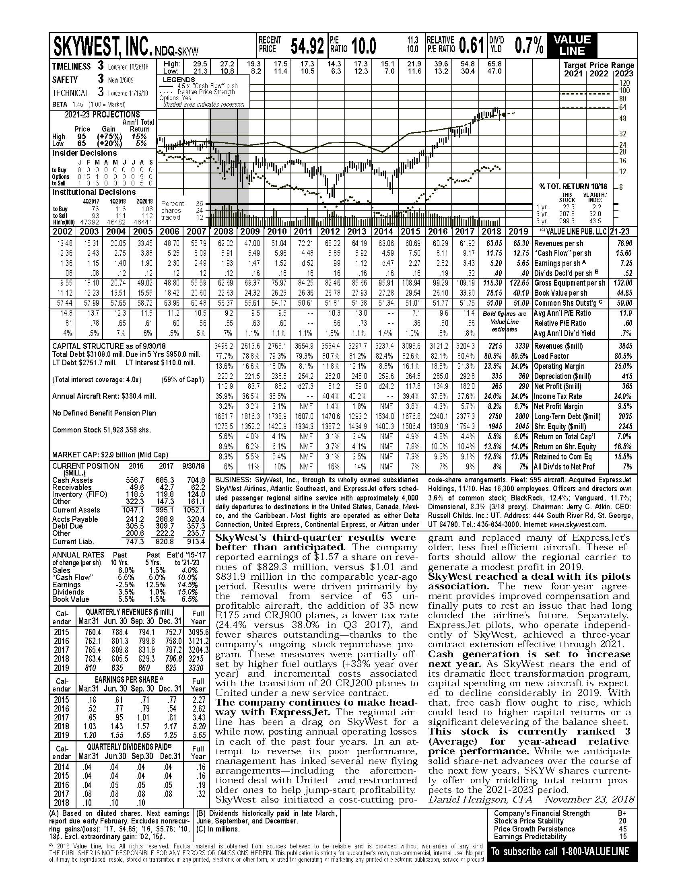

Cash Flow per Share projection for 2018 - 2019 is shown here.

Debt Rate Component

For the 2019 tax year, the Kentucky Department of Revenue analyzed the long-term bond indexes provided by Mergent Bond Record to estimate the debt rates for each market segment. Typical assessment theory requires the use of current yield for direct capitalization – yield to maturity for yield capitalization. The variation between these two calculated debt rates is fractionally small. For most new issues of debt, there is no variation.

According to Western States Association of Tax Administrators (WSATA) appraisal handbook on unit valuation of centrally assessed properties:

“The theoretically correct debt rate to use in a direct capitalization rate is the current yield. The current yield is the current interest expense divided by the market value of debt. If the appraiser makes the assumption that all debt is issued at par value, the yield to maturity rate can be used in the calculation of the direct capitalization rate.”

“Some appraisers advocate using the actual coupon rates on existing debt (embedded debt). The logic is that during times of rising interest rates a prospective purchaser would most likely assume the existing debt rather than refinance. This position lacks merit because, even in the case of an assumption, debt with a low nominal interest rate will be discounted in the marketplace at an effective rate equivalent to the current cost of debt. The use of embedded debt rates in estimating the current cost of capital results in a capitalized earnings indicator, which reflects high or low interest debt instruments at their face value rather than at their market value. Regardless of the regulatory practice of using embedded debt rates, their use is contrary to the market value concept.”

The measure of the rate for debt used in the direct capitalization rate is the current yield. Current yield is equal to the annual coupon rate divided by price (expressed as a percent). While the measure of the rate of debt for the yield rate is yield to maturity. The yield to maturity is the interest rate that equates the present value of a bond’s cash flow to its current price (expressed as a percent). Yield to maturity assumes that the bond will be held to maturity. If the bond is not held until maturity, or if the interim cash flows are reinvested at a rate that differs from the yield to maturity, an investor’s actual yield will differ from the yield to maturity. The yield to maturity calculation equates a bond’s cash flows to its current price; this yield calculation considers both coupon and income and any capital gain or loss the investor will realize by holding the bond to maturity. Valuation theory typically requires the use of current yields (the annual coupon rate divided by price) for direct capitalization and the use of yield to maturity for yield capitalization, the two rates will generally not vary significantly for seasoned issues (except under certain circumstances) and they will be the same for new issues.

For all industry groups, the debt rate component selected by Kentucky is the 4th quarter median rate from Mergent Bond record.

Important Considerations

- Development of the debt rate is from the expected position of a prospective purchaser at the lien date.
- For the 2019 cap rate study, the Department of Revenue reviewed and compared debt information from numerous state governments that annually prepare a ‘cost of capital’ and/or ‘capitalization rate’ study for unit assessment purposes.
- The 4th quarter median bond ratings from Mergent Bond Record were used in the comparison process. Mergent assigns yields only to bond groups Aaa, Aa, A and Baa.
- The KDOR also examined information from Standard & Poor’s, Duff & Phelps, Capital IQ, Moody’s Investor Service, Bloomberg Finance, and Mergent Financial Information Services: Bond Records.
- Only long-term debt obligations are included since only long-term liabilities are included in a capital structure.
- The long-term bond yield averages from the Mergent Bond Record for public utility, corporate, and industrial bonds were used to estimate the market rate of debt, perceived as typical, for our various industry groups. The corporate bond yield averages for public utility bonds from Mergent Bond Record were used for the electric, gas and water utilities. The corporate bond yield averages for corporate bonds and industrial bonds from Mergent Bond Record were used for the gas transmission, fluid pipeline, railroad, and airline segments.
- The debt rate selected for each market segment is an approximation.
- Flotation costs are not considered in the development of the debt component, because the market-determined opportunity cost of capital is not affected by the flotation costs of a particular firm. The cost of debt for each market segment has been rounded upward, to the nearest quarter percent, to produce an industry conservative debt rate.
- The estimated cost of debt is before income tax. The department adjusts the debt rate by the default income tax rate in order to incorporate the tax benefits of debt and to match the after-tax equity rate in the band-of-investment technique.
- Kentucky’s selected debt rates for each market segment are similar, if not parallel, with other state governments’ performing capitalization rate studies.

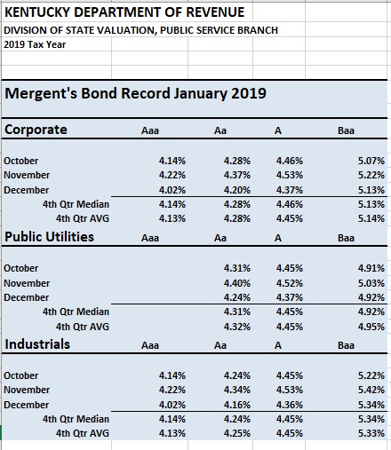

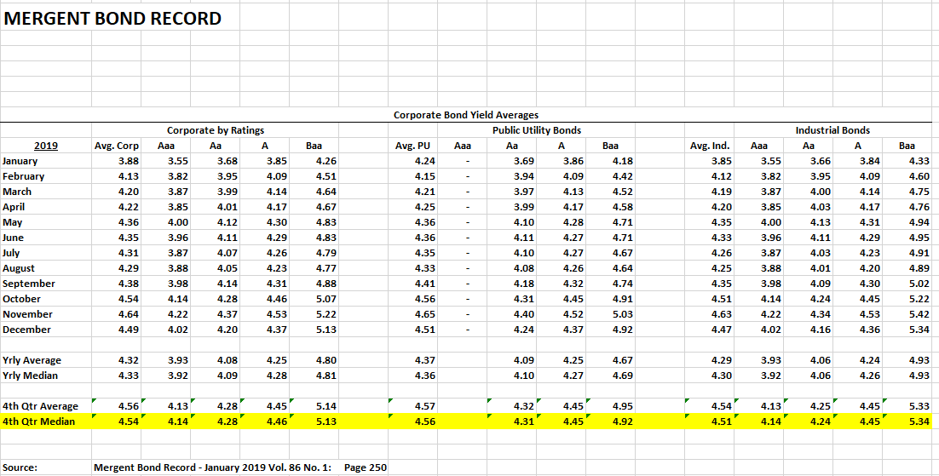

Moody’s | S&P | Grade | Risk
Aaa1,2,3 | AAA+- | Invest. Highest Quality | Lowest Risk
Aa1,2,3 | AA+- | Invest. Very High Quality | Low Risk
A | A+ | Invest. High Quality | Low Risk
A | A | Invest. High Quality | Low Risk
A | A- | Invest. High Quality | Low Risk
Baa1 | BBB+ | Min. Invest. Grade | Med Risk
Baa2 | BBB | Min. Invest. Grade | Med Risk
Baa3 | BBB- | Min. Invest. Grade | Med Risk
Ba1 | BB+ | Junk, Speculative | High Risk
Ba2 | BB | Junk, Speculative | High Risk
Ba3 | BB- | Junk, Speculative | High Risk
B1 | B+ | Junk, Very Speculative | Higher Risk
B2 | B | Junk, Very Speculative | Higher Risk
B3 | B- | Junk, Very Speculative | Higher Risk
Caa1 | CCC+ | Junk, Default Possible | Higher Risk
Caa2 | CCC | Junk, Default Possible | Higher Risk
Caa3 | CCC- | Junk, Default Possible | Higher Risk
Ca | CC | Junk, Default Probable | Extr. Risk
C | D | Junk, imminent default | Highest Risk

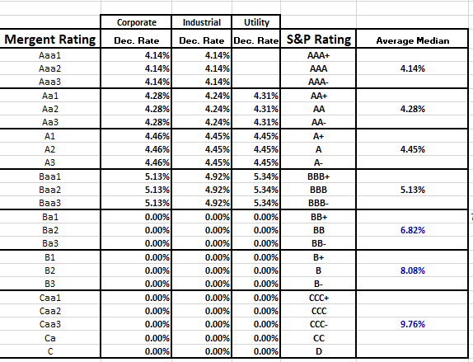

Preferred Stock Component

The Kentucky Department of Revenue does not provide a separate calculation for preferred stock in the band of investment technique. Instead, the preferred stock is included in the debt portion of the capital structure. If the preferred stock can be valued, the department will incorporate the resulting market value with the long-term debt component. For most industry groups, preferred stock is not an issue.

Tax Rate Component

The Kentucky Department of Revenue performs research regarding the income tax rates paid by the selected guideline companies. Examination of the 2018 income tax rates paid reveals a wide variation ranging from 0% to 32%. Liquid pipeline companies and gas pipeline companies tend to report tax rates at the lower range (0% to 25%). For most other company types, the range was 0% to 32% and the median range was 15.75% to 25.43% in 2018. The department has selected and applied a default income tax rate of 26.0% for imputing income tax as applied to the cost of debt in the band-of-investment technique. The rate selected represents the combined state rate of 5% and Federal corporate tax rate of 21%.

The Department of Revenue will incorporate the lower state and federal income tax rate of 26.0% in the band of investment technique to develop the capitalization rate and will be utilized in the income approach.

Comparison of Cap Rate Studies

For the 2019 tax year, the Kentucky Department of Revenue examined and compared our capitalization rate study with the studies performed by the following states.

The states include > Washington State Louisiana
Montana Missouri
Utah Minnesota
Oregon Oklahoma
California Colorado
Nevada

Beta Measurements

According to Value Line Investment Survey, the Beta measurement is a relative measure of the historic sensitivity of the stock’s price to overall fluctuations in the New York Stock Exchange Composite Index. A Beta of 1.50 indicates a stock tends to rise (or fall) 50% more than the New York Stock Exchange Composite Index. The “Beta coefficient” is derived from a regression analysis of the relationship between weekly percentage changes in the price of a stock and weekly percentage changes in the NYSE Index over a period of five years. In the case of shorter price histories, a smaller period is used, but two years is the minimum. The Betas are adjusted for their long-term tendency to converge toward 1.00.

Flotation Costs

When new issues of both debt and equity capital are sold to investors, the issuing company incurs transaction costs such as underwriting fees, legal expenses, and prospectus preparation costs. These costs of issuing securities are known as flotation costs. Much like loan fees or points on a mortgage, flotation costs effectively reduce the net proceeds that a firm will receive from issuing securities. For further insight on this topic, please see the Western States Association of Tax Administrators, Appraisal Handbook – Unit Valuation of Centrally Assessed Properties, 2009, page III-30 through III-31.

The department did not include flotation cost adjustments in our direct capitalization rate. Financial theory suggests and observed evidence supports the fact that firms do not typically issue new common equity as a common practice. Therefore, the direct capitalization rate does not include an adjustment for flotation costs. In addition, the income stream is not adjusted for hypothetical flotation costs. The direct rate is not a mechanism to recover the cost of doing business.

Thomas E. Copeland and Fred J. Weston believe that adjusting for flotation costs in the rate of return is erroneous because it implicitly adjusts the opportunity cost of funds supplied to the firm. The true market-determined opportunity cost is unaffected by the flotation costs of a particular firm. The correct procedure for the economic analysis of flotation costs does not alter the weighted average cost of capital.

Mr. Richard Simonds points out in the Journal of Property Tax Assessment & Administration, “When capitalizing net operating income in the income approach, a flotation-cost adjustment cannot be applied to the cost of capital. Advocates of an adjustment may be confusing the concept of the allowed rate of return on invested capital in a rate-regulated environment with the concept of the market-determined opportunity cost of capital."

The incorporation of flotation costs by some state tax organizations does occur. California, Nevada, and Louisiana allow flotation cost adjustments while Minnesota, Washington, Kentucky, Missouri, and Oklahoma do not adjust for flotation costs.

Consideration > When you buy a house, is your long-term bank loan (APR) rate adjusted for one time closing costs (legal fees, underwriting, points, and other fees)? The answer is “no.” Similarly, a flotation cost adjustment should not be applied to the cost of capital when capitalizing net operating income in the income approach.

Operating Leased Property

In Kentucky all companies as defined and listed in KRS 136.120, are subject to annual central assessment. All operating property both owned and leased plus the franchise is subject to taxation. Operating leased property is included in our valuation process.

Operating leased property for most guideline companies is relatively small (less than 2% of the total debt financing). The exception is air transportation companies. Leased property financing is quite high for airlines (33% or more of the total debt financing). Adjustment for these long-term lease commitments in the assessment process is critical. Both appraisal experts and credit rating agencies recognize operating leases as a debt equivalent.

According to the National Conference of Unit Valuation States (NCUVS), unit valuation standards, the full market value of non-capitalized operating leases is not reflected in an income capitalization approach unless adjustments have been made to the income stream. Therefore, in Kentucky, we add back the operating lease expense (after-tax) to the earnings to be capitalized when performing the income approach. The lease expense is not operating income. This mathematical operation is effectively treating the operating leased property as owned property. KRS 136.120 requires the leasee to pay the full property tax on the operating leased property – this included the lessor’s interest and leasee’s interest. The full market value of the lessee’s and the lessor’s interest, in the property financed with operating/non-capitalized leases, must be added to the cost approach and the market approach.

For the 2019 tax year, the Department of Revenue will include operating leases in the analysis of the air transportation carrier capital structure to capture the value of off-balance sheet leased assets. The future rental expense is capitalized using a rate that ensures the lessor is compensated with both a return on and of the investment. Further, because the leased asset generally reverts to the lessor upon default, a lower average cost of secured debt is used in our present value formula instead of the company’s overall cost of debt.

In the 2019-2020 calendar year, all lessees, with a lease term of more than 12 months will be required to report on their balance sheets “a right to use” asset and its lease liability based on net present value rent and if applicable, maintenance reserves payments taking into account the lease term as determined under IFRS 16. Depreciation of lease assets will be recognized separately from interest on profit and loss statements. This upcoming change may have an effect on the capital structure of some public service companies including but not limited to air carriers and railroads.

Additional Notes

For the 2019 tax year, the default income tax rate of 26.0% is applied to all market segments, including the state rate based regulated utilities.

The US Treasury 30 year Coupon Bond Yield was 3.101% on January 2, 2019.
According to Dr. Aswath Damodaran, “[s]ince no firm can grow forever at a rate higher than the growth rate of the economy in which it operates, the constant growth rate cannot be greater than the overall growth rate of the economy.” Therefore, the risk-free rate can be viewed as the maximum constant growth rate for each market segment.

The LIBOR rate as of January 2, 2019 was 2.51%

Stock Prices reflect December 31, 2018 closing price. The information was obtained from Yahoo Finance (2019) and/or the SEC 10K report filings.

Bond rate data was obtained primarily from Mergent Bond Record (January 2019 Vol. 83, No. 1) Mergent Incorporated.

Fair market value of Long Term Debt was obtained from the 12/31/2018 SEC 10K report filings for each selected guideline company.

Fair market value of Preferred Stock was obtained from the 12/31/2018 SEC 10K report filings for each selected guideline company.

FERC and SEC financial reports are both subject to public scrutiny, regulatory oversight, and potential sanctions for inaccurate reporting.

All intangible property is included in the Kentucky unitary assessments. The ultimate assessment goal is to produce a fair market estimate of the entire business enterprise as of January 1.

Income Approach (Example)

2020 Estimated Pretax Operating Income (EBIT) 380,000
Effective Income Tax Rate 26.00%

Estimated Net Operating Income (EBI) 281,200

Plus: Depreciation and Amortization Expense 351,000
Minus: Preferred Stock Dividends Paid 0
Plus: Op Lease Property Payments After Income Tax 50,000

Operating Cash Flow from Operations after Taxes (EBIDAR) $682,200
Capitalization Rate 8.10%

Capitalized Value $ 8,422,222

UNIT VALUE AS INDICATED BY INCOME APPROACH $ 8,422,222

NORMALIZED PRETAX INCOME: (EBIT) AMOUNT % CHANGE

2015 $294,946
2016 $266,947 -9.49%
2017 $272,735 2.17%
2018 $371,545 36.23%
2019 $377,507 1.60%
2020 Estimated $380,000 0.66% Projected

Copeland, T. & Weston, J., Financial Theory and Corporate Policy (3rd ed.), Addison-Wesley Publishing Company at 534.
Simonds, R., “Income Capitalization, Flotation Costs, and the Cost of Capital,” Journal of Property Tax Assessment & Administration, Volume 3, Issue 4, 2006.
Damodaran, Aswath, Dr. (n.d.) The Stable Growth Rate, found online at: http://pages.stern.nyu.edu/~adamodar/New_Home_Page/valquestions/stablegrowthrate.htm, last visited September 23, 2019.

